CLEAN HYDROGEN JOINT UNDERTAKING

2021
ANNUAL ACTIVITY REPORT

JU’s LOGO
In accordance with Article 26 of the Council Regulation (EU) No 2021/2085 establishing Clean Hydrogen Joint Undertaking and with Article 23 of the Financial Rules of the FCH 2 JU as re-adopted by the Clean Hydrogen Governing Board on 17/12/2021 (CleanHydrogen-GB-2021 -02) .
The annual activity report will be made publicly available after its approval by the Governing Board.

TABLE OF CONTENT

TABLE OF CONTENT 2
FACTSHEET 5
FOREWORD 8
EXECUTIVE SUMMARY 10
1. Implementation of the Annual Work Plan 2021 14
1.1. Key objectives 2021 and associated risks 14
1.2. Research & Innovation activities 22
1.2.1. Scientific and technological achievements 22
1.2.1.1. Transport applications 22
1.2.1.2. Research oriented activities for transport applications 29
1.2.1.3. Trials and deployment of fuel cells applications for energy 31
1.2.1.4. Next generation of products -energy 34
1.2.1.5. Hydrogen for sectoral integration 37
1.2.1.6. Hydrogen storage, distribution and purification 44
1.2.1.7. Hydrogen territories 45
1.2.1.8. Support for market uptake - cross-cutting activities 46
1.2.2 Knowledge management 47
1.2.3 Regulations, Codes and Standards Strategy Coordination (RCS SC) Group 49
1.2.4 European Hydrogen Safety Panel (EHSP) 49
1.2.5 Collaboration with the JRC 52
1.2.6 Support to JU policies and funding/financial engineering 54
1.2.7 International cooperation 60
1.3. Calls for proposals and grant information 61
1.3.1. Progress against KPIs / Statistics (Annexes 5, 6 and 7) 61
1.3.2. Evaluation: procedures and global evaluation outcome, redress, statistics (no. of evaluators, gender, area, etc.) 61
1.4. Calls for tender 61
1.5. Dissemination and information about projects results 64
1.6. Operational budget execution 73
1.7. In-kind contributions 74
2. SUPPORT TO OPERATIONS 83
2.1. Communication activities 83
2.2. Legal and financial framework 100
2.3. Budgetary and financial management 101
2.4. Procurement and contracts 110
2.5. IT and logistics 112
2.6. Human Resources 114
3. GOVERNANCE 117
3.1. Governing Board 117
3.2. Executive Director 119
3.3. States Representatives Group 119
3.4. Scientific Committee 119
3.5. Stakeholders Forum 119
3.6. Preparation of Stakeholders Group 120
4. INTERNAL CONTROL FRAMEWORK 121
4.1. Financial Procedures 121
4.2. Ex ante Controls on Operational Expenditure 121
4.3. Ex-post Control of Operational Expenditure and Error Rates identified 125
4.4. Audit of the European Court of Auditors 134
4.5. Internal Audit 135
4.6. Risk management and Conflict of Interest 135
4.7. Compliance and effectiveness of internal control 136
5. MANAGEMENT assurance 138
5.1. Assessment of the Annual Activity Report by the Governing Board 138
5.2. Elements supporting assurance 138
5.3. Reservations 138
5.4. Overall conclusion 140
5.5. Statement on management reporting 141
6. DECLARATION OF ASSURANCE 142
7. ANNEXES 142
Annex 1 – Organisational chart 143
Annex 2 – Staff Establishment Plan 144
Annex 3 - Publications from projects 145
Annex 4 - Patents from projects 157
Annex 5 - Scoreboard of H2020 common KPIs 159
Annex 6 - Indicators for monitoring cross-cutting issues 161
Annex 7 - Scoreboard of KPIs specific to JU 166
Annex 8- Draft annual accounts 169
Annex 9 – Materiality criteria 171
Annex 10 – List of acronyms 173

FACTSHEET
Name | Fuel Cells and Hydrogen 2 Joint Undertaking (until 30/11/2021)  Clean Hydrogen Joint Undertaking (as of 30/11/2021)
Objectives | For Fuel Cells and Hydrogen 2 Joint Undertaking  General objectives  a) to contribute to the implementation of Regulation (EU) No. 1291/2013, and in particular the Secure, Clean and Efficient Energy Challenge and the Smart, Green and Integrated Transport Challenge under part III of I of Decision 2013/743/EU  b) to contribute to the objectives of the Joint Technology Initiative on Fuel Cells and Hydrogen, through the development of a strong, sustainable and globally competitive FCH sector in the Union  Specific objectives  a) to reduce the production cost of fuel cell systems to be used in transport applications, while increasing their lifetime to levels which can compete with conventional technologies;  b) to increase the electrical efficiency and the durability of the different fuel cells used for power production to levels which can compete with conventional technologies, while reducing costs;  c) to increase the energy efficiency of production of hydrogen mainly from water electrolysis and renewable sources while reducing operating and capital costs, so that the combined system of the hydrogen production and the conversion using the fuel cell system can compete with the alternatives for electricity production available on the market;  d) to demonstrate on a large scale the feasibility of using hydrogen to support integration of renewable energy sources into the energy systems, including through its use as a competitive energy storage medium for electricity produced from renewable energy sources;  e) reduce the use of the EU defined ‘Critical raw materials’, for instance through low-platinum or platinum-free resources and through recycling or reducing or avoiding the use of rare earth elements.  For Clean Hydrogen Joint Undertaking  General objectives  a) to contribute to the objectives set out in the communication from the Commission of 17 September 2020 on Stepping up Europe’s 2030 climate ambition: Investing in a climate-neutral future for the benefit of our people, the European Green Deal and the European Climate Law by raising the Union’s ambition on reducing greenhouse gas emissions to at least 55 % below 1990 levels by 2030, and climate neutrality at the latest by 2050;  b) to contribute to the implementation of the 2020 Commission’s Hydrogen Strategy for a climate neutral Europe;  c) to strengthen the competitiveness of the Union clean hydrogen value chain, with a view to supporting, in particular for SMEs, the acceleration of the market entry of innovative competitive clean solutions;  d) to stimulate research and innovation on clean hydrogen production, distribution, storage and end use applications.  Specific objectives  a) to improve through research and innovation, including activities related to lower Technology Readiness Levels (TRLs), the cost-effectiveness, efficiency, reliability, quantity and quality of clean hydrogen solutions, including production, distribution, storage and end uses developed in the Union;  b) to strengthen the knowledge and capacity of scientific and industrial actors along the Union’s hydrogen value chain while supporting the uptake of industry-related skills;  c) to carry out demonstrations of clean hydrogen solutions with a view to local, regional and Union-wide deployment, aiming to involve stakeholders in all Member States and addressing renewable production, distribution, storage and use for transport and energy-intensive industries as well as other applications;  d) to increase public and private awareness, acceptance and uptake of clean hydrogen solutions, in particular through cooperation with other European partnerships under Horizon Europe.
Founding Legal Act | Council Regulation (EU) No. 559/2014 of 6 May 2014 – OJ L169/108-129 of 7.6.2014 (FCH 2 JU founding Regulation)  Council Regulation (EU) No. 2021/2085 of 19 November 2021 – OJ L427/17-119 of 30.11.2021 (Clean Hydrogen JU founding Regulation)
Executive Director | Bart Biebuyck
Governing Board | Chair: René Schutte  Vice chair: Rosalinde van der Vlies  Governing Board composition: https://www.clean-hydrogen.europa.eu/about-us/organisation/governing-board_en
Other bodies | For Fuel Cells and Hydrogen 2 Joint Undertaking  States Representative Group, Scientific Committee, Stakeholder Forum  For Clean Hydrogen Joint Undertaking  States Representatives Group, Stakeholders Group
Staff | 24 temporary agents, 3 contract agents and 2 SNEs
2021 Budget | EUR 15.8 million of which EUR 10.2 million (in terms of commitment appropriations) allocated to operational activities and EUR 5.6 million to administrative expenses
Budget implementation | 98.3% in terms of commitment appropriations  88% in terms of payment appropriations
Grants | 134 signed for a total value of 632.6 million at end of 2021
Strategic Research Agenda | Multi-Annual Work Plan 2014-2021  Addendum to the MAWP endorsed by the Governing Board on 15 June 2018
Call implementation | Global project portfolio (since setting up): 155 projects under FP7 (of which 154 are closed and 1 is open) and  134 signed projects under H2020 (of which 52 are closed and 82 are open)  Number and value of tenders (if any): 2 operational procurement activities were contracted in 2021 for a total value of EUR 718k
Participation, including SMEs | Total number of participations in funded projects: 1 544  of which:  % of SMEs = 23 %  % of SME funding: 28%  % of private for profit/large companies = 70%

FOREWORD
[Bart’s picture top left]

2021 was a significant year for the hydrogen community and the continuation of the Partnership. It was a year marked with substantial efforts in order to finalise the transition to a new ambitious policy programme. Hydrogen will be at the forefront of this new era as the European Union will strive to transform itself into a modern, resource-efficient and competitive economy.
All these efforts culminated in November 2021, when the Council and the Parliament adopted the regulation establishing the Clean Hydrogen Joint Undertaking. The JU will have the leading role in research activities related to hydrogen, collaborating closely with most of the end-use European partnerships on hydrogen applications in the relevant sectors. Its focus will be different from FCH 2 JU, shifting to areas related primarily to the production of clean hydrogen, as well as the distribution, storage and end use applications of low carbon hydrogen in hard to abate sectors.
The current report does not only cover the hard work to shape the future path but primarily details the main developments of the JU programme in 2021, main technological developments, insight in participations, statistics, our output and impact, important information on outreach and details on Programme execution and management of the programme office.
You will read on how JU supported demonstration of 1,064 fuel cell electric vehicles with an overall positive user satisfaction in terms of performance and refuelling times. 350 fuel cell buses operate successfully in the European streets for which the cost and prices have already reached Programme targets. The fleet is supported by an expanded network of 113 Hydrogen Refuelling Stations, directly financed by the Programme.
You will also notice the significant achievements in energy sector, with 1,900 Fuel Cells micro-Combined Heat and Power units deployed in domestic and commercial buildings, indicating the maturity of technology. Electrolysers capacity has already reached multi-MW scale and their use in large demonstration projects helps in brining hydrogen to the centre of EU energy policy as a key enabler for sectoral integration.
And the above are perfectly combined in 3 European territories that already benefit from an integrated system approach which includes hydrogen production, and search for storage and distribution solutions.
Among the highlights of the year was the second European Hydrogen week, which marked the public launch of the Clean Hydrogen Partnership in the presence of the President of the European Commission, Ursula von der Leyen.
With 288 projects, a combined public-private investment of over EUR 2.2 billion has been realised since 2008. Each euro invested by the EU has attracted more than three euros in private contributions. The COVID-19 pandemic left its impact on current projects but we have been able to adjust grant agreements wherever possible in order to address the consequences and to enable projects to remain on track to achieve their objectives.
In 2021, the JU maintained the excellent budget execution rates. Combined with the outstanding leverage effects, it demonstrates that it continues to provide an excellent example of a mature, sound and well-controlled environment.
FCH 2 JU has engaged 778 participants (unique beneficiaries) from 43 countries, of which 23% are SMEs, showcasing the attractiveness of the Programme. This success has been achieved thanks to the hard work and dedication of many people, passionate about tackling climate change by using hydrogen and fuel cells technology, such as colleagues in the European Commission, the Governing Board, the States Representative Group, the Scientific Committee and the many stakeholders who give their valuable inputs on our plans and activities.
Finally, I would like to thank my entire team in the Programme Office who, every day in these difficult times, give the best of themselves to serve the interests of European citizens.
Enjoy the read!

Bart BIEBUYCK
Clean Hydrogen JU Executive Director

EXECUTIVE SUMMARY
2021 was a year of transition for the FCH 2 JU in the context of the adoption by the Council on 19th November of the regulation establishing the new Clean Hydrogen Joint Undertaking under Horizon Europe. This decision acknowledges the central role played by FCH 2 JU in the development of hydrogen technologies and mandates its successor to contribute to the objectives set by the European Hydrogen Strategy published on 8th July 2020 by the European Commission.
This year was marked by an intense preparation work and dialogue with all stakeholders to build the new Strategic Research and Innovation Agenda (SRIA) which sets the new research & innovation priorities for the next decade.
Highlights during the year include:
Operational and communication activities
- The JU continued the implementation of its research and innovation programme, supporting a portfolio of clean and efficient solutions which exploit the properties of hydrogen as an energy carrier and fuel cells as energy converters to the point of market readiness.

- In the transport sector, demonstration of light duty vehicles has progressed in 2021 and the number of fuel cell electric vehicles (FCEV) demonstrated since the beginning of the programme has reached 1064 (10% increase compared to 2020), with plans to deploy more than 1 200 vehicles in 8 countries and 49 HRS in 5 countries. A users’ survey reported most fleet operators and drivers having positive overall experiences with FCEVs, based on the vehicle performance and refuelling time, which are meeting the operational needs.

- Fuel cell bus demonstration activities have grown considerably from earlier projects reaching 350 FC buses in operation in 2021. The European flagship projects JIVE and JIVE2 alone have ordered 274 buses out of the 310 planned and 80% were in operation at the end of 2021. The targeted bus prices, hydrogen price and maintenance costs have reached the FCH 2 JU MAWP targets, considering their time horizon of 2023. Fuel cell buses are getting ready for commercialisation. Twelve European bus OEMs are offering/preparing to offer fuel cell buses for sale or lease. This shows an improvement compared with the previous years.

- The geographical coverage of hydrogen refuelling infrastructure (HRS) continues to expand, providing the necessary support to the increasing number of FCEVs being deployed. The total number of HRS funded had already reached 113 by early 2021. By the end of 2021, the total number of HRS in Europe monitored by the JU funded European HRS availability system (https://h2-map.eu/), had reached 179 refuelling stations (part of them not funded by the FCH 2 JU).

- In the energy sector fuel cells have demonstrated a great potential to provide combined heat and power (CHP) in buildings with high energy efficiency. As of November 2021, the 4 European manufacturers involved in the PACE project have already deployed 1,900 FC µ-CHP units in domestic and small commercial building sectors, with 900 additional units expected to be installed by the end of 2022. The technological development of µ-CHP installations is mature, but scaling-up of production is still needed to bring further cost reduction.

- In the mid-size installations, the COMSOS project aims to validate and demonstrate the advantages of mid-sized SOFC-based (Solid Oxide Fuel Cell) CHP systems in industrial or utility services environments. Concerning off-grid applications, projects REMOTE, RoRePower and EVERYWH2ERE aim to produce results that could be applied in new fields where there is need for storage of local RES, like grid balancing and the production of hydrogen for mobility.

- Support to electrolysis research and demonstration continued to deliver good results, providing a solid basis for the support of the EU hydrogen strategy and the European hydrogen value chain. The support to game-changer low temperature electrolysers has significantly improved the techno-economic characteristics of this technology. Moreover, FCH 2 JU supports three projects on anion exchange membrane electrolysers (AEMEL), an alternative low TRL technology to the two main low temperature electrolyser technologies (alkanine – AE – and proton exchange membrane - PEM).

- At the same time, high temperature electrolysis starts finding its place in the industrial courtyard, facilitating strategic partnerships. The JU supports both lower TRL projects, like SELySOS, SWITCH and GAMER aiming to improve the performance of these electrolysers, as well as demonstration projects in industrial environments, such as a steel plant (GrinHy2.0) and a bio-refinery (MultiPLHY).

- In terms of size, demonstration of large electrolysers has reached the multi-MW scale. In the last decade, electrolyser capacity increased 500 times and funding per MW installed reduced by a factor of 100. The large demonstration projects in refineries (Refhyne), steel industry (H2FUTURE) or chemical industry (Djewels) have proved electrolysers as a reliable enabler for sectorial integration and helped bring renewable hydrogen to the centre of EU energy policy.

- The area of hydrogen storage, distribution and purification has been receiving an increasing amount of attention and funding the recent years. The HYSTOC project aims to develop and demonstrate a transport and storage system for HRS using a liquid organic hydrogen carriers (LOHC). The HYCARE project is developing a prototype large scale hydrogen storage tank based on solid-state storage. The HYGRID project aims to develop, scale-up and demonstrate a novel membrane-based hybrid technology for the direct separation of hydrogen from natural gas grids. The MEMPHYS project targeted the development of a low-energy hydrogen purification system.

- All the above areas are also demonstrated together in an integrated system approach through the Hydrogen Valleys. Currently, the JU supports three hydrogen territories, BIGHIT in the norther Scottish islands of Orkney, HEAVENN in the northern regions of the Netherlands and GREEN HYSLAND at the island of Majorca (Spain). Although they vary significantly in size, they all have in common integrating hydrogen production from renewable electricity and the search for various storage and distribution solutions that are specific to each territory, the amount of hydrogen produced, the type of end use and the distance to the end uses.

- The above research and innovation actions are complemented by a number of cross-cutting activities related to pre-normative research (PNR), input in regulations codes and standards (RCS), education and training, as well as safety aspects. The comprehensive portfolio of FCH 2 JU activities strengthens the whole FCH sector and supports the market uptake of hydrogen technologies.

- Knowledge management activities focused on improving the annual Programme Review exercise and the quality of information provided through the Fuel Cell and Hydrogen Observatory (FCHO). The duration of the Programme Review, covering 85 projects, was reduced by 6 months, permitting the publication of the Programme Review Report on the Programme Review Days. In parallel, the FCHO extended its content, publishing more data and information, including a new module on the Levelised Cost of Hydrogen.

- Dissemination and exploitation of results is an important part of the JU which participates actively in several initiatives: the Horizon Results Platform, the Innovation Radar, the Horizon Results Booster. Until the end of 2021, 25 FCH 2 JU project results have been uploaded in the Horizon Results Platform. Moreover, in 2021, 24 project participants of 5 FCH 2 JU projects submitted 10 innovations to the Innovation Radar, that were included in the platform. The EC Horizon Results Booster was launched in 2019; so far 8 projects have applied or already benefitted from these services.

- Communication activities focused in 2021 on two main areas: promoting the results of the FCH 2 JU and the development of the communications framework of its successor Clean Hydrogen JU. This last part included the development of a new brand and visual identity, the development of the new website ( www.clean-hydrogen.europa.eu), and of a new newsletter. A communication campaign was launched around the new partnership, generating media coverage and awareness among various stakeholders.

- The second edition of European Hydrogen Week brought together over 2 000 participants from the public and private sectors across Europe and beyond to review progress and look ahead to new opportunities for the production and use of hydrogen throughout the economy. The event marked the public launch of the Clean Hydrogen Partnership in the presence of the President of the European Commission, Ursula von der Leyen.

- Hydrogen week concluded with the FCH 2 JU Programme Review Days, which presented the progress of supported projects and technological developments in the transport and energy sectors.

Support activities and internal control environments
- Budget execution further improved to 98.3% in terms of commitment appropriations, recording the best performance in JU history, and reached 88% in terms of payment appropriations. Administrative budget showed the best rates in JU history at 93% in terms of commitments and 78% in terms of payments.

- Time-to-pay improved for a 3rd consecutive year (for operational payments) and for 5th consecutive year (for administrative payments).

- Leverage effect and in-kind contributions
By the end of 2021, the JU had supported 134 projects under the H2020 programme for a combined public-private investment close to EUR 1.2 billion. Together with its additional activities, FCH 2 JU managed to achieve a combined amount of private-public investment for the H2020 programme of over EUR 2.2 billion

- Reinforcement of internal control system
Due to persistent systemic errors for declared personnel costs, particularly in case of SMEs and new beneficiaries (who are more error-prone than other beneficiaries), the JU had already strengthened its internal control to address the increased risk regarding SMEs and new beneficiaries. The results of these measures were evident for the first time in 2021 and contributed to significantly lowering the representative error rate from SMEs and new beneficiaries in the last 2 years.

- The huge preparatory work, in support of the Commission, for the transition to the new Programme was successfully concluded with the first meeting of the GB, allowing the JU to continue operating as from 30 November 2021.

Implementation of the Annual Work Plan 2021

Key objectives 2021 and associated risks

H2020 programme
The overall objective of the Fuel Cells and Hydrogen Joint 2 Undertaking (FCH 2 JU) was to implement an optimal research and innovation programme at the EU level to develop a portfolio of clean and efficient solutions that exploit the properties of hydrogen as an energy carrier and fuel cells (FC) as energy converters to the point of market readiness. This will provide feedback and related support to EU policies on sustainable energy and transport, climate change, the environment and industrial competitiveness, as embodied in the Europe 2020 strategy, and job creation. It will also help to achieve the EU’s overarching goal of smart, sustainable and inclusive growth. The overall direction of the programme was guided by the multi-annual plans: Multi-Annual Implementation Plan (MAIP) for 2008-2014 under FP7 and Multi-Annual Work Plan (MAWP) for 2014-2020 under Horizon 2020. These plans specify targets for the state of hydrogen technologies in Europe (covering cost, durability and performance) and specific key performance indicators (KPIs). The programme’s progress and therefore scientific/technological achievements are always assessed according to the progress towards achieving these targets and KPIs. As the technology has progressed substantially in recent years and new applications have begun to emerge, these KPIs (fixed in 2014) were revised and included in an addendum to the MAWP, endorsed by the JU Governing Board (GB) on 15 June 2018. The main objectives and achievements are presented in Section 1.2.
Horizon Europe programme
The new EU Clean Hydrogen Joint Undertaking launch was announced during the opening keynote by the President von der Leyen at the EU Hydrogen Week 2021, and officially established in November 2021 with the Council Regulation (EU) 2021/2085. The new Joint Undertaking (JU) aims to bring together the European Commission, the hydrogen industry, researchers and innovators as well as policy-makers from the Member States, building on the joint efforts of FCH 2 JU.
The overall direction of the programme will be guided by a new strategic research and innovation agenda (SRIA), replacing MAWP, which was adopted by the Clean Hydrogen JU Governing Board on 25 February 2022.
Leverage effect in H2020 programme
A key objective and measure of the JUs’ success is their capacity to leverage private funding.
The Council Regulation establishing the FCH 2 JU explicitly mentions the minimum target leverage effect over the whole 2014-2020 period at 0.57.
By the end of 2021, under the H2020 programme, the JU had supported 134 projects for a combined public-private investment close to 1.2 billion EUR.
- CHART 1.1.1: Total committed private and public investment in JU actions over 2014-2020 in EUR million

In addition, in 2021, industry and research members reached an overall amount of EUR 1.039 million of certified additional activities, so-called IKAA (covering the years 2014-2020). Due to this high number of certified IKAA, there was no new IKAA plan adopted for year 2021 for Horizon 2020.

This demonstrates the sector’s huge success of the H2020 programme and a continuous willingness to invest and grow.
By combining committed EU and private funds in the JU actions with the amount of the certified additional activities for the years 2014-2020, at the end of the year 2021, a total EUR 2.22 billion programme can be observed:
CHART 1.1.2: EU/PRIVATE INVESTMENTS IN JU ACTIONS VS. IKAA FOR 2014-2021, IN EUR BILLION

Values of leverage effect for the Calls concluded by December 2021

Chart 1.1.3: Total committed private and public investment in JU over the period of 2014-2021 (committed private funding in all signed FCH 2 JU actions and certified additional activities 2014-2020) up to 31 December 2021
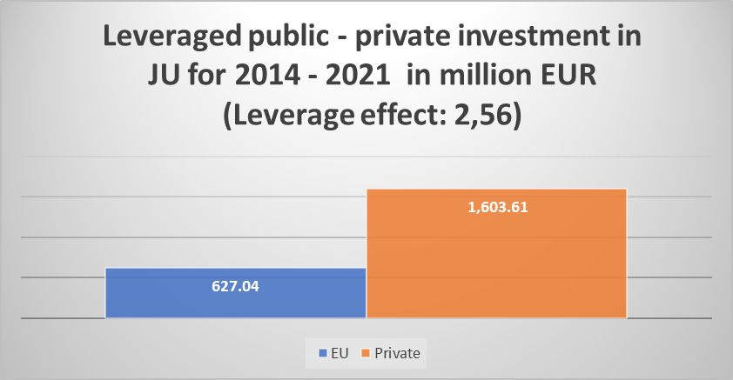

This overall level of the leveraged funding clearly demonstrates a huge commitment of the private sector, significantly exceeding the set targets in the FCH 2 JU Council Regulation.

Leverage effect in Horizon Europe programme
The new Council Regulation is based on the principles and criteria set out in the Horizon Europe Regulation, including openness and transparency, a strong leverage effect and long-term commitments of all the involved parties.

According to the new Council Regulation (ref. to Article 171), the joint undertakings shall organise the continuous monitoring and reporting of the management and implementation of their activities and periodic reviews of the outputs, results and impacts of the funded indirect actions implemented in accordance with Article 50 of and Annex III to the Horizon Europe Regulation. That monitoring and reporting shall include (among others):
- information on quantitative and qualitative leverage effects, including on committed and actually provided financial and in-kind contributions, visibility and positioning in the international context, impact on research and innovation related risks of private sector investments.

Annex III of the Horizon Europe Regulation requires that the financial or in-kind contributions from members other than the Union should be at least equal to 50 % and may reach up to 75 % of the aggregated joint undertaking budgetary commitments.

The Union should be in a position to reduce its contribution if members other than the Union fail to fulfil their commitments.

For the Clean Hydrogen JU, specific leverage targets have been defined as following:

Union financial contribution (Article 76):
The Union financial contribution to the Clean Hydrogen Joint Undertaking, including EEA appropriations, to cover administrative and operational costs shall be up to EUR 1 000 000 000, including up to EUR 30 193 000 for administrative costs.

Contributions from members other than the Union (Article 77):
The members of the Clean Hydrogen Joint Undertaking other than the Union shall make or arrange for their constituent or affiliated entities to make a total contribution of at least EUR 1 000 000 000, including up to EUR 30 193 000 for administrative costs, over the period ending 31 December 2031.

More details on in-kind contributions for additional activities can be found in section 1.7.

Risk assessment in 2021
Risk management is a crucial part of the strategic decision-making process. Robust risk management frameworks help to ensure that taxpayers‘ money is used effectively and efficiently, that potential risks to achieving objectives are identified in a timely fashion and that appropriate mitigating action is taken.
All members of staff, regardless of their level, shares responsibility for risk management. The Executive Director is accountable to the Governing Board and is ultimately responsible for the management of the JU activities and achievement of objectives and must ensure that the JU critical risks are known and appropriately managed.

Relationship with the Internal Control Framework
On 16 August 2018, the JU Governing Board adopted a new Internal Control Framework (ICF) stemming from the most updated internationally acknowledged COSO model of internal control, in line with the EC’s ICF.
Risk assessment is one of the five key Internal Control Framework components and consists of the four (4) principles, No.6 - 9:
Internal Control Framework Components and Principles
Risk Assessment | - The organization specifies objectives with sufficient clarity to enable the identification and assessment of risks relating to objectives.
Risk Assessment | - The organization identifies risks to the achievement of objectives across the entity and analyses the risks as a basis for determining how the risks should be managed.
Risk Assessment | - The organization considers the potential for fraud in assessing risks to the achievement of objectives.
Risk Assessment | - The organization identifies and assesses changes that could significantly impact the system of internal control.

Risk Identification and Assessment
In November 2021 an annual risk assessment exercise was conducted for the purpose of identifying, analysing and responding to key risks (including fraud risks) across all of the JU program office (PO) areas of responsibility of the, for the purposes of establishing the first version of the Annual Work Programme 2022, related to continuation of the JU activities under the new Clean Hydrogen partnership.
The risk identification started with assessment of the relevance of the risks identified in the previous risk-assessment exercises and continued with the identification of any new relevant risks (related to continuation of the JU operations under Horizon Europe programme, including transitional risks.)
The aim of this annual exercise was to identify risks that could harm achievements of the H2020 objectives, including (among others) operational, financial and compliance risks.
Due to continuation of COVID-19 related circumstances, the risk assessment exercise in November 2021, evaluated also existing risks and action plans related to COVID-19.
During the exercise, the following aspects of all the risks presented in AWP 2021 were assessed (in view of COVID-19):
- Relevance of the risk -> is the risk still present? Has it materialised?
- Rating the risk -> did the rating (in terms of impact/likelihood) increase or decrease?
- Relevance and fulfilment of the action plan -> should we continue/expand/reduce action plans?
In addition to regular risk-assessment exercise, a special brainstorming session, taking into account an input from all members of staff, chaired by the ED, was conducted to identify any new emerging risks related to transition to the new partnership.
Based on the discussions, the risks were either removed (when considered no longer relevant) or modified, while the action plans were reviewed for adequacy and completeness.
The table below provides a summary of the outcome of the exercise on risks and fulfilment of the action plans, as at 31 December 2021:
TABLE 1.1.5: Fulfilment of the action plans
 | Risk Identified  (AWP 2021) | Action Plan  (AWP 2021) | Action Plan – status as at 31 December 2021
MEDIUM | Due to limitation of H2020 ex-ante controls (trust-based approach with minimum amount of default checks), representative error rate for FCH 2 JU may increase.  Consequently, there is a risk of obtaining a qualified opinion and of not getting the discharge from the European Parliament due to fact that the Court of Auditors’ threshold for a residual representative error rate stays at the level of 2%.  (NB: H2020 ex-ante control strategy envisaged level of the residual error rate in the range between 2-5%) | Annual analytical risk – assessment at the beneficiary level and subsequent introduction of the targeted ex-ante controls for the projects / beneficiaries with higher identified inherent risk.  Application of the feedback from ex-post audits and lessons learnt on ex-ante controls, e.g. from accompanying auditors in the missions for FCH audits.  Continuation of interactive financial webinars for complex projects or where there are numerous newcomers in the consortia in the first 12 months of the project duration.  Additional review of potential financial risks within FCH 2 JU top beneficiaries, followed up by bilateral telcos. | In 2021, we executed the action plan accordingly and results were positive. High risk beneficiaries were identified based on the lessons learnt.  Individual bilateral financial webinars were set up to prevent and detect early any potential financial errors.  Impact analysis showed that several possible misstatements were corrected at ex-ante level and that the error rate, especially in the riskiest categories of the beneficiaries (SMEs & newcomers) has progressively decreased.  Ex-ante control strategy for Horizon Europe further supports a risk-based oriented ex-ante approach. Many newcomers and new beneficiaries are entering our programme.  For H2020, the screening will focus on the projects from Call 2020 which will only report their costs in 2022 for the first time.
MEDIUM | Due to COVID-19, to ensure business continuity, FCH 2 JU is highly dependent on safe and proper functioning of the IT tools and network connection, which become increasingly vulnerable to potential cyberattacks, performance inefficiencies and connection failures due to increased traffic, different level of security connection and increased levels of pirate attacks and phishing.  Unknown weaknesses in the systems may pose higher risks of failures of the operations, and also they may create opportunities for fraudulent behaviour. | Mitigating actions include raising awareness of staff and mechanisms to prevent attacks including the following:  - Improved ex-ante and ex-post security systems controls for automated attacks;  - Increased the level of controls were implemented with CERT-EU;  - Increased level of security and advanced protection were adopted.  Training and awareness sessions for increased security measures should be put in place further. | In 2021, we continued trainings and awareness sessions on cyber-security, phishing, etc.  The IT systems have continuously been updated.  Thanks to numerous actions adopted in 2021, we are in the position to reduce impact and likelihood, therefore reducing the residual level of the risk from medium to low.
MEDIUM | Risk that program objectives will not be achieved fully and timely due to delays in project execution attributed to COVID-19. | Mitigating actions are in place for monitoring of any delays in the project, restructuring of the projects, if necessary, granting project extension in average of 6 months due to COVID19 via amendment process. | In 2021 we had concrete examples from our projects – mainly demonstration projects reflect these issues (e.g. delays in component supplies, change of investment strategies, lack of skilled people and turnover and mobility of talents).  Due to increased amount of activities in the sector, there is higher demand on experts and we may suffer from lack of their availability.  Rating of the risk: we keep at least one more year this risk as medium, and we re-evaluate next year.
MEDIUM | Risk of disruption of the operations in case substantial amount of people would be infected by COVID-19 virus, combined with a risk of staff disengaging from the culture of the organization. | Adequate back-up systems are in place, coaching sessions and regular virtual team meetings are in place. | In 2021, mitigating measures were implemented, including: vaccinations, limits on the presence of the % of the people physically in the office, reinforced use of teleworking, adopting new ways of hybrid working, etc.  No distortions of the operations were observed, also due to virus becoming less strong.  Therefore, we are reducing the impact and likelihood of the risk, moving the residual level of the risk to low.

The outcome of the 2021 risk assessment workshop on new or continuing risks for 2022 are included in the AWP 2022.

Research & Innovation activities

Scientific and technological achievements
The overall objective of the FCH 2 JU is to implement an optimal research and innovation (R&I) programme at the EU level to develop a portfolio of clean and efficient solutions exploiting the properties of hydrogen as an energy carrier and fuel cells (FCs) as energy converters to the point of market readiness. Thanks to the partnership between leading research organizations and industrial companies, the activities of the JU cover all stages of product development from low TRL research up to large demonstration projects.

Section 1.2.1 presents the main achievements for all activities, as identified by the Programme Office with the support from the Joint Research Centre of the European Commission during the annual review 2021 of the Programme, with some additional recent data of 2021 – when available – that were presented in the Programme Review Days 2021. To facilitate the reading, these are split in the main pillars of transport and stationary applications, hydrogen production, hydrogen storage-distribution-purification and cross-cutting activities.

Transport applications
The demonstration actions in this field aim to prove technology readiness, reliability, robustness, fuel efficiency and sustainability. Historically, demonstration activities have focused on road transport, based on cars and buses, but are now shifting towards heavy-duty road transport, rail and maritime

Light duty vehicles
The projects dedicated to fuel cell cars demonstration are H2ME, H2ME2, SWARM and ZEFER. H2ME and H2ME2 are the largest European deployment initiatives to date for hydrogen mobility, with plans to deploy more than 1 200 vehicles in 8 countries and 49 HRS in 5 countries. The number fuel cell electric vehicles (FCEV) demonstrated since the beginning of the Programme has reached 1064 (10% increase compared to 2020. A users’ survey reported most fleet operators and drivers having positive overall experiences with FCEVs, based on the vehicle performance and refuelling time, which are meeting the operational needs.

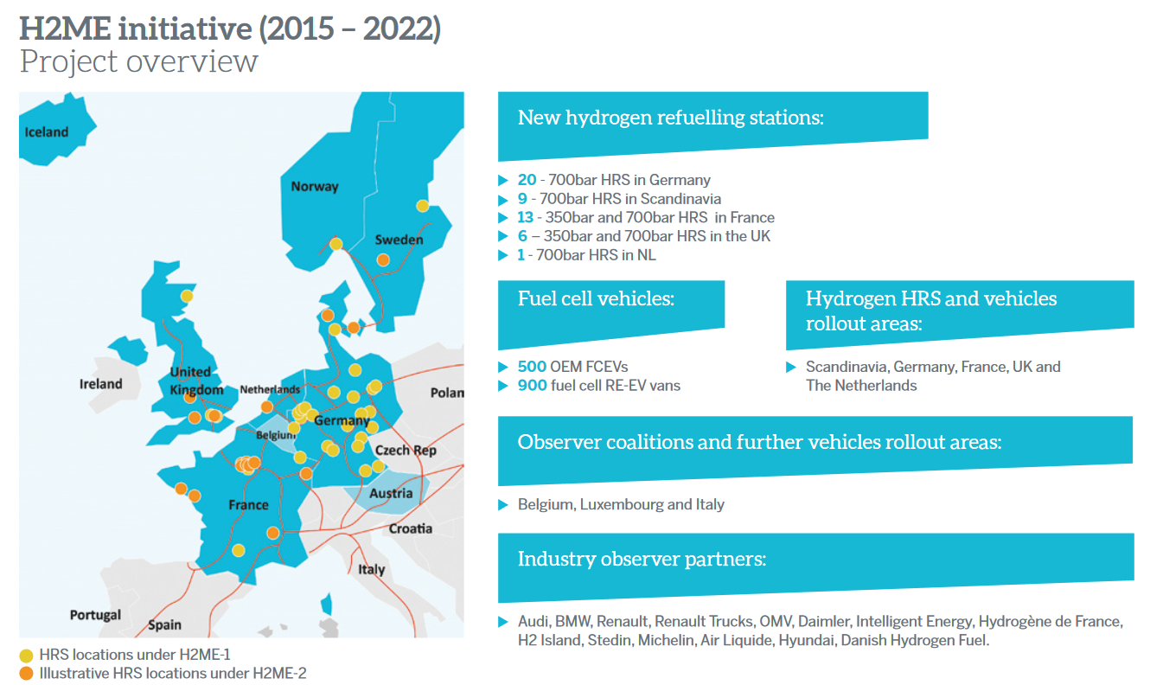
Figure 1: Overview of H2ME initiative, January 2021. Source https://h2me.eu/
H2ME finished in 2020 and H2ME2 will go on until 2022, having already deployed by 2020 together 687 vehicles and 38 HRS in total. Project H2ME has deployed 311 vehicles and 29 new hydrogen refuelling stations (HRSs) in Germany, Scandinavia, France and the United Kingdom. H2ME2 has already deployed 376 FC electric vehicles from 5 original equipment manufacturers and 9 HRSs.

Project ZEFER started in 2017 with the aim of demonstrating viable business cases for captive fleets of fuel cell electric vehicles (FCEVs) (taxi, private hire and police services) and will continue until 2022. Of the 180 FCEVs planned, 117 are already in operation (57 in Paris and 60 in London).
In 2020, in total 607 cars were reported in TRUST, close to the 597 cars reported in 2019. In 2020, they drove slightly more than 4.9 million kilometres (km) and consumed 52.7 tonnes of hydrogen, which is around half of that reported in 2019, with 8.9 million km driven and 91.5 tonnes of hydrogen consumed. These differences can be explained partly by the COVID-19 pandemic, which had a direct impact on the operation of the taxi fleets (in practice, operating only from January to March 2020), responsible for half the difference above (taxis drove 0.7 million km in 2020 instead of 2.8 million in 2019). The other half is mainly due to structural changes in the fleets, whereby a number of cars with significant driven km in 2019 (2.5 million km) were sold in the first half of 2020 and thus did not report in TRUST. The cumulative distance driven is shown in Figure 2.

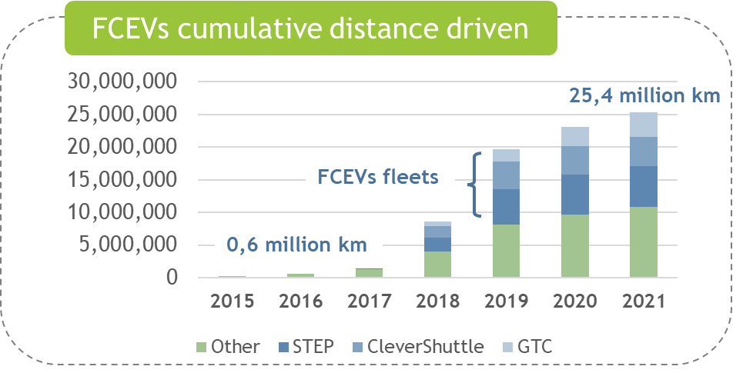
Figure 2: Distribution of FCEV Deployed of FCEV Deployed by FCH 2 JU Demonstration Projects (the 2021 figure is an estimate)
Fuel cell bus demonstration projects
European demonstration activities have grown considerably from earlier projects to the most recent, as shown in Figure 3. In 2019 and 2020, JU bus demonstration activities concerned the projects High V.LO-City, HyTransit, 3EMOTION, JIVE and JIVE 2.

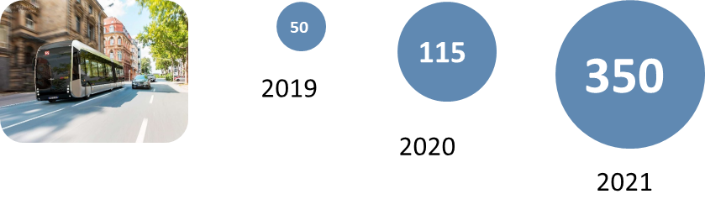
Figure 3: Evolution of FCB in operation in the EU (the 2021 figure is an estimate).
Bus demonstrations supported by JU grants involve 350 vehicles in 11 countries. 3EMOTION, JIVE and JIVE 2 are ongoing and progressing. The European flagship projects JIVE and JIVE2 alone have ordered 274 buses out of the 310 planned for 22 cities across Europe (Figure 4), with 80% in operation in the end of 2021. The local fleets range from 5 to 50 FCBs, typically 10 to 20.

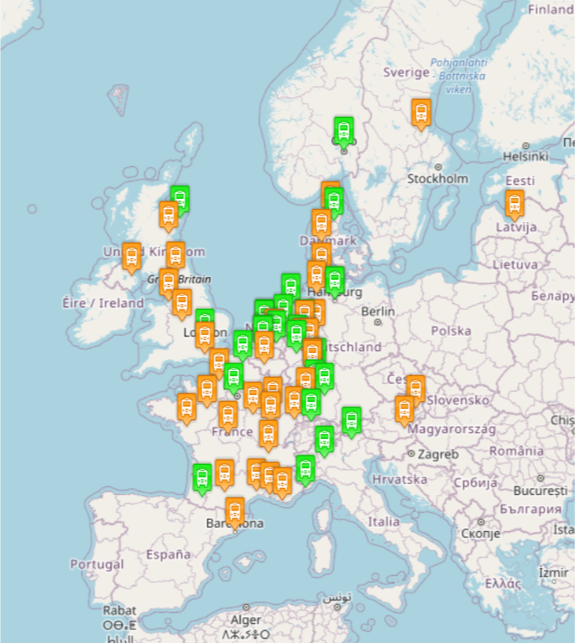
Figure 4: FCB demonstration in Europe (source https://www.fuelcellbuses.eu/) including national initiatives and Interreg-funded demos.
In 2019-2020, 119 buses were in operation in 7 cities. From the bus demonstration projects that were reporting in TRUST between 2016 and 2020, a total distance of over 8.9 million km was accumulated, with almost 1 million km accumulated in 2020 alone. Over the last 4 years, over 602 tonnes of hydrogen have been consumed. In 2020, the average fuel consumption was 10.42 kg H₂/100 km, while the minimum reported was 8 kg H₂/100 km, meeting the 2020 MAWP target (8 to 10.2 kg H₂/100 km). The 2020 MAWP targets for FC system cost and vehicle cost which had already been achieved in 2018, were also met in 2020.
In 2020, the average fuel cell bus (FCB) availability was 82%, with a number of buses greatly exceeding this percentage( maximum availability reported was at 96.1%). The low average availability value is explained by the longer period observed for receiving replacement parts from international suppliers due to the pandemic for the gradually ageing FCB fleets. In addition, a teething period of a few months is usually observed at the start of FCB operation on sites previously unfamiliar with FCB, which adversely affects their availability.
Truck demonstration projects
JU demonstration activities on heavy-duty trucks started in 2018 with the REVIVE project which aims to demonstrate 15 heavy-duty refuse trucks in 8 sites across Europe. It was enlarged in 2019 with the addition of the H2Haul project. REVIVE will set the basis and state of the art reference for future HDV refuse truck demonstration projects. Its activities include the life cycle analysis of the project performance in terms of CO2 emissions, air pollution and noise reductions.
H2Haul, ‘Hydrogen fuel cell trucks for heavy-duty, zero emission logistics’, will lead to the demonstration of 16 trucks, in 4 European countries. In addition, three new HRS for truck refuelling will be deployed in Belgium, France and Switzerland. The project is currently in the planning and pre-deployment phase. The design of three new types of FC trucks (including rigid and articulated vehicles up to 44 tonnes) is ongoing and specifications are being prepared as per specific customer requirements and mission profiles. These two projects will establish policy recommendations to foster the deployment of FCH trucks. The HRS that will support the truck fleet are also being demonstrated or upgraded.
Hydrogen refuelling infrastructure for cars and buses
The geographical coverage of hydrogen refuelling infrastructure continues to expand, supporting the increasing number of FCEVs being demonstrated (see Figure 5). The total number of HRS funded under the transport pillar is 113, of which 64 (53 for cars and 11 for buses) have already been deployed, dispensing hydrogen at 700 bars, and have been integrated into petrol forecourts; 13 also have a 350 bars dispenser. The European HRS availability system (https://h2-map.eu/), an initiative funded by the JU, provides a portal giving information on the live status of each HRS in Europe, and available on any mobile application or tool for the convenience of FCEV users. Currently, 179 fuelling stations (some not funded by the JU) are both connecting and sending live data.
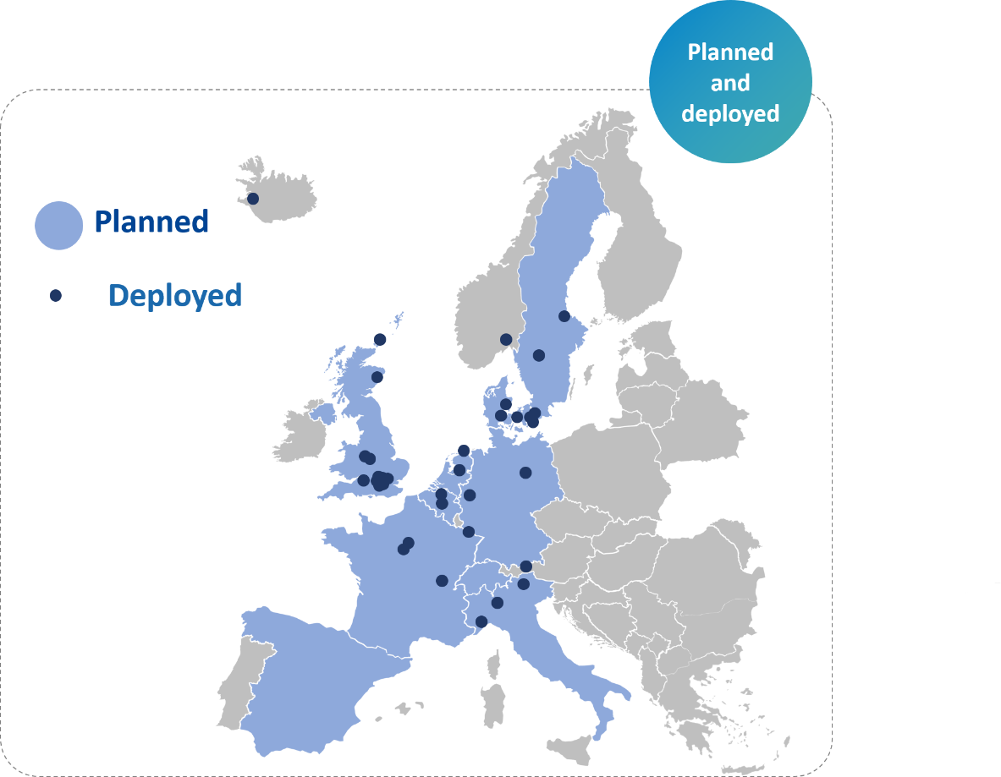
Figure 5: Distribution of hydrogen refuelling stations co-funded by JU.
To date, the JU-funded HRS network for cars covers 8 countries and, in 2020, delivered 58.8 tonnes of hydrogen in 25 060 refuelling operations. This amount represents 40 % of the total amount of hydrogen refuelled since 2016. The average HRS availability for cars in 2020 was 90%. The major causes of station downtime are the compressor and the scheduled maintenance/upgrades, which highlights the need for R&D in this area, such as the projects COSMHYC and COSMHYC XL (described below). H2ME reported that with the increasing number of HRS, chiller cooling hydrogen to the level required by SAE J2601 is also becoming a reason for downtime.
Car demonstration projects have reported that 66 % of dispensed hydrogen was certified as low carbon from Guarantee of Origin (GO) schemes for Green and Low-Carbon Hydrogen, such as CertifHy (see Section 1.2.6). Of this, renewable hydrogen accounted for 57 %. The average reported cost of renewable hydrogen was 11.31 €/kg H2, which means the related MAWP 2020 target of 11 €/kg H2 was almost achieved. More research is needed though the coming years in reducing the average capital expenditure (CAPEX) for hydrogen stations, which is still more than 50% higher than the expected MAWP 2020 targets.
JU has also funded the installation of 23 refuelling stations for buses in 10 European cities, 16 of which have been demonstrated. The amount of hydrogen dispensed between 2016 and 2020 was almost 529.8 tonnes, 16 % of which was consumed in 2020 in 5 917 refuelling operations. Of this dispensed amount, 63 % is certified as renewable hydrogen
Demonstration projects are still suffering from a lack of experience among local authorities and the absence of standardised processes for reviewing and approving HRS permit authorisation. However, with the help of such projects (and related awareness), difficulties encountered when requesting permits for HRS are declining, with the lead time for commissioning an HRS in Germany falling from 24 to 12 months.
New developments in compression for hydrogen refuelling stations
COSMHYC and COSMHYC XL are developing a hybrid compression solution (1-1 000 bar) by combining a metal hydride compressor and a mechanical diaphragm compressor. This new design allows for a reduction in CAPEX and the operating expense (OPEX), less noise, greater availability and therefore better hydrogen delivery efficiency in HRS (COSMHYC) and extra-large HRSs able to serve heavy duty vehicles (COSMHYC XL). H2REF developed and tested a novel hydraulic-based compression and buffering system, using of a bladder accumulator technology. Both have high potential for improving techno-economic parameters for hydrogen compression at refuelling stations.
Hydrogen storage/tanks – innovative technologies for on-board storage
The objective of this topic is to improve the gravimetric and volumetric capacity of hydrogen storage tanks on board vehicles by using new materials and innovative manufacturing techniques. The projects TAHYA and THOR are addressing these goals, they are in the early development phase, with a TRL range of 4 to 6.
TAHYA aims to develop a complete, competitive and innovative European hydrogen storage system. The tank is developed and is ongoing design qualification tests. Fire tests need completion as well as the integration of structural health monitoring and the optimisation of the filling nozzle.
THOR develops high-pressure thermoplastic composite hydrogen tanks (moving from TRL 4 to TRL 6) based on thermo-plastic resins. The tank based on a new design is requiring prototype testing. The final tank has the potential as a breakthrough technology for hydrogen storage, with reduced material use and costs.
Waterborne applications
Hydrogen in the maritime sector is nowadays a topic of great interest due to the expected changes in emissions regulation in the near term. Three projects demonstrating zero-emission FC ships and hydrogen in maritime ports started in 2019-2020, all having common issues in hydrogen safety, permitting of ships and infrastructure, and standards (see Figure 6).
The MARANDA project aims to develop an emission-free hydrogen-fuelled 165 kW (2 x 82.5 kW AC) PEMFC based hybrid powertrain system for marine applications and validate it on board the research vessel Aranda. Out of three assembled fuel cells systems (at 40 EUR/kW CAPEX), one was already tested in December 2020 and connected to the electricity grid. Significant improvement in stack & FCS durability (15,000 hours was achieved) along with system electrical efficiency of 48% (LHV) were obtained.
FLAGSHIPS will demonstrate two FCH vessels in commercial operation: one cargo vessel in France and one passenger and car ferry in Norway. In addition, FLAGSHIPS will perform a techno-economic analysis of European marine FC power systems.
The ShipFC project is developing a 2-megawatt (MW) ammonia-powered FC and will operate a retrofitted offshore vessel. ShipFC aims to prove that long-range zero-emission voyages with high power are possible on larger ships. In addition, the project is providing input on alternative shipping fuels LCAs and is studying how to set up a certification scheme for green ammonia.
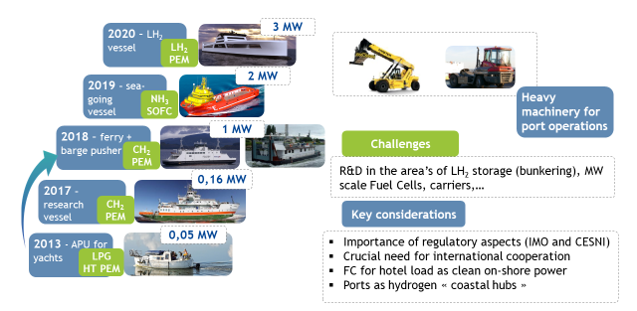
Figure 6: Maritime projects, evolution of technologies and main challenges
Hydrogen powered aviation
Project FLHYSAFE seeks to demonstrate a cost-efficient modular fuel cell system for replacing most critical safety systems and for an emergency power unit to be used on-board a commercial airplane. The final technological demonstration aims at demonstrating enhanced safety functionalities and the ability of integration into current aircraft designs respecting both installation volumes and maintenance constraints . So far the project has completed the design for fuel cell integration into airborne applications, as well as the emergency power system architecture and a virtual reality tool allowing design optimisation and maintenance instructions. FC short stack testing (using oxygen instead of air) as well as start/stop cycle stack degradation analysis is in progress.
The project HEAVEN focuses on demonstrating airworthiness and economic viability of a FC/Liquid-H2 powered four passengers passenger aircraft and gathers reliability data for future certification. It produced the conceptual design of the overall powertrain by adapting two 45 kW PEM FC systems. It also intends to integrate them with optimised Balance of Plant components using cryogenic hydrogen-storage technology and without using a battery. Meeting the main aircraft requirements is particularly difficult as no aviation regulation yet exists for Liquid-H₂. Failure hazard assessment, including the identification of hazardous and catastrophic events were also performed.

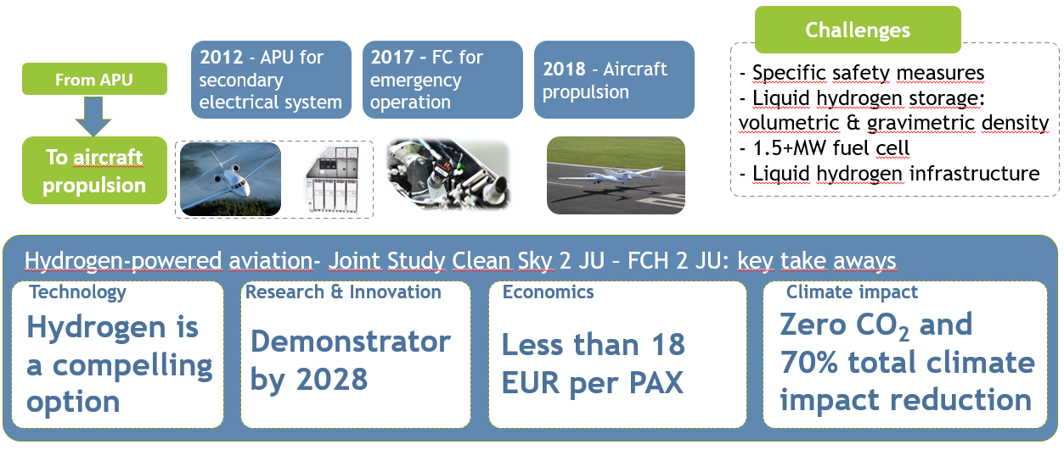
Figure 7: Hydrogen potential for use in aviation, taking the steps to zero emission aviation

Research oriented activities for transport applications
Fuel cells components
Research activities focused on the development of novel materials, processes, architectures and optimised interfaces. In particular, projects are exploring the development of non-platinum group metals (PGM) or low-cost catalysts (PEGASUS, CRESCENDO).
PEGASUS is working on a promising route towards the removal of platinum (Pt) and other critical raw materials (CRM) from PEMFC. Their replacement with non-critical elements and structures should still provide stable electro-catalysis conditions, and the development of appropriate uses of Pt-alternative and competitive cathode catalysts.
CRESCENDO is developing diagnostic methods for determining active site density and turnover frequency and realising successful approaches to the stabilisation of non-PGM cathode catalysts during operation, as well as advancing research on non-PGM and ultra-low-PGM hydrogen oxidation catalysts.

Vehicle stacks
The project GAIA is developing components (electro-catalysts, membranes, Gas Diffusion Layer, and MPL) and is aiming to improve their interfaces to minimise polarisation resistance in next-generation membrane electrode assembly (MEA). This will lead to reduced costs, increased power density, and greater durability, while accommodating higher operating temperatures. It has delivered a beginning of life (BoL) power density of 1.8 W/cm² at 0.6 V, thereby achieving its performance target.
CAMELOT is investigating the performance of ultra-thin and ultra-low-loading layers required by future MEAs by combining numerical modelling with innovative in-situ characterisation and is developing a scientific understanding of the limitations of advanced MEAs, achieving an open-source model accessible to the global FC community.
DOLPHIN is exploring an unconventional, highly innovative route towards a newly designed cell architecture featuring a dual-core single repeat unit (DC-SRU) delivering a lightweight and compact FC stack architecture. By using mechanically strong and corrosion-resistant structures redesigned for more coherent cell-internal interfaces to delay ageing and increase system reliability compatible with automotive durability targets, it is aiming for stack production costs of less than 20 EUR/kW.
FURTHER-FC builds upon the PEMICAN project. It is aiming to improve gas and proton transfer near catalytic structures and to investigate and validate performance limitations resulting from the coupling of electrochemical and transport issues in the cathode catalyst layer. It has progressed with the characterisation of reference catalyst layers by AFM, Raman and 3D FIB-SEM and direct numerical simulations.
Manufacturing
Five projects are related to manufacturing processes, with the following goals:
- To advance the critical steps of the proton exchange membrane (PEM) FC assembly processes and associated in-line quality control and end-of-line test (DIGIMAN).
- To industrialise stack production, delivering affordable FC systems in larger quantities able to meet the demands of the emerging market, and building new manufacturing machines allowing for serial stack production (Fit-4-AMandA).
- To develop and integrate the most-advanced critical proton exchange membrane FC (PEMFC) stack components into an automotive stack showing a BoL performance of 1.5 W/cm² at 0.6V, less than 10% power degradation after 6 000 hours, and costing less than €50/kW at a 50 000 units annual production scale (INSPIRE).
- To scale-up PEM manufacturing and reduce the cost.
DIGIMAN’s main outputs are a proof-of-process and a blueprint design for beyond-current state automotive PEM FC European manufacturing. The demonstrator equipment for the uplifted cell assembly automation process has been manufactured and validated.
Fit-4-AMandA completed the assembly and validated the machine for serially producing PEMFC stacks using automatic assembly methods. For a 90 % automated production process, it demonstrated stack production in less than 30 minutes throughput time for one stack on a small scale.
INSPIRE designed and tested three generations of stack prototypes. The project met its performance and durability targets, and the estimated stack costs are within 10 % of its target.

INLINE and INN-BALANCE started in 2017. Their goals include the scale-up of PEM manufacturing, balance of plant (BoP) definition (identifying and developing efficient and reliable components to reduce overall system costs), and the development of quality control practices for manufacturing and assembly procedures. At the same time, they should reduce the life cycle environmental impacts of stacks and components.
INLINE aimed to reduce the cycle time for production of an entire FC system from 15 hours to under 2.5 hours, thanks to continuous improvements in the production process. INN-BALANCE will develop highly efficient and reliable FC BoP components and therefore reduce the cost of current market products using FCs.

Trials and deployment of fuel cells applications for energy
The JU supported projects for all ranges of stationary power applications, from residential micro-scale Combined Heat and Power (μ-CHP) for domestic and small commercial buildings (0.3-5 kW), through mid-sized installations for commercial and larger buildings (5-400 kW), to large-scale FC installation demonstrations (0.4-30 MW). Fuel cells are showing great potential for the provision of heat and power in domestic and small commercial buildings. They have the advantages of high electrical and total efficiencies, and they are able to run on conventional heating fuels.

Figure 8 shows the connections between partners present in the demonstration projects using the TIM software. For clarity, only the partners involved in the largest numbers of projects are named. TIM software indicates clusters of partners by colour using its own algorithm. As shown in the figure, the key partners present in multiple projects are the FC stacks/system providers (SOLIDpower, Sunfire, Ballard), the Politecnico di Torino, and the research institute VTT. These projects are higher TRL demonstration projects and private companies dominate the participants.
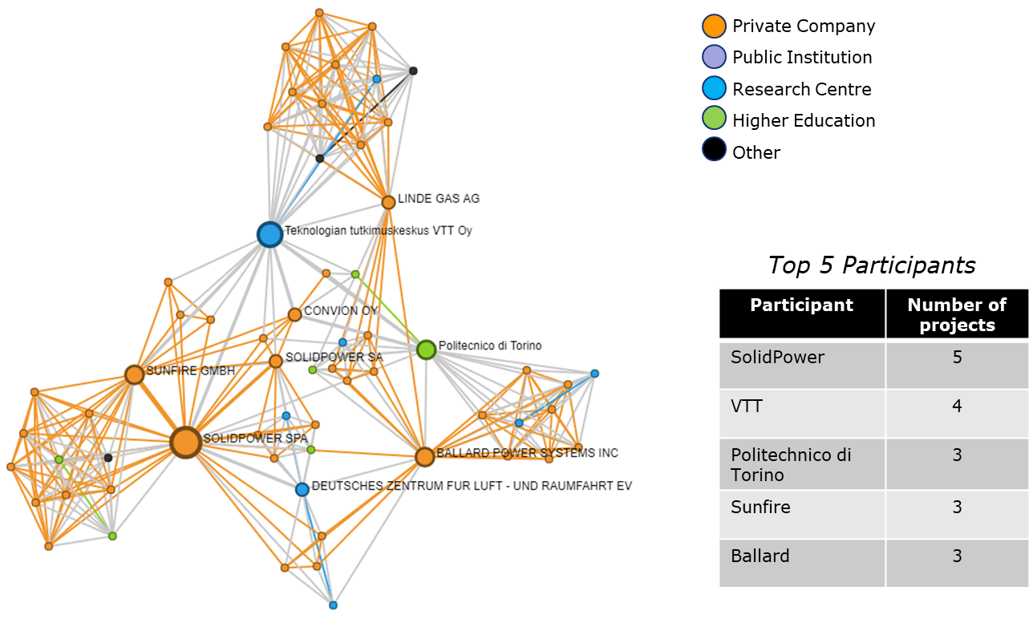

Figure 8: TIM plot showing the participants in the 10 projects on fuel cells application for energy
Combined heat and power for residential applications, µ-CHP (<5 kWe)
The PACE project plans to move the market towards mass commercialisation with up to 2 800 FC µ-CHP units expected to be installed and demonstrated by the end of the project. As of November 2021, the 4 European manufacturers involved in the PACE project have already deployed 1,900 FC µ-CHP units in domestic and small commercial building sectors, making PACE Europe’s largest micro-CHP project to date, with the remaining units expected to be installed by the end of 2022. The project also aims to reduce the average unit costs to below EUR 10 000 per small FC system (<1 kWe) and below or EUR 10 000 kWe for systems above 1 kWe, through more automated production and introduction of the next-generation systems. The technological development of µ-CHP installations is mature, but scaling-up of production is still needed to bring further cost reduction. Figure 9 shows the deployment of µ-CHP units in Europe by March 2021, resulting from JU funding and support from the German national programmes.

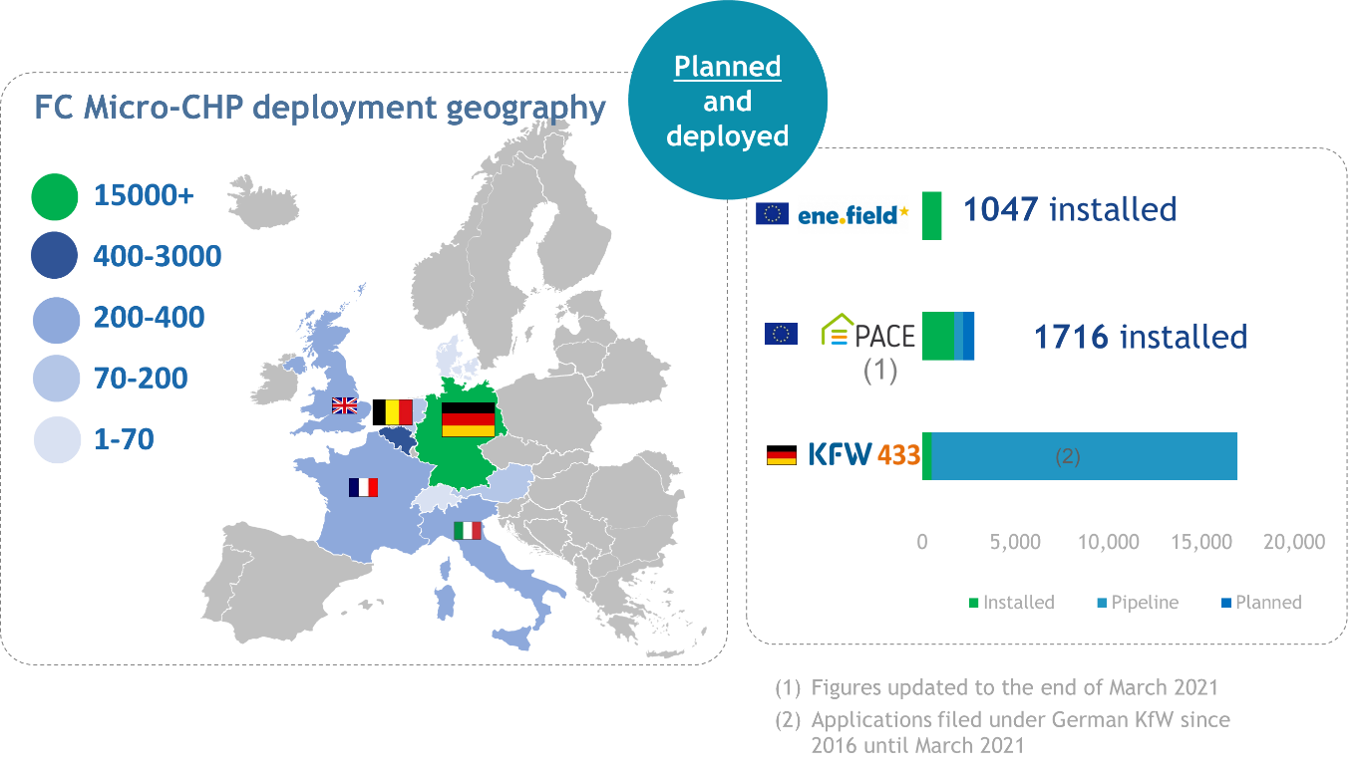
Figure 9: Deployed and Planned FC Micro-CHP Installations across the EU
Figure 10 shows how the cost-reduction curve can be expected to progress with increasing manufacturing volumes.
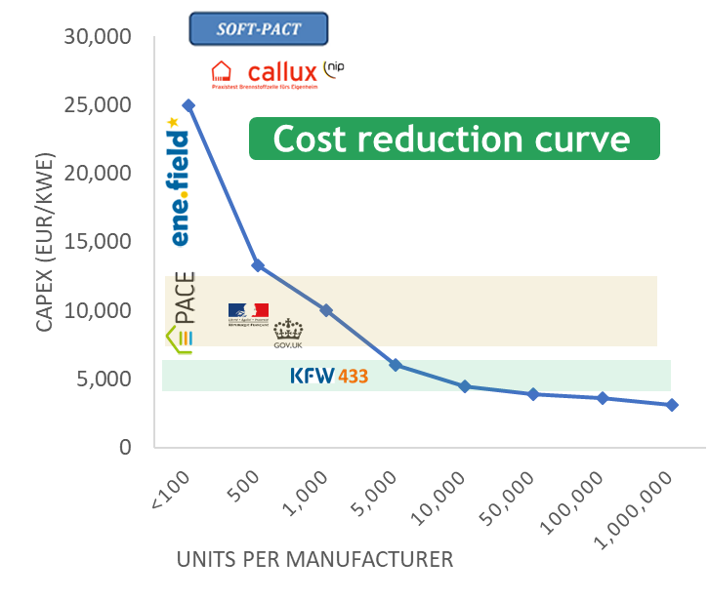
Figure 10: Cost reduction with market scale-up in the focus area µ-CHP demo (<5 kWe).
Combined heat and power for mid-size applications (5-400 kWe)
In the mid-size installations focus area, the DEMOSOFC project, completed in October 2020, aimed to demonstrate the technical and economic feasibility of installing a 174 kWe SOFC system at a wastewater treatment plant in the Turin area (IT). This would have supplied ~30 % of the site’s electricity needs and almost 100 % of its thermal energy consumption. Ultimately, the project was only able to install two SOFC modules (1 x 58 kWe and 1 x 44 kWe) due to delays to the final module. Despite this reduction in size, the overall goal of demonstrating an industrial-size biogas-fed SOFC plant has been achieved. The lessons learned have informed the design of the next generation of units developed under the R&I project INNOSOFC. These next-generation units are expected to be demonstrated in real installations in the COMSOS project. Further reductions in CAPEX and OPEX have been identified as essential for market take-up.
The main objective of the COMSOS project is to validate and demonstrate the advantages of mid-sized SOFC-based CHP systems in industrial or utility services environments. Three different sizes of ‘mini/commercial-size FC-CHP’ are being demonstrated in the power ranges of 10-12 kW, 20-25 kW and 50-60 kW. The consortium plans to install 23 demo systems.
Combined heat and power for large scale applications (>400 kWe)
Demonstrations of large-scale FC systems such as the ClearGenDemo project aimed to demonstrate a 1 MWe PEMFC system utilising a refinery by-product hydrogen and using the 1 MW PEM FC to produce electricity for the Martinique public electricity grid (French overseas territory). Installation of the FC system and component was completed, along with integration in the refinery systems. Due to the COVID-19 travel ban, it was not possible to complete commissioning within the project’s lifetime (which ended in September 2020). The system achieved 50 % electrical efficiency in the factory acceptance test, which exceeded its target (48 %). The lessons learned from ClearGenDemo will be taken up by a power-to-power project in French Guiana which is being developed by one of the partners, Hydrogene de France. ClearGenDemo intends to report on system performance once it has been commissioned, even if the project has ended.
Demonstrations – off-grid, back-up and genset
This area gathers together three demo projects – REMOTE, RoRePower and EVERYWH2ERE – focused on off-grid applications, both in remote places as well as in temporarily powered event areas.
The REMOTE project is demonstrating the technical and economic feasibility of FC technologies combined with RES and hydrogen storage solutions on island grids or in remote areas. In 2020, two demonstrations were installed in Norway and Greece and are now operational. The third new demonstration site will be in the Canary Islands, Spain). Detailed engineering and the permitting procedures are currently being developed.
A number of MAWP targets have been successfully achieved: rated PEM electrolyser efficiency of 50.5 kWh/kg, rated alkaline electrolyser efficiency of 50.6 kWh/kg, rated PEM FC efficiency of 45 % LHV, 15 years lifetime for the FC and 20 years lifetime for the BoP equipment. REMOTE was awarded the title of best renewable energy project in the European Sustainable Energy Week (EUSEW) 2020 Awards in the Innovation section.
In general, project results could be applied in new fields where there is need for storage of local RES, not only for power production but also for hydrogen use in different sectors. Grid balancing and the production of hydrogen for mobility could be potential fields of application.
The aim of the RoRePower project is to further develop and demonstrate SOFC systems for off-grid power generation in markets, such as gas and oil infrastructure, in remote regions with harsh climate conditions (from -40 °C to +50 °C), and the power supply for telecommunication towers, especially in emerging countries. Twelve RoRePower units have been installed at customer sites. The Sunfire-remote 400 and 900 units have passed design freeze and have been introduced on to the market. The first RoRePower unit has been installed for a telecom application in Alaska, with the aim of gathering reliable field data and demonstrating the technology.

The EVERYWH2ERE project aims to demonstrate at TRL 8 FC gensets to replace diesel-fuelled generators for temporary power at construction sites, music festivals, exhibition centres, etc.). Two prototypes (1x25 kW and 1x100 kW), together with their hydrogen storage bundles, have currently being commissioned and started demonstration in June 2021.

Next generation of products -energy
Following the calls between 2008 and 2020, the JU supported 54 projects with a total JU contribution of about EUR 124.9 million plus a contribution from partners of EUR 76.7 million.
Figure 11 shows the connections between partners present in these projects. The size of the node (circle) represents the number of projects a partner is involved in, whilst the thickness of the lines linking the nodes represents the number of projects two partners have in common. For clarity, only the partners involved in the largest numbers of projects are given. TIM indicates clusters of partners by colour using its own algorithm. The figure includes one large cluster around the projects dealing with SOFC technologies (INSIGHT, Waste2Watts, NewSOC, etc.) whilst the smaller cluster at the bottom of the figure contains two PEMFC projects (MAMA-MEA and GRASSHOPPER). In this low TRL research area a good mix of private companies, universities and research centres are present. VTT is the most active participant, followed by CEA and SOLIDpower.
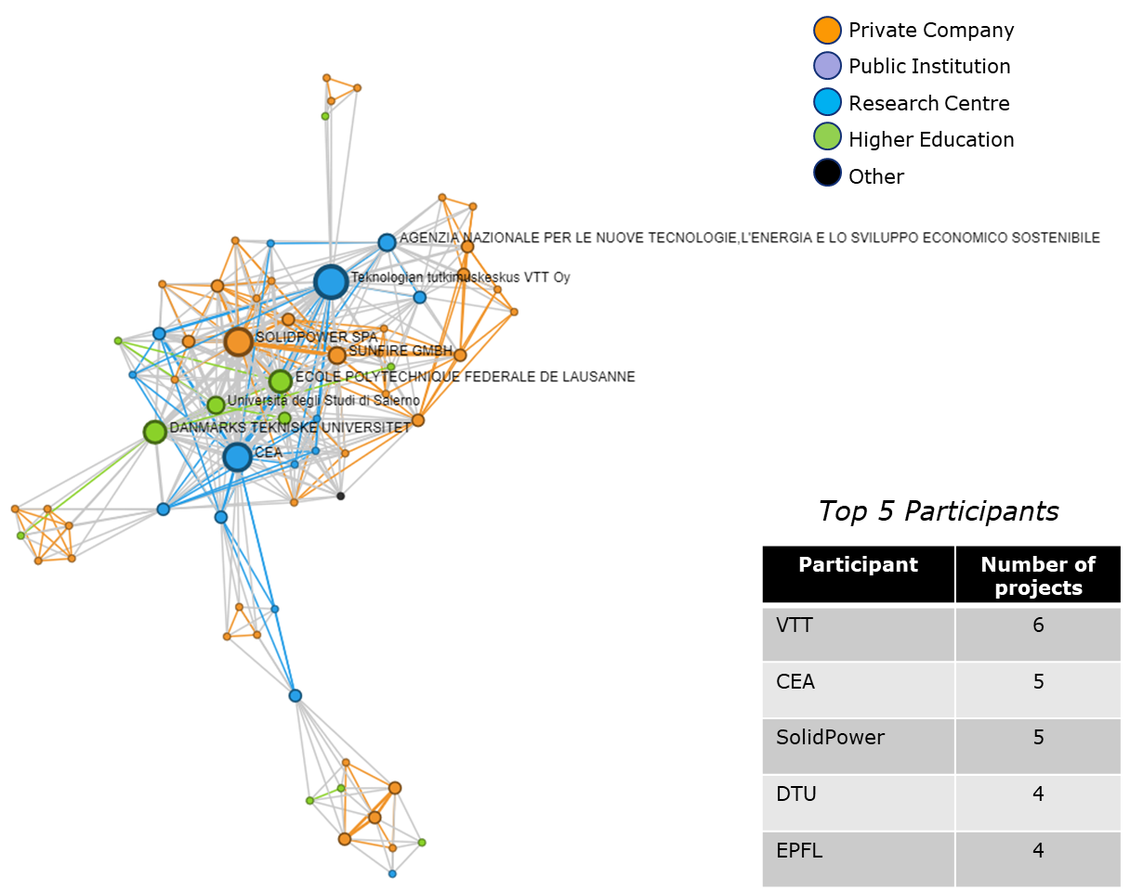
Figure 11: TIM plot showing the participants in all projects related to the next generation of products on energy

Manufacturing
Only one project in this area (MAMA-MEA) focuses on PEM FC manufacturing, with the rest investigating SOFC manufacturing options (qSOFC, CELL3DITOR and NewSOC). The projects’ overall goal is to enable the efficient manufacturing of large volumes of FC technologies with improvements regarding current costs, FC performances and environmental impact. Noticeable improvements have been achieved by FC products developed using innovative manufacturing methods. Even if improvements can be detected for many KPIs linked to performance and CAPEX which remains a long way from the expected values. Cost projections (especially for smaller-sized FC applications like micro-CHP) highlight the potential savings offered by scaling up manufacturing volumes. The reported rated electrical efficiency for SOFC has reached an impressive maximum of 74 % at stack level.
MAMA-MEA (finished in 2021) developed an innovative additive layer-deposition process using a single, continuous roll-to-roll MEA manufacturing process for the PEM FCs. The first two MEA prototypes have been assembled into rainbow stacks and their testing has been performed successfully.
Cell3Ditor developed a 3D-printing technique for the fabrication of SOFCs. A hybrid industrial printing machine, now commercially available, is able to print complete cells and stacks. The environmental impact of the new 3D-printing method has been assessed through LCA and deemed more favourable than conventional SOFC manufacturing techniques.
NewSOC is aiming to significantly improve the performance, durability, and cost competitiveness of solid oxide cells and stacks compared to the current state-of-the-art (SoA). The project has five industrial partners offering finite SOFC products. It will develop several actions targeted at developing innovative architectures based on conventional materials. It will also test new materials with enhanced performance and new manufacturing processes providing products with excellent durability and better environmental performances, using less raw materials.
By increasing the automation level of the production process, the qSOFC project has significantly driven down the production cost of SOFCs for an Elcogen SOFC design. A purposely developed new automated machine vision inspection system was used to improve the quality assurance processes. Development of time-saving stack conditioning procedures led to a reduction of the order of 75 %.
The finished INNOSOFC project has developed an innovative 50-kW SOFC system based on an all-European value chain (an Elcogen stack and Convion system). The project identified three niche applications with EU market potential under current energy prices: small server rooms, smart grid CHP, and bio-CHP. System calculations and preliminary field tests confirm that the targeted performance of the 50-kW SOFC system developed has been achieved with 61.4 % electrical and 81 % CHP system efficiencies. In addition, (and based on successful results in the JU projects) Elcogen has received a EUR 12 million European Investment Bank quasi-equity loan facility for expanding research capacity and manufacturing. A new factory with a capacity target of 50 MW/year will be located in Tallinn (EE).

Degradation, performance and diagnostics
In this area, projects are aiming to bring the TRL for the investigated technological solutions up to 7 from an initial level of 3.
The INSIGHT project built on knowledge developed by past consortia with a well-defined constant core of participants developing different diagnostic tools for SOFCs and PEMFCs across several already finished projects (GENIUS, D-CODE, DESIGN, DIAMOND and HEALTH-CODE). The project is finished and positive technical results have been achieved. The combined project targets of a 5 % lifetime increase at the expense of a maximum increase of 3 % for system cost have been reached. A significant experimental result from INSIGHT is the build-up of a library of data linked to typical faults and associated mitigation measurements.
Demonstrating the advantages of the large-scale introduction of these diagnostic instruments for both PEM and SOFCs now lies with the RUBY project, which should bring the TRL above level 7. Involving two FC system manufacturers, RUBY is continuing the long sequence of concluded projects already described for INSIGHT. At the end of the project, the tools developed are expected to be integrated into a commercial FC system.
The OxiGEN project is developing an all-ceramic stack design and specifications for a modular hotbox for an innovative SOFC platform. It is aiming to build a prototype µ-CHP system with an electrical power capacity of 1kW. Detailed market specifications for residential and small commercial applications have already been defined.
LOWCOST-IC is aiming to apply SoA large-scale roll-to-roll manufacturing to increase the reliability and reduce the cost of interconnects in SOFC. The selection of suitable new materials for metallic interconnects also has the goal of increasing SOFC stack lifetime. The selection of more resistant and cheaper steels which can be incorporated in available Sunfire and SOLIDpower FC stacks is the project’s main goal.
GRASSHOPPER aims to test a new concept for an MW-size PEM FC plant unit. The objective is to provide more cost-effective and flexible grid support in its power output. Modelling and validations have been completed and have been instrumental in achieving an innovative stack design. The targeted CAPEX is below EUR 1 500 kWe for the FC at a yearly production rate of 25 MWe. The newly developed MEA has higher durability with lower Pt loadings. The pilot plant 100-kW prototype system is expected to be fully tested soon.
Waste2Watts will design and engineer an integrated biogas-SOFC CHP system with minimal gas pre-processing, focusing on low-cost biogas pollutant removal and optimal thermal system integration. The project is addressing unutilised biogas produced by millions of farms and bio-wastes from municipalities. The aim is to perform a test campaign using representative test gases with viable reforming catalysts and SOFC stacks. EMPOWER is aiming to develop a micro-CHP system fed by methanol and based on HT-PEMFC. The project is still designing and testing sub-components.

Hydrogen for sectoral integration
The projects in this area contribute towards achieving the techno-economic objectives of making hydrogen production from renewables competitive, demonstrating hydrogen as a medium for energy storage, and sector coupling. This part of the energy pillar is aimed mainly at reducing costs and improving the efficiency of hydrogen production, with a clear focus on demonstrating large-scale electrolysers. The topics supported by FCH-JU are:
- Low-temperature electrolysis
- High-temperature electrolysis (incl. co-electrolysis)
- Other production routes
- Hydrogen storage and distribution, purification and admixture
- Hydrogen territories.
Following the calls between 2008 and 2020, the JU supported 74 projects relevant to this area with a total contribution of EUR 239.3 million plus a contribution of EUR 227.1 million from partners. As shown in Figure 12, 59 % of JU funding went to electrolysis (38 % of JU funds supported LT electrolysis and 21 % supported HT electrolysis).
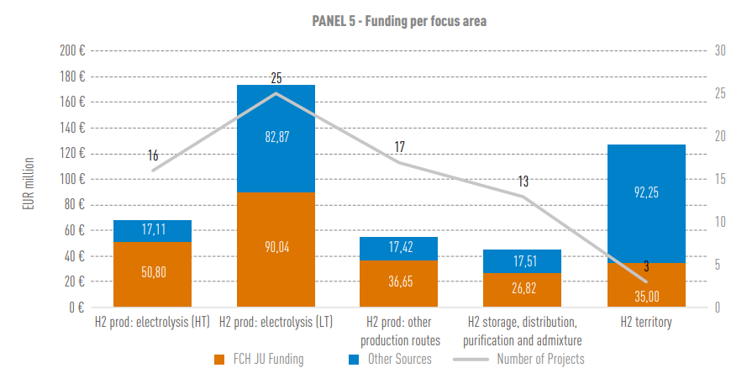
Figure 12: Funding for Panel 5 (hydrogen for sectoral integration), 2008-2020
Figure 13 provides an overview of some of the most relevant electrolysis demonstration projects. In 2011, the activities of the JU started with project DON QUICHOTE (PEM technology electrolyser) with a capacity of 150 kW and eight years later REFHYNE project will install a 10 MW PEM electrolyser, which is an increase of almost two orders of magnitude. The DJEWELS project will install an alkaline electrolyser with a capacity of 20 MW. Over the same period, JU support per MW installed has reduced by a factor of 100.
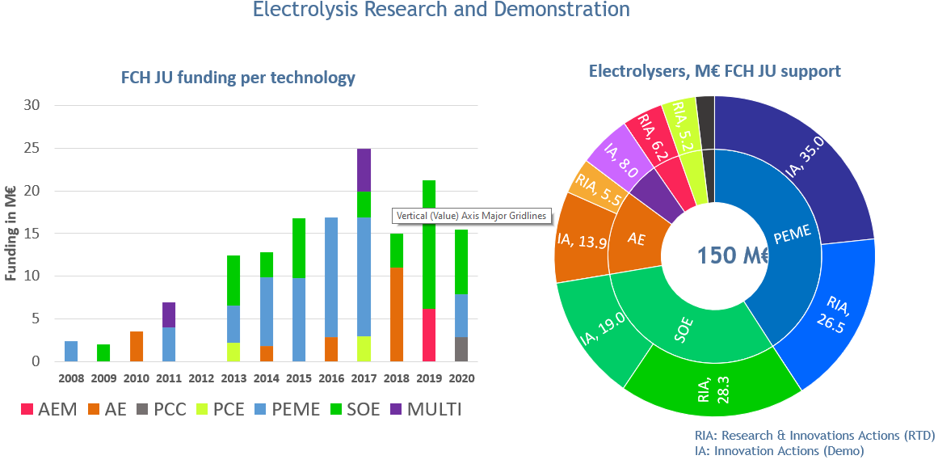
Figure 13: Funding for electrolysis projects since 2008 under FCH JU and FCH 2 JU
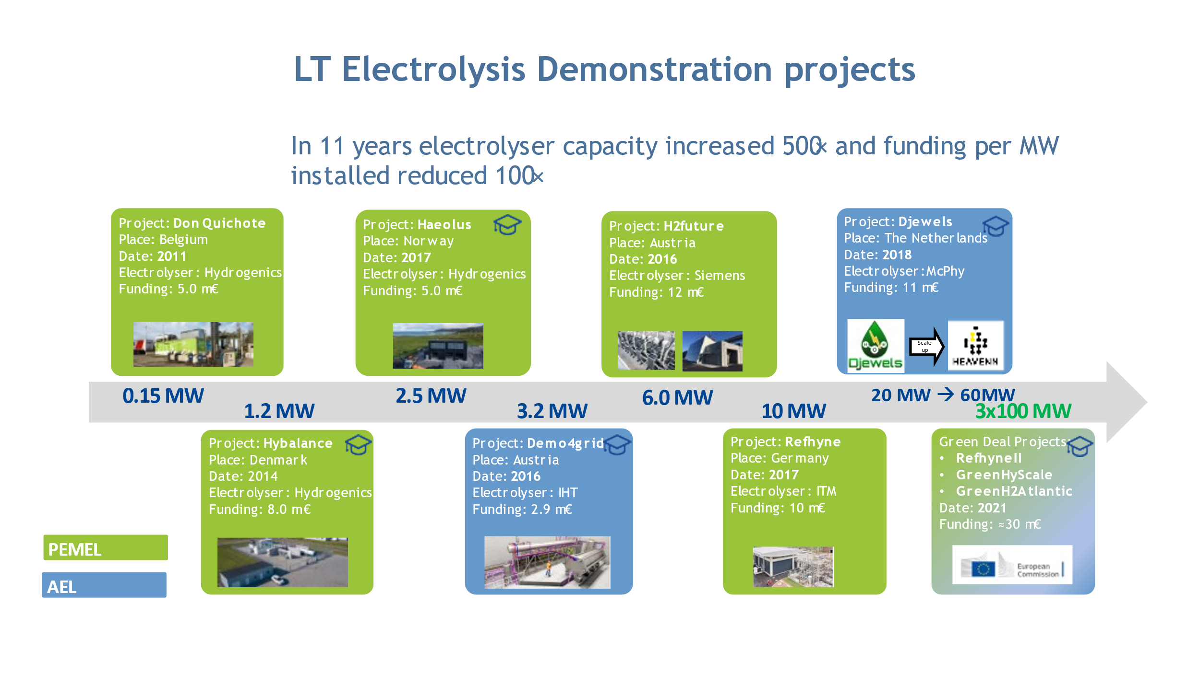
Figure 14 Key low temperature electrolysis demonstration projects
This area currently consists of 12 projects including 3 on anion exchange membrane electrolysis, 2 on alkaline electrolysis, and 6 on PEM electrolysis. One project is focused on the development of testing protocols for grid services. Hydrogen production through electrolysis has also been supported in the transport pillar, where low-temperature electrolysers have been deployed to provide hydrogen for HRS.

Alkaline electrolysis
The Djewels project is building and demonstrating a 20-MW electrolyser for the production of renewable methanol in Delfzijl industrial park in the Netherlands. The design foresees a system efficiency of 75 % which would make a significant contribution towards reaching the MAWP 2024 targets. The stacks should have an operating range of 20-110 %, and the system a hot ramp idle time of 30 seconds. A current density of 0.9 A/cm2 can be implemented through the development of novel electrodes. The project is currently at the engineering phase and the construction of the 1-MW stack testing facility has been completed. Once operational, Djewels may reach the 2024 electricity consumption target of 49 kWh/kg H2.

The Demo4Grid project is preparing to install a 3.1-MW pressurised alkaline electrolyser which will supply hydrogen near Innsbruck for the demonstration of grid Services and the production of green hydrogen for industrial purposes and mobility. The project has carried out an assessment of potential business cases, with a focus on power-to-heat and mobility markets. The former will become interesting when natural gas prices are high and electricity costs low.

PEM electrolysis
As intended, the electrolysers demonstrated should have a rapid response time (of a few seconds) in order to participate in the primary and secondary grid-balancing markets. A key challenge has been to upscale the PEM electrolysers (PEMEL) to a multi-MW level, and much progress has been made in this respect.
The HyBalance project, which ended in 2020, has installed and commissioned a 1.25-MW PEMEL in Hobro in northern Denmark, providing hydrogen for industrial and mobility customers. The stack operates at 30 bar with an efficiency of 72 %. As certified by the Danish Transmission System Operator Energinet.dk, the plant can provide grid services on the energy market. The overall energy demand of the plant per kg of hydrogen produced has reached 56.5 kWh/kg H2 in line with the project target of 57.5 kWh/kg H2.
Through the H2FUTURE project, a 6-MW PEMEL from Siemens has been operating at the Voestalpine Linz steel plant in Austria since October 2020. The hydrogen produced will support fossil-fuel-based steelmaking technology as part of a stepwise decarbonisation approach to steel production proposed by the steel manufacturer. In future, the direct reduction of iron ore by hydrogen will lower the footprint of steelmaking significantly.
Refineries need hydrogen for upgrading fuels and removing sulphur components. The REFHYNE project will provide bulk quantities of hydrogen to the Shell Rhineland refinery in Germany (currently supplied by two steam methane reformers). With a capacity of 10 MW, it is Europe’s largest electrolyser (ITM). It began operations in July 2021 and will produce 4 000 kg H2/day at a pressure of 20 bar. The second phase of the project has been selected in the Green Deal call to expand the capacity of the electrolyser from 10 to 100 MW.
HAEOLUS is combining a 2.5-MW PEMEL and a 100-kW FC in the remote harbour of Berlevåg, Norway. The aim of the project is to test control strategies for each mode of operation in wind-hydrogen systems: energy storage, mini-grid and fuel production. The results will be relevant to many wind farms across Europe and worldwide. The two components were installed in the remote harbour in May 2021, the objective being to optimise the use of wind power for this challenging location close to the Arctic Circle.
Game-changer PEM electrolysers
Hydrogen costs must be reduced for the large-scale provision of hydrogen to industry. Whilst OPEX is inextricably linked to the local cost of electricity, CAPEX reductions could be realised by increasing current density or improving efficiency by operating at higher pressures. The two projects funded – NEPTUNE and PRETZEL – focused on increasing the current density and output pressure of PEM electrolysers.
The NEPTUNE project aims to reduce CAPEX for PEMEL, by increasing both hydrogen production rates and the output pressure in order to enhance efficiency. The goals are to achieve a current density of 4 A/cm2 at low PGM loading and an increase in output pressure to 100 bar, while retaining the nominal energy consumption of <50 kWh/kg H2. The project includes developments at cell, stack and system level resulting in a final demonstration at 48 kW capacity. Good results at small scale have already been obtained.
The PRETZEL project is aiming to develop an innovative game-changer PEMEL. A maximum 25-kW system generating 4.5 m3 h-1 of hydrogen at rated power, with a feed water temperature up to 90 °C and 100-bar output pressure are the project’s ultimate goals. The stack is based on a hydraulic system of pressurisation where it is contained within a pressure vessel, which should ensure homogeneous pressure, even current density distribution and should minimise degradation. This means that the targeted oxygen output pressure is also 100 bar. The targeted current density (4 A cm-2) required by the call goes well beyond the MAWP 2020 target (2.2 A cm-2).
Testing protocols
The testing and qualification of electrolysers is essential to assess their ability to operate dynamically and perform electricity-balancing grid services. The QualyGridS project has developed testing protocols for AEL and PEMEL electrolysers taking into consideration a variety of different grid services as well as multiple hydrogen end-users. The scope was to identify the systems’ capability to provide grid services as well as to indicate possible gaps. Testing protocols have been defined and applied for three alkaline and two PEMEL systems. The project ended successfully in 2020. The results showed that protocols are clear and implementable, and that all proton exchange membrane water electrolysis and alkaline water electrolysis can meet most of the grid services’ requirements. A report compiling testing protocols for five different low-temperature electrolysers in various locations in Europe was submitted to the ISO/TC197 standardisation technical committee and formally approved by its members, which constitutes a great success for the project.

Anion Exchange Membrane electrolysers (AEMEL)
In addition to the two main low-temperature electrolyser technologies (alkaline and PEM electrolysis), recent years have seen the development of anion exchange membrane electrolysers which operate in alkaline media but use a solid electrolyte. In principle, this means they can combine the use of non-Pt group metal catalysts with the production of high-purity hydrogen due to the presence of the solid electrolyte.
However, this technology is currently at a low TRL level and has yet to achieve the performance and durability of other water electrolysis technologies. To date, there is only one AEMEL manufacturer (Enapter) on the market and three projects are funded by JU: CHANNEL, ANIONE and NEWELY. The objectives of all three projects are similar: to develop high-performance, cost-effective and durable AEMEL technology, by developing 2-kW prototype stacks.
The consortium behind CHANNEL has performed a market and cost analysis of the 2-kW prototype to develop a cost-reduction strategy towards a capital cost of < EUR 600 per kW for a 500-kW system. ANIONE has successfully developed non-CRM anode catalysts which achieve the project’s performance and durability targets, while work is ongoing to improve the performance, in particular the durability, of novel cathode catalysts under investigation. NEWELY’s novel catalysts (but with a commercial membrane) have already achieved very good performance results, with the projected recently submitting its first patent applications and publications.
High-temperature electrolysis
This area covers the research and development (R&D) projects SElySOs, GAMER, and SWITCH, as well as the demonstration projects GrinHy2.0, MultiPLHY, REFLEX and Waste2GridS.

- R&D projects
The SElySOs project is testing modified nickel (Ni)-based and Ni-free cathodes and new air electrodes, seeking to enable the development of new solid oxide electrolyser cells (SOECs) less prone to degradation and with improved performance and stability. Experimental work is combined with theoretical modelling to understand reaction mechanisms and processes that cause degradation.
The SWITCH projects seeks to develop a reversible system able to operate in both SOEC (solid oxide electrolysis) and SOFC (solid oxide fuel cell) mode, with a capacity of 25 kW (SOFC) / 75 kW (SOEC) and a minimum operating time of 5 000 hours. In FC mode, other feedstocks (natural gas, biomethane, etc.) can be used to produce hydrogen when renewable electricity prices are high.
The GAMER project seeks to develop and operate a 10-kW tubular proton ceramic electrolyser (PCEL), producing hydrogen at 30 bar at a high electrical efficiency of up to 77 % for the system, provided there is an external steam source. It has demonstrated a single engineering unit in pressurised electrolysis mode at 600 °C at up to 10 bar. If maintained at the final stage, the performance and degradation results achieved to date at the small scale would make tubular stack configuration a game changer for PCEL.
- Demonstration projects
In recent years, there has been a marked increase in the capacity of HTE demonstration projects, while receiving lower funding per MW (see Figure 15). HTEs are now being demonstrated in industrial environments such as a steel plant and a bio-refinery.
Figure 15: Capacity of HTE demonstration projects in MW versus funding in MEUR per MW
The GrinHy2.0 project is the successor to the GrinHy project’s electrolyser installed at the Salzgitter steel production plant. This will be the world’s biggest high-temperature electrolyser with a capacity of 720 kW AC and an electrical efficiency of 84 % LHV. The aim is to achieve production of at least 100 tonnes of hydrogen over 13 000 operational hours with a system availability of 95 % by the end of 2022.
To date, the manufacturing of the system units’ ‘electrolyser’ and ‘hydrogen processing’ have been completed and they have been installed onsite. The first-time injection of about 100 Nm³/h of hydrogen took place during commissioning. The CAPEX target of 4 500 EUR/(kg/d) was met by the project mainly due to the integration of multiple stacks in one system

Building on GrinHy and GrinHy2 results, the MULTIPLHY project aims to install and operate the world’s first high-temperature electrolyser system at the multi-megawatt-scale (~2.4 MW), at a chemical refinery in Salzbergen (DE) to produce hydrogen (≥ 60 kg/h) for the refinery’s processes.

In May 2021, the MultiPLHY project successfully tested a 225-kW HT electrolysis module, consisting of 60 stacks with 1 800 cells. This module will be part of a 2.7 MW system for a total of 12 modules for the 2.2 MW electrolyser, with a power consumption of less than 40 kWh/kg H₂. The electrolyser will be demonstrated in a biorefinery in Rotterdam (NL). The project is seeking to demonstrate that SOE technology is reducing the TRL gap (by bringing it to TRL 8) to PEMEL and AEL by installing and operating a multi-MW system. It is aiming for a design enabling a CAPEX of ≤ 2 400 EUR/(kgH₂/d), in line with the 2024 MAWP target.
The REFLEX project is developing reversible solid oxide cell technology (rSOC) to be implemented as an integrated energy-storage solution (Smart Energy Hub) at community/district level. The project has developed improved rSOC component cells, stacks, power electronics and heat exchangers. The performance and durability target were achieved in rSOC operation at cell scale as well as with enlarged cells (200 cm²). A current density of 1.25 A/cm² was achieved in SOEC mode (target 1.2 A/cm²). Several other objectives were partially achieved, such as durability in the SOEC step during rSOC operation at 0.58 A/cm² and SC=68 % power range in SOEC and SOFC.

The aim of the Waste2GridS project is to identify the most promising industrial pathways for waste gasification and solid-oxide-technology integrated plants. Biomass sources being considered are agricultural wastes, forest residues and municipal solid waste. Waste2GridS is proposing a novel concept of a triple-mode grid-balancing plant enabled by biomass gasification and rSOC technology. These plants can provide a grid-balancing service by switching between: (i) power-generation mode, converting waste to electricity for the grid; (ii) power-storage mode, using the grid electricity to convert waste into methane; and (iii) power-neutral mode, converting waste into methane with no grid interaction. Feasible business cases were identified for power generation and power storage operations of over 3 500 hours. The project concluded that Waste2GridS plants could be feasible economically with 5 years payback time with a significant cost reduction < 1 600 EUR/kWe-SOFC in stack costs.

Other hydrogen production routes
In addition to electrolysis, FCH2 JU is supporting R&D projects to explore alternative hydrogen production technologies, such as the projects BioROBURplus, BIONICO, HYDROSOL- beyond and PECSYS.
- Reforming
The BIONICO and BioROBURplus projects are aiming to develop the decentralised production of renewable hydrogen by reforming biogas at capacities of around 100 kg H₂/day. The goal of the BioROBURplus project is to demonstrate a biogas fuel processor for decentralised hydrogen production based on oxidative steam reforming. Focus is on increasing the efficiency of the reactor to 72 % (higher heating value). An extensive testing programme was carried out to identify a suitable catalyst. If the testing campaign proves successful, this technology should reach TRL 6. The demonstration unit has been installed in a biogas facility and is being commissioned.
The BIONICO project (ended in 2019) developed and tested a catalytic membrane reactor system to produce pure hydrogen from raw biogas (CO₂ containing) in a single step (reforming and purification). The project’s achievements include the development of a novel reforming catalyst and support. The lab experiments demonstrated the stability of both catalyst and membrane in fluidised bed conditions. The performance of palladium-silver-gold membranes were measured in the presence of hydrogen sulphide, showing improved performance for the membrane with higher gold content.
- Thermochemical hydrogen production
Solar thermochemical production has much promise due to the potentially high solar to hydrogen efficiency (35-50%, compared to PV+EL efficiency of around 12%). The HYDROSOL-beyond project, a 750-kW solar plant in Almeria, Spain, is currently the only large-scale solar thermochemical hydrogen production unit in the world. The concept is based on redox-structured monolithic solar reactors for the production of hydrogen from water. HYDROSOL-beyond is aiming to address material and component issues encountered in its predecessor HYDROSOL-PLANT. The project should double the current SoA of 5 % solar-to-hydrogen efficiency through novel design solutions, in particular a more efficient heat exchanger to improve heat recovery.

- Photoelectrochemical hydrogen production
The PECSYS project, which ended in 2020, developed and tested an integrated photo- electrochemical cell hydrogen generator at various prototype scales. Several concepts were explored for the direct coupling of an electrolyser to photovoltaic panels (see Figure 16). For a smaller device, a solar to hydrogen conversion efficiency of up to 13 % (ambient conditions 1 000 W/m², 25 °C) for a 100 cm² CIGS/NiO|NiMoV unit has been reached. Overall, the project achieved TRL 6; the demonstrator achieved an average efficiency of 10 % and produced 22 kg of hydrogen during its 9 months of operation. The final 10 m² demonstrator consisted of an array of CIGS and SHJ photovoltaic modules directly coupled to an electrolyser stack. A hydrogen production rate which is almost double that of the current SoA of 2.3 g/h m² has been achieved.
The cost and lifetime issues may limit the potential of this technology for its intended application, namely, to be deployed on residential rooftops in remote areas. More operational data would be needed for the JU programme to assess the prospects of this technology.
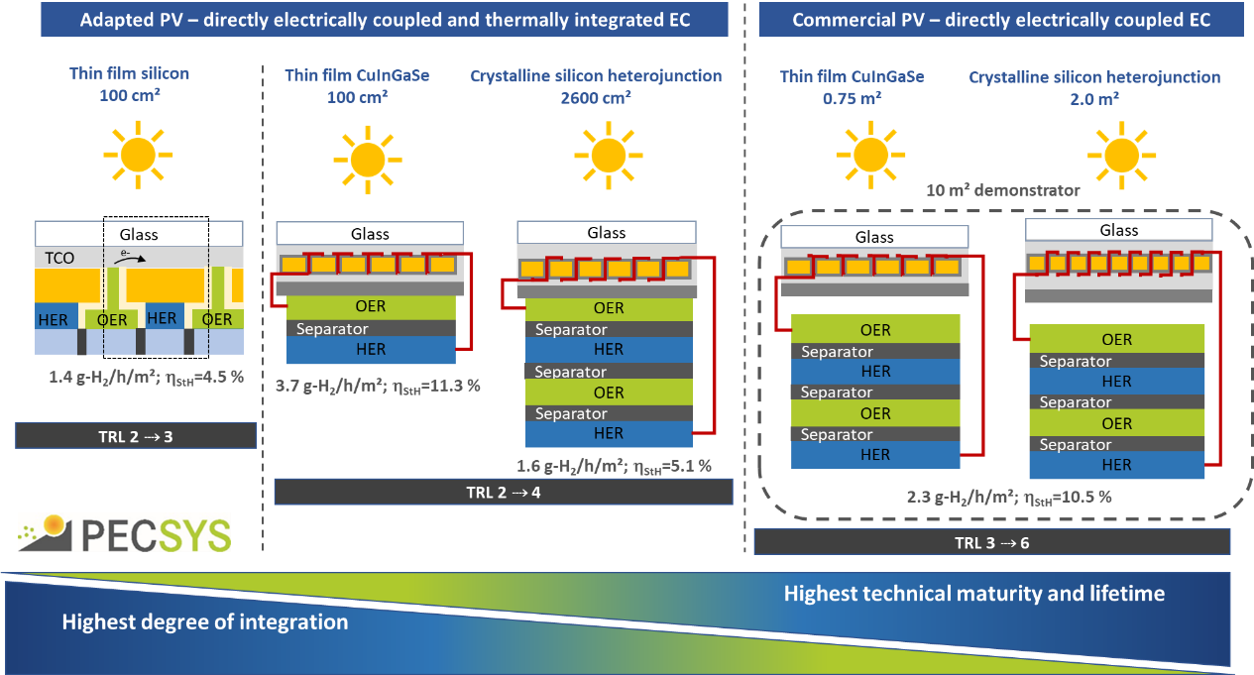
Figure 16: PECSYS Concepts. Source: HTTPS://WWW.HELMHOLTZ-BERLIN.DE/PROJECTS/PECSYS/

Hydrogen storage, distribution and purification
This area covers the projects HySTOC, HyCARE, HyGrid, MEMPHYS and HIGGS.
The HYSTOC project aims to develop and demonstrate a transport and storage system for HRS using a liquid organic hydrogen carriers (LOHC). These compounds, which are able to release or accept hydrogen, have similar properties to crude oil and can be stored and transported over long distances at ambient conditions in large oil tankers without significant losses. According to a recent study by the JRC, hydrogen carrier systems can be among the lowest cost options for the long-distance transportation of hydrogen. the LOHC under consideration is dibenzyltoluene (DBT) which has advantageous properties in terms of storage and transport efficiency: a high storage density and little or no need for cooling and compression or purification. Currently, the project is close to finalising the commissioning of a hydrogen release plant which will be able to release up to 20 kg of hydrogen per day, with the hydrogenation plant already operational.
The HYCARE project is developing a prototype large scale hydrogen storage tank based on solid-state storage (ferro-titanium). If successful, this system will be the largest demonstration of stationary solid state hydrogen storage, with a capacity of 50 kg of hydrogen stored. This storage technology has also advantages in terms of safety due to the low storage pressure of less than 50 bars.

The HYGRID project aims to develop, scale-up and demonstrate a novel membrane-based hybrid technology combining membranes, electrochemical separation, and temperature swing adsorption for the direct separation of hydrogen from natural gas grids. The objective is to reduce the cost of hydrogen separation to < 1.5 EUR/kg H₂ for recovery rates > 95 % and with an energy consumption of < 5kWh/kg H₂. These targets are for hydrogen concentrations of < 10 vol % in natural gas. All relevant components of the prototype are ready and the project can start to test the concept. The development of membranes has led to the creation of a new company involving TECNALIA and TUE, namely H2SITE, for the manufacturing and commercialisation of the technology.
The MEMPHYS project, which ended in 2019, targeted the development of a low-energy hydrogen purification system based on electrochemical hydrogen purification (EHP). The focus was on high contaminant tolerance (carbon monoxide) at low system cost, making the system suitable for different applications. The main project targets were to purify 5 kg H₂/day with an energy consumption of <5 kWh/kg H₂ with a hydrogen recovery rate of >90 %. The best performance of the third-generation stack fell significantly short of the project targets (recovery rate of 95 % and energy demand of 3 kWh/kg H₂) with an energy demand of 6.4 kWh/kg H₂ at an 83 % recovery rate.

Hydrogen territories
The JU is working together with European regions to realise their potential to demonstrate hydrogen technologies. Part of a larger regional initiative in the Netherlands, the HEAVENN hydrogen valley is seeking to promote and enable the use of green hydrogen across the whole value production chain, distribution, storage and end-use. The project comprises four clusters (see Figure 17) which are at various stages of implementation. For cluster IV, the first vehicles have been procured, including garbage trucks, and the HRS will open soon. A 4-MW electrolyser, for which the concept design has been completed, will be deployed as part of cluster III. The hydrogen pipeline will be designed to enable a future connection to the hydrogen backbone. In cluster II, activities for the salt-cavern hydrogen storage have commenced with first test set-ups.

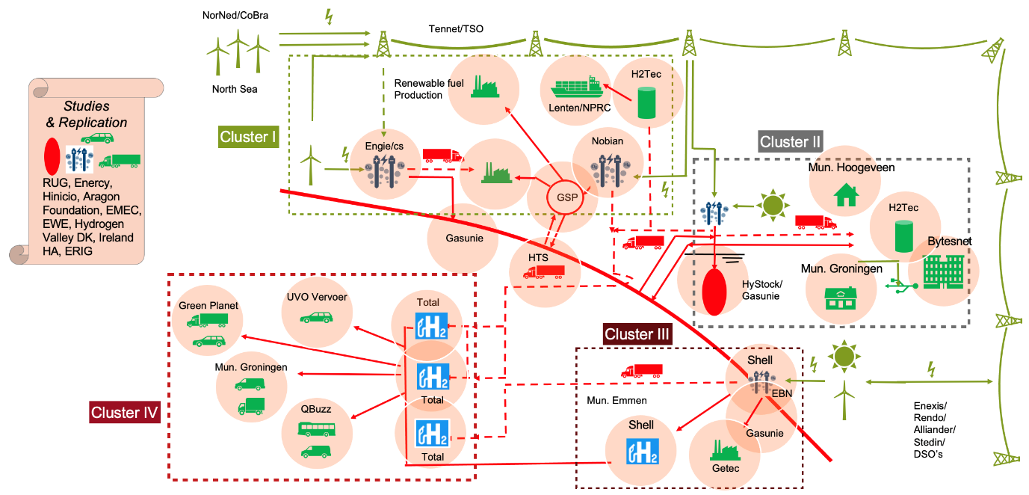
Figure 17: Schematic of the HEAVENN project
Green Hysland is the first Hydrogen Valley in a European Island and will showcase the ability of hydrogen to decarbonise islands at an unprecedented scale. It will generate, distribute and use at least 300 tonnes of renewable hydrogen locally per year, produced from solar energy on the island of Mallorca. Green hydrogen will have multiple applications on the island, including the fuel supply to a fleet of fuel cell buses and fuel cell rental vehicles, the generation of heat and power for commercial and public buildings, the supply of auxiliary power for ferries and port operations and the creation of a hydrogen refuelling station. The estimated duration for the Green Hysland project will be from 2021 to 2025 and will aim to reduce the CO2 emissions of Mallorca up to 20,700 tonnes per year by the end of the project.

The Building Innovative Green Hydrogen Systems in Isolated Territories (BIG HIT) project is in the process of creating a hydrogen ecosystem in the Orkney Islands (Scotland), which will help to minimise the curtailment of renewable electricity. The hydrogen produced is used locally in cogeneration and transport applications. The project has achieved several milestones by deploying 5 hydrogen trailers (250 kg hydrogen storage), a hydrogen catalytic boiler (30 kW), 1-MW electrolyser (ITM Power), 5 hydrogen FC vans, and a 75-kW FC system for cogeneration. The electrolyser is operating and capable of providing hydrogen for the FC vans, and 833 refuelling actions were performed in 2020.

Support for market uptake - cross-cutting activities
Cross-cutting activities are related to:
- Pre-Normative Research (PNR) and input in Regulations Codes and Standards (RCS)
- Education and training
- Safety aspects.
To date (2008 to 2020 calls), the JU has supported 48 projects relevant to these activities with a total contribution of EUR 67.5 million complemented by EUR 28.8 million of other contributions.
Pre-Normative Research/ Safety Codes and Standards (PNR /RCS)
This area PNR/RCS comprises five pre-normative research projects: HYDRAITE, ID-FAST, AD ASTRA, THyGA and PRHYDE.
HYDRAITE (2018-2021) is studying the effects of hydrogen contaminants on FC systems in automotive applications, building on the results of the previous project HyCORA. A major achievement of the HYDRAITE project is the development of three laboratories in Europe capable of measuring hydrogen quality according to the European and international harmonised standards.
Project ID-FAST (2018-2021) is developing accelerated stress tests (AST) for PEMFC for automotive applications and a methodology able to predict ageing. The test carried out in the ID-FAST project will contribute to the development of a new standard by IEC/TC 105 on FC technologies. With a similar approach to ID-FAST (2019-2022), the AD ASTRA project is developing AST protocols for SOC stacks, operating in both FC and electrolysis modes. The final product will test protocols able to predict the degradation of SOC and their integration into a future standard.
Project THyGA is testing how domestic and commercial gas appliances perform in the presence of hydrogen up to 60% in volume of the natural gas. It will then establish the hydrogen concentration limit below which hydrogen can be added to natural gas without changing the current certification of boilers, burners and cookers. THyGA will propose revisions of the existing standards section within the European RCS framework covered by the Gas Appliances Regulation 2016/426.
PRHYDE is studying the parameters and components required for the hydrogen refuelling of heavy-duty vehicles, such as trucks and buses, to identify the optimal solutions for minimising filling time, maximising travel autonomy and, at the same time, guaranteeing safety. The final output will be the recommendation of a non-proprietary filling protocol.
Education and training
Four projects are dedicated to education and training: NET-Tools, TeacHy, FCHgo! and HyResponder.
The NET-Tools project focuses on the development of new e-education methods based on ICT tools, enhancing knowledge, productivity and competitiveness of those interested in FCH technology deployment. The project’s tangible output is an e-learning platform based on open-source software.
The TeacHy project is developing learning tools and materials mainly for university students (undergraduates and postgraduates) although it also includes vocational training. Its overarching goal is to give students across Europe access to high-quality and harmonised training material. Its major aim is a European MSc course on FCH technologies.
The project FCHgo! is focusing on school pupils by developing educational tools directed at future generations. FCHgo! outputs range from a toolkit with narrative explanations of the technology to workshops in classrooms, a website and an annual award for the best ideas.
The HyResponder project builds on the previous project HyResponse (2013-2016) which targeted first responders and developed a physical platform for this purpose. This new project will provide a ‘train the trainer’ programme in hydrogen safety for responders across Europe. The European Emergency Response Guide developed by HyResponse will be revised and expanded to include strategies and tactics for liquefied hydrogen applications.
Safety
The two projects on safety issues are PRESLHY and HyTunnel-CS. PRESLHY, the first European project in over 10 years completely dedicated to the study of liquid hydrogen, looked into the safety of liquid hydrogen release under accidental conditions. It provided information and data on release, ignition and combustion under realistic conditions which have been used to improve and validate the physical models and simulations used for describing releases. The results will be used by the newly formed ISO/TC 197 WG 29 to review and update obsolete ISO standard(s) on liquid and cryogenic hydrogen.
HYTUNNEL-CS is focusing on the public and environmental safety of hydrogen vehicles in semi-confined spaces, such as tunnels and public garages. The project identifies hazards and risks and reviews the safety measures already in place, including emergency response strategies. The final goal is to propose a new safety approach to this public infrastructure, which could become the basis for a standard within the framework of the CEN-CENELEC Joint Technical Committee 6 on Hydrogen in the energy systems.

Knowledge management

Knowledge management activities have continued to monitor technology progress with TRUST being used as the central data-collection platform enabling comprehensive data collection and analysis, complemented by the Fuel Cell and Hydrogen Observatory monitoring of the deployment of hydrogen technologies and the developments in the sector.
Programme Review/Annual Data Collection Exercise
The annual Programme Review exercise (supported by JRC – see details under JRC Rolling Plan chapter too), including the annual data collection exercise, monitoring the progress towards the technology KPI targets, and the Programme Review report, presenting the findings of the exercise, continued to be the main source of knowledge for the JU. An effort was made to reduce the duration of the exercise, bringing the reporting period forward and enriching the report with more information valuable to its readers. In practice, the ongoing projects (85 in total) were requested to provide data concerning their research and innovation results generated in 2020 almost 1.5 month earlier, on March 1st. This allowed JRC to start working much earlier on the Programme Review, thus permitting the Programme Review Report to be published on the Programme Review Days, in the end of November 2021 (more than 6 months earlier than previous reports). Consequently, a single Programme Review Report was published for the years 2020-21 (one report for both years).
The submission of the data was performed through TRUST, concerning technology related indicators (78 projects reporting), and through an EU Survey questionnaire (85 projects reporting). Projects were encouraged to share their data as public as much as possible (facilitating the effort to make public the relevant KPIs reached), while all confidential data were appropriately cleaned and anonymised.
The data collection exercise was completed successfully, with all projects answering the questionnaires and providing timely input on most of the queries. TRUST data-collection activities continued to be streamlined with the annual Programme Review exercise, which provides a detailed analysis of the projects’ results.
The results and reported progress were included as content during the portfolio analysis part of the Programme Review 2021, with a summary of its results presented in Section 1.2.1 as well as in the Programme Review Days event, including the project officers’ portfolio overviews and project posters.
Fuel Cell and Hydrogen Observatory
The JU contributes towards the monitoring of the deployment of hydrogen technologies, the adoption of related policies and academic activities and research results through the Fuel Cells & Hydrogen Observatory (FCHO). FCHO is an open platform providing data and up to date information about the entire hydrogen sector, aiming to address the lack of data publicly available at EU and national level concerning the uptake of fuel cell and hydrogen technologies on the EU market and the absence of a coordinated methodology on how to monitor their market evolution.
In 2021 FCHO updated and further increased the data made available on its platform, most notably including a module for the calculation of the Levelised cost of Hydrogen (LCOH) and information about hydrogen pipelines. The data on the portal were updated to the latest available statistical data, while a set of six reports was published on all main information and data tracked by the FCHO:
- Technology and Market
- Hydrogen Supply & Demand
- EU and national Policies
- Standards
- Patents
- Education and Training

Regulations, Codes and Standards Strategy Coordination (RCS SC) Group
The industry-led Regulations, Codes and Standards Strategy Coordination (RCS SC) group is composed of 18 representatives from Hydrogen Europe and Hydrogen Europe Research, is supported by the European Commission's Joint Research Centre and the JU programme office.
The RCS SC group coordinates the strategy on RCS within the JU, with a focus on the identification of strategic themes for RCS development and their proposed follow-up. The goal of this work is to provide the JU Programme with an evidence-based analysis of urgent priorities for pre-normative research and standardisation needs supporting the design of the future annual work plans.
In general, RCS activities consist of identifying and prioritising RCS needs of strategic importance for the EU. In addition, the necessary PNR activities to support the RCS priorities are identified.
In 2021, the RCS SCG members centred their activity around two main items:
- Support to set out the section devoted to the RCS SC on the Strategic Research and Innovation Agenda 2021 – 2027 of the Clean Hydrogen JU, supporting the provision of a clear framework for the RCS SC activities in the years to come. As a result, the continuation of the works for the RCS coordination within the Clean Hydrogen JU Programme have been discussed, agreed, and the streamlined continuation of the activities has been outlined for an effective RCS Strategy Coordination in the next Programme.

- Follow up and support of activities going on in 2021 regarding standardisation in support of European legislation, and the Sector Forum Energy Management Working Group (SFEM WG) Hydrogen. In this regard, RCS SCG members have been involved in the mapping of standards deemed necessary in the future in the general area of hydrogen. Besides, RCS SCG members have participated and supported the preparatory works of the SFEM WG Hydrogen Task Force on Industrial Needs Hydrogen Quality, and the preparation of three expert workshops on maritime, heavy-duty vehicles, and liquid hydrogen, scheduled early 2022.

European Hydrogen Safety Panel (EHSP)
European Hydrogen Safety Panel (EHSP) initiative was launched by the JU in 2017. The mission of the EHSP is to assist the JU both at programme and at project level in assuring that hydrogen safety is adequately managed, and to promote and disseminate hydrogen safety culture within and outside of the JU Programme.
The EHSP is composed of a multidisciplinary pool of experts - 15 experts in 2021 - grouped in ad-hoc working groups (task forces) according to the tasks to be performed annually and to expertise. Collectively, the members of the EHSP have the necessary scientific competencies and expertise covering the technical domain needed to make science-based recommendations to the JU.
The following sections provide a summary of the activities performed by the EHSP over 2021, per task force.
Support at project level
ESHP activities under this category aim at coordinating a package of measures to avoid any accidents by integrating safety learnings, expertise, and planning in the JU-funded projects by ensuring that all projects address and incorporate the state-of-the-art in hydrogen safety appropriately.
In 2021, the EHSP has published a new guidance document for the Safety Planning and Management in EU hydrogen and fuel cell projects. Building on the first safety planning guidance document published in 2019, the new document provides further information on safety planning, monitoring, and reporting for hydrogen and fuel cell projects in Europe and provides an integrated approach to project safety planning, monitoring and reporting needs to best address technical and organisational aspects related to hydrogen safety, supporting EU projects to incorporate state-of-the-art hydrogen safety by integrating safety learnings, expertise and planning.
In addition, the EHSP activities in 2021 have continued with the assessment of all JU projects from a safety-related perspective. Building on this assessment, ca. 10 safety plans of JU funded projects have been reviewed, providing recommendations for their improvement where was necessary. Besides, the EHSP has continued providing support in case a project consortium did not have its own safety expertise or wishes an independent view. In this sense, for example, it can be highlighted the REFLEX project has benefited from the EHSP advice and support, which facilitated receiving the permits for the installation of the SOFC targeted within the project.
Last, within the activities carried out in supporting specific projects, and Online Workshop on Safe Storage of Compressed Gas Hydrogen in road transport applications and related infrastructure focused on the safety aspects of was held on 18 November 2021 with the participation of the 15 JU projects involving hydrogen storage in road transport applications and related infrastructure. The projects presented their project specific approaches and experiences regarding safety planning, regulation codes and standards, risk assessment and incidences specifically related to hydrogen storage. In total, more than 90 participants were connected online and a summary report alongside the presentations will be hosted onto the EHSP webpage on the JU website for public dissemination.
Support at programme level
EHSP works under this category include a set of activities intrinsically linked with the activities of the previous task force but with a broader and cross-cutting dimension, focused on the JU Programme itself and how safety-related aspects can be enhanced within the overall programme and activities.
The activities within this task force in 2021 were focused on the support to set out the section devoted to the EHSP on the Strategic Research and Innovation Agenda 2021 – 2027 of the Clean Hydrogen JU, providing a clear framework for the EHSP activities in the years to come. In addition, following the activities initiated last year, the EHSP has supported the JU in identifying safety issues and researching that still might require support within the Programme to better understand and assess the current and near-future needs in hydrogen safety.
Moreover, as part of the activities within this task force, the EHSP has kept developing a procedure for an incident response aiming at providing a structured response to any incident or safety threat to a project.
Besides, the EHSP is keeping contact with the International Association IA HySafe, the American Hydrogen Safety Panel (HSP) traditionally supported by U.S. DOE’s Fuel Cell Technologies Office, and the Hydrogen Council, seeking synergies and topics of mutual interest. As an example, the EHSP participated in the IPHE Hydrogen Safety Forum held on 22 June 2021, supporting a better understanding of the international systems in place that are supporting, researching, and continuing to improve hydrogen safety in production to transmission to use, and making a joint presentation with the American HSP. Last, more systematic cooperation with these organisations is foreseen from the next year 2022.
Data collection and assessment
As learning from others is an essential element of a high-level safety culture, activities in this category are centred on the collection and analysis of hydrogen safety-related data to derive lessons learned and provide further general recommendations to all stakeholders. Together with fundamental safety research and applied studies, one of the most fruitful methods used in industry to develop and improve safety strategies for a specific technology is the return of experience obtained from its previous deployments. In the case of hydrogen, previous scarce penetration in the market and society does not yet allow for reliable statistics to be generated and in-depth knowledge about incidents and near misses is still lacking. It is, therefore, important to collect and structure all available information on accidental hydrogen behaviour along its supply chains, up to end uses, to maximise the lessons learned from the past and develop future-proof safety strategies to help ensure safe handling of hydrogen and inform standards and regulations.
In close collaboration with the JRC, the EHSP has continued to enlarge the HIAD 2.0 database in 2021. The number of validated events increased from 272 in 2018 to 706 in 2021, and the overall quality of the published events has also been improved.
Besides, the EHSP has conducted statistical analysis to identify trends in the type of incident/accident, origin, causes, severity, and violation of relevant safety principles, etc. The gathered statistics informed the subsequent analysis to derive lessons learned and formulate recommendations that can be drawn from the events to improve hydrogen safety in different sectors. During this process, the EHSP formulated internal guidance to help harmonising the analysis of the individual experts. As a result, in 2021, the EHSP has published a new document with the Statistics, lessons learnt and recommendations from the analysis of the Hydrogen Incidents and Accidents Database (HIAD 2.0) .
The research supporting this document has been presented in the 9th International Conference on Hydrogen Safety (ICHS2021) by the EHSP, which received the Best Paper award.  Last, preliminary lists of the phenomenological models, risk assessment approaches and computational fluid dynamics (CFD) models developed from JU projects and elsewhere by the international hydrogen safety community have been compiled with links to relevant published documents. | 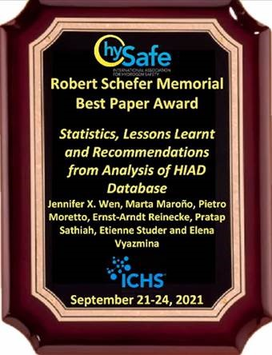
These form the basis of the planned work in 2022 towards developing a one-stop-shop for hydrogen safety engineering, which will include comprehensive lists of phenomenological models, risk assessment approaches and CFD models for hydrogen safety engineering applications.
Public outreach
Framed within the context of the intended broad information exchange, in 2021 the EHSP has concluded its communication strategy. This internal document outlines specific considerations for the communication strategy for the EHSP and the inherent challenges associated with the safe implementation of hydrogen as an energy carrier in society. It suggests clear and measurable communication goals and objectives, provides an analysis of the target audience for communication, prioritised by groups, etc. It also provides a summary of relevant communication channels and a list of key messages.
In line with the communication strategy, the EHSP has established regular meetings with the communication team at JU Programme Office and has performed a comprehensive revision of the EHSP webpage on the website of the Clean Hydrogen Joint Undertaking .
Besides, in cooperation with the Joint Research Centre (JRC) of the European Commission, the EHSP has developed a specific research thematic for hydrogen safety on Tools for Innovation Monitoring (TIM) .
Last, outreach activities of the EHSP in 2021 have included presentations at several events, such as on the FABIG Seminar on 21 April 2021, the Safety Forum of the International Partnership for Hydrogen and Fuel Cells in the Economy (IPHE) on 22 June 2021, the 9th International Conference on Hydrogen Safety (ICHS2021) on 21-24 September 2022, and the European Hydrogen Week on 29 November – 3 December 2021.

Collaboration with the JRC

The EC’s JRC undertakes high-quality research in the FCH field, which is of considerable relevance to the implementation of JU activities.
In 2016, a Framework Contract between the JU and JRC was drawn up for the Horizon 2020 programme. The scope of this Framework Contract covers the activities the JRC provides at the level of the JU programme. These activities are outlined in annual Rolling Plans which also detail the specific deliverables to be provided against payment (heading B of Article 2 in the Framework Contract).
The annual Rolling Plan 2021 constituted part of the AWP 2021, with an indicative budget of EUR 990 000 foreseen from the JU operational budget, but incurring in the end EUR 786 200 due to differences in the services provided. The JRC activities covered by the Framework Contract were planned and agreed between the JRC and the PO, with the involvement of one representative each from Hydrogen Europe and Hydrogen Europe Research.
In line with the JRC’s mission, these support activities have primarily contributed to the formulation and implementation of the JU strategy and activities in the areas of RCS, safety, harmonisation of testing protocols, and technology monitoring and assessment.
JRC support to the formulation and implementation of the RCS strategy
JRC supports the industry led Regulations, Codes and Standards Strategy Coordination Group (RCS SCG). In general, RCS activities should consist of identifying and prioritising RCS needs of strategic importance for the EU. In addition, the necessary PNR activities to support the RCS priorities should be identified. The activities of the RCS SCG group are described under Section 1.2.3.
JRC’s direct contribution to implementing the RCS strategy
The development of JRC ZERO∇CELL, a single cell PEMFC (Proton Exchange Membrane Fuel Cell) testing hardware was initiated based on a request from automotive original equipment manufacturers (OEMs) in the frame of the Working Group on harmonisation of PEMFC for automotive application of the Fuel Cells and Hydrogen second Joint Undertaking (FCH2JU). The JRC efforts are summarised in the JRC Technical Report “Development of reference hardware for harmonised testing of PEM single cell fuel cells” published in February 2021, while the design documentation of the JRC ZERO∇CELL is publicly available under CERN-OHW-v2 license at DOI: 10.17632/c7bffdv7yb.1.
The JRC is also leading the initiative of setting-up an EU harmonised terminology for hydrogen generated by electrolysis. A technical report has been produced and agreed with the working group on harmonisation activities for high temperature electrolysers. Following considerable efforts to resolve the extensive comments received following the public stakeholder consultation and once the approval was granted for the use of many terms defined by ISO, IEC and BPIM was obtained, the report is published on the JU website and JRC’s repository (https://data.europa.eu/doi/10.2760/293538).
In view of the harmonisation activities for low temperature electrolysis, a JRC technical report on EU harmonized protocols for testing of low temperature water electrolysis (LTWE) was eventually finalised and published (https://data.europa.eu/doi/10.2760/502481). This was following the resolution of several expert comments and consequentially, an extensive revision of the structure and layout of the report for better comprehension of the various aspects of LTWE testing and improving user guidance.
JRC’s contribution to programme monitoring and assessment
In collaboration with the Knowledge Management team of the JU, JRC has populated and revised the Tools for Innovation (TIM) system with customized FCH Technology fields.
The JRC performed the 2020/21 annual Programme Review. As the timeline of the programme review was advanced, in order to have the public version of the report ready for the programme review days, the 2020 and 2021 reports were merged. The resulting report was used to prepare the public version which can be accessed on the website of the JU.
JRC’s contribution to sustainability
In particular, JRC was invited to the meetings discussing the implementation of a material criticality indicator (SH2E-WP3) and has hence provided feedback and suggestions for the on-going methodological work. In the meantime, JRC started reviewing the existing scientific publications on LCA and Social LCA applied to hydrogen and fuel cells technologies.
JRC has been invited by the CertifHy consortium to provide a scientific support in the GHG emissions accounting for hydrogen produced among the various sectors. The aim was to assess, by means of an overall, internationally accepted methodology, the carbon footprint of hydrogen produced as main product or co-product. The discussions of JRC with project partners focused on the available LCA methodologies and their assumptions as regards system boundaries, allocation criteria and input data. In 2021, JRC.C.2 and JRC.C.1 attended several WG2 meetings as observers, and supported the CertifHy consortium to assess various methodologies to allocate emissions for hydrogen production in different case studies.
JRC’s contribution to safety and safety awareness
JRC operates two databases dedicated to hydrogen related incidents: the Hydrogen Events and Lessons LEarNed (HELLEN) and the Hydrogen Incidents and Accidents Database (HIAD 2.0).
HELLEN is a repository of events occurring during the life of JU projects. Its access is restricted and is a JU tool for the monitoring and control of safety during the execution of the programme. The JRC is collecting and analysing all reported incidents and informs the Programme Office through the annual report.
The database HIAD2.0 is used for collecting publically available safety-related events regarding hydrogen technologies hydrogen supply chain and applications. The 2021 activities continued along the same lines of the work delivered in 2020:
1. Identification of new hydrogen-related events and input into the database.
2. Continuous improvement of already existing data.
3. Relations with stakeholders and sharing of the data.

Approximately 30 new events have been added to HIAD 2.0 in 2021. Since begin of 2021, HIAD2.0 is not accessible anymore online. This is due to new Commission security rules which makes very complex and expensive the availability of a completely public accessible online service. The JRC has created a database batch export function which create EXCEL file for offline analyses. This file became a great success. The EHSP has been facilitated in its assessment work, and users can receive it upon request. It facilitates statistics and enables full textual search, something impossible in the previous online version.

Support to JU policies and funding/financial engineering
Policy support and feedback
Throughout its mandate, the JU has contributed to a large and diverse number of activities for multiple EC services (and accordingly provided the necessary feedback for further policy development). Although contributions have varied in content and format, they all share the common goal of providing fact-based information on the state of the art of hydrogen technologies and their contribution to EU initiatives and policies, especially in the energy, transport and industry sectors, as well as to competitiveness and growth and to the environment policy files.
In practical terms, the JU support to policies meant taking part in a number of technical groups organised by the EC and other international bodies, taking an active role during the meetings, providing written technical input, the organisation of events, and ensuring that hydrogen technologies are properly represented in the relevant sectors and files of policymakers.
As in previous years, supporting DGs ENER, R&I, MOVE and CLIMA, the JU continued to actively follow and contribute to the European Strategic Energy Technology Plan (SET-Plan) activities during 2021, Action 6 ‘Energy Efficiency for Industry’ and Action 8 on ‘Renewable Fuels’. In 2021, work for the Implementation Working Group for Action 6 was facilitated by consultancy Ecorys and focused on establishing a structure around thematic groups. A cross-cutting thematic group on ‘Enablers’ was set up covering hydrogen, renewables and CO2 which can be expanded to ammonia and energy storage. This group is currently engaging with Member States and industry. Action 8 work is being facilitated by the SET4BIO project. Work focused on synergies among the various Working Groups. The JU is included in the core group of the action.
The JU also continued to work on developing a Guarantee of Origin (GO) Scheme for Green and Low-Carbon Hydrogen, an effort that started back in 2014 with the first ‘CertifHy’ project. A procurement procedure was launched in 2020 and a Framework Contract signed in order to pursue the following key objectives:
- Support further the establishment of an independent and self-sustainable community that will deal with all hydrogen certification issues (GOs and target compliance).
- Support and accelerate the establishment of harmonised and mutually recognised GO schemes for renewable and non-renewable hydrogen across Member States while ensuring compliance with article 19 of the RED II.
- Design a hydrogen certification system that is able to demonstrate compliance with RED II targets on the share of renewables following the specific requirements that are applicable in each case.
- Engage in communication and outreach activities with hydrogen consumers, traders and policymakers with the aim of increasing the use of GOs, thereby adding to their market value.
In 2021, the on-going procurement continued this work in what can be considered as the third phase of CertifHy. During this third phase, CertifHy has become an observing member of the AIB (Association of Issuing Bodies), effectively working towards the harmonisation of the H2 GO market in Europe by working directly with future Issuing Bodies. One of the most important highlights from the work of CertifHy in 2021 is the decision of Vertogas, which was appointed as the H2 GO Issuing Body in the Netherlands, to adopt the CertifHy scheme for renewable and low-carbon H2 regarding renewability and GHG footprint methodology. Harmonised calculation of GHG emissions is especially important to avoid any market distortion. In the absence of any well-established international standard for GHG footprint assessment, CertifHy has provided guidance through its work with the CertifHy stakeholder platform.
CertifHy has setup the building blocks for the development of a future EU Voluntary Scheme recognized by the European Commission to provide Renewable Fuels of Non-Biological Origins (RFNBO) certificates to hydrogen producers and fuel suppliers, working towards the 14% target of renewable fuels by 2030 set by the revised Renewable Energy Directive (RED2). In practice, CertifHy has developed an architecture to accommodate the complex framework for hydrogen certification, considering not only RFNBO certificates but also GOs as well as the future Union Database.
During the second half of 2021 the Tender “Study on impact of deployment of battery electric vehicles (BEV) and fuel cells electric vehicles (FCEV) infrastructure” was awarded to the consultancy McKinsey. The purpose of the tender is to produce a comprehensive study to describe the possible optimal blend of infrastructure for Fuel Cells Hydrogen mobility and battery electric vehicles. The implementation of the study is meant to conclude at the end of March 2022. Representatives of the industry as well as of the European Commission are involved in the steering group ensuring that all relevant stakeholders can contribute and that policy recommendations emerging from the study are taken on board by policy makers.
In the maritime sector, the absence of RCS for hydrogen as a maritime fuel has been the focus of regular exchanges and meetings between the JU, DG R&I, DG MOVE, EMSA, the JRC, ZEWT, and CEN/CENELEC. Of particular importance is the contributions from projects MARANDA, FLAGSHIPS, and e-SHyIPS on their work on regulations, codes and standards and gaps analysis for the IGF Code correspondence group of the IMO (through the European Commission). In 2021, the IMO committee Carriage of Cargoes and Containers has endorsed draft interim guidelines for ships using fuel cells, and will develop guidelines for the safety of ships using hydrogen as a fuel. The contribution of the projects above will help this second stream of work from IMO.
The JU support to EC policymakers goes beyond energy and transport. During 2021, it has continued working closely with DG ENER and other DGs. Building on this good collaboration with various EC services, it provided extensive evidence-based policy input that was somehow incorporated in new EC communications, namely the ‘Fit for 55’, the Gas Decarbonisation package and other subsidiary measures.
During 2021, the JU continued exchanges with DG INTPA and the EU Global Technical Assistance Facility for Sustainable Energy (EU GTAF) to explore potential synergies in Africa and in Chile, also via the Team Europe Initiative.
Moreover, in 2021, the JU has provided regular updates on its activities related to RCS/ PNR to DG RTD, DG ENER, and DG GROW, as well as updates on the situation with respect to FCH standardisation at the European and international levels. Furthermore, the JU has provided information on areas for PNR on hydrogen safety in the maritime sector to DG RTD, has provided inputs on strategic supply chain vulnerabilities of hydrogen production and fuel cells to DG GROW, provided information on the JU activities related to Life Cycle Assessment to DG JRC in view of strengthening the links between projects and the JRC activities in this field and supporting EC activities, and has provided updates concerning the JU´s latest activities on RCS and safety to DG RTD for reporting to IPHE (IPHE Country Update).
Collaborations with other agencies and joint undertakings
The JU has continued exchanges which include executive agencies managing other parts of H2020 and HE in areas relevant to hydrogen technologies. For example, in the transport sector, it continues to work with CINEA on activities related to FC buses, maritime and HRS. In 2021, in order to support and accelerate the wide roll out of hydrogen mobility options in 2022, they worked together on the preparation of support to be provided by two ambitious flagship projects, one on trucks and one in vessels. For the refuelling infrastructure in these two projects synergies with CEF Transport programme are also foreseen. Similarly, collaboration is ongoing in the energy sector. A number of hydrogen-related CINEA projects presented their progress in the 2021 edition of the Joint Undertaking PRD (during the European Hydrogen Week in December 2021).
The JU has also remained proactive in taking up opportunities for collaboration with other partnerships, EU agencies, initiatives and actions with the potential for synergy with its research agenda. In particular, the JU co-operated closely with other partnerships in an effort to align their work Programmes and identify synergies. When possible, they developed common roadmaps, aiming to better coordinate the planned activities per partnership in the context of R&I in hydrogen technologies. This common planning should prevent overlaps, enable synergies and lead to a more effective allocation of funds towards hydrogen technologies in the context of the Horizon Europe Programme. In addition, the JU has continued exchanges with the European Defence Agency on transport and energy. This has consisted in raising awareness and stimulating the Defence community towards the potential role of hydrogen technologies in the defence sector. The JU has also created bridges between the defence sector and the FCH industry and research community by bringing all the actors together.
Working with regions
As part of the FCH Regions initiative, the JU study on ‘Fuel Cells and Hydrogen for Green Energy in European Cities and Regions’, published in 2018, identified project implementation intentions in excess of EUR 1.8 billion over a 5-year period. Since then, the JU has been working closely with regions to realise this potential.
Since then, the JU has facilitated the creation of a growing European Hydrogen Valleys Partnership (EHV-S3P) working across the hydrogen value chain and aiming to enhance the role of green hydrogen in the European energy transition process. In 2021, the JU continued to collaborate with this partnership’s activities.
In 2021, the FCH Regions Hub was further updated, to keep on helping regional and local authorities to develop and turn their concepts for regional hydrogen projects into detailed work plans. The Hub centralises the relevant information gathered within the projects, studies and initiatives of the JU. It also offers links to specific external sources and complementary initiatives capable of helping them to deploy regional FCH plans and projects.
Project development assistance for regions
In addition, in 2019, the JU launched a pilot PDA facility to help develop detailed project planning in regions and cities with a lower maturity level, with a special focus on Central and Eastern Europe. The final report covering the results of the Project Development Assistance (PDA) initiative of this initiative was presented in a webinar on 19 October 2021, with the participation of some of the regions involved and the representatives of the European Commission and the European Investment Bank. The PDA initiative supported 11 selected regions to develop detailed work plans for the implementation of hydrogen projects and concluded in June 2021. The report contains summaries of the project plans and work undertaken in each of the selected regions, the activities delivered as part of the observer network, and the next steps after the end of the PDA support period. The pilot PDA for Hydrogen in regions sets the path for further such initiatives possibly targeting regions which are not yet involved in the development of hydrogen projects and which could make use of the encompassing advantages of hydrogen as a green energy carrier to ensure local, sustainable and integrated energy solutions. Its follow-up PDA was foreseen in the AWP2022, with a clear focus on Cohesion Countries, Outermost Regions and Islands. The tender was published in December and the awarding is expected in the Q1 2022.
Hydrogen valleys and ecosystems
Building on projects developed since the AWP2015, the Hydrogen Valley concept has gained traction among our community. Projects like BIG HIT (call 2015), HEAVENN (call 2019) and GREEN HYSLAND (call 2020) have become flagships of this concept. Hydrogen Valleys are another success of the JU policy feedback, with the EC backing the support of such projects until the hydrogen market becomes fully regulated in 2030 (see for example the Gas Decarbonisation package published in December and mentioned under the above sub-section on Policy support and feedback).
In 2021, the JU released the Hydrogen Valley Platform under the umbrella of Mission Innovation’s ‘Renewable and Clean Hydrogen’ Innovation Challenge. The platform was launched publicly on 19 January 2021, gathering more than 1000 participants from across the world. The platform presents and connects the existing regional clusters with 36 hydrogen valleys from over 18 countries already featured. It is aimed primarily at project developers but is also raising awareness among policymakers and is intended to inspire others willing to replicate similar projects. The contract ended in May 2021 but a new tender has been launched (December 2021) to give continuity to it and contribute to the EC role under the renewed Mission Innovation 2.0 and more specifically, to its leadership of the second pillar – Hydrogen Valleys. The platform will be further updated, developed and enhanced to become a dynamic and interactive platform, contributing decisively to the Clean Hydrogen Mission objectives of reaching at least 100 Hydrogen Valleys by 2030 and at least three per Member of the Mission Innovation.
Synergies, funding and financial engineering
Despite the COVID-19 disruptions in face-to-face events and meetings that are essential for establishing trust between partners, in 2021, the JU activity on funding/financial engineering did not lose momentum. While the evolution of the EU strategy and policy framework gave further clarity and business certainty to investors and financiers alike, the various stimulus packages brought forward during the year, including the Innovation Fund, the Recovery and Resilience Facility and the Just Transition Fund, boosted the activity in terms of project development in Europe. The market introduction and acceleration of the deployment of technologies stemming from the JU projects is helping to further establish the JU in terms of a partner providing advice and support to prospective or past beneficiaries of JU projects. The goal is to support large project ideas to combine funding from various programmes, and optimise structured finance operations.
Furthermore, raising awareness among the banking and investor community has become a regular JU activity. This has taken place in various formats, namely in dedicated meetings and brainstorming with bank/investor/project developer teams in specific virtual presentations around the state of play of hydrogen-related activities and studies promoted by the JU.
Strong cooperation is key to deal with bigger yet fragmented EU Funds to meet the EU Green Deal ambition. New challenges emerge when hydrogen projects evolve and grow from R&D&I to large demos and full market deployment. An important element supporting the implementation of the European hydrogen strategy is the reinforcement of synergies among European funding instruments and actions to close the innovation gap in Europe. Synergies are needed pull together resources, align priorities and ultimately maximise the impact of clean hydrogen R&I investments. In view of the prominent role synergies play in the 2021-2027 Multi-annual Financial Framework, 2021 was the year in which the seeds for effective cooperation between different EU funds gained decisive momentum. In preparation of the call 2022 and the SRIA of the Clean Hydrogen JU, discussions were held with all members of the Joint Undertaking, i.e. the EC, Hydrogen Europe and Hydrogen Europe Research but also other European partnerships which will use clean hydrogen as an enabler of the decarbonisation of their specific sectors and even with Member States and Regions. Building on the mandate provided in the Single Basic Act, the SRIA that was adopted on 25 February 2022 properly frames these activities (see 4.1. Interface with EU policies and other programmes (Synergies)). A toolbox to generate funding synergies was identified and cooperation mechanisms to deliver synergies between different stakeholders was established, also using the advisory bodies of the newly created Clean Hydrogen JU (see 3.3 STATE REPRESENTATIVES GROUP and 3.4 STAKEHOLDERS GROUP below for more detail on the advisory bodies of the JU).

International cooperation
Given the importance of international cooperation in science and technology, explicitly recognised in the EU’s Innovation Union flagship initiative and the H2020 programme, and described in the Communication ‘Enhancing and focusing EU international cooperation in research and innovation: a strategic approach’, the JU has continued to be active at the international level in order to align with, facilitate and accelerate the worldwide market introduction of FCH technologies.

As the deployment of FCH technology is carried out globally and key partners of the JU are involved in these developments, the JU has continued to develop links with the major deployment programmes globally, mainly through the IPHE but also through the Mission Innovation’s Innovation Challenge 8: Renewable and Clean Hydrogen (MI-IC8) to harmonise standards and regulations and to accelerate market preparation.

In this respect, the JU continued its straight collaboration with EC representatives on the MI2.0 - Clean Hydrogen Mission and, during 2021, developed a Hydrogen Valley Platform under the umbrella of Mission Innovation’s Renewable and Clean Hydrogen Innovation Challenge. As mentioned in Section 1.2.6 Hydrogen valleys and ecosystems, the platform was publicly launched on 19 January 2021 and gathered more than 1000 participants from across the world. It presents and connects the existing regional clusters, with 36 hydrogen valleys from over 18 countries already featured. It is aimed primarily at project developers but is also raising awareness among policymakers and is intended to inspire others willing to replicate similar projects. A new contract to further developed the successful Hydrogen Valley Platform shall be awarded in the first half of 2022.
In support of the JRC, the JU continued to contribute to the activities of the IEA Hydrogen Technology Collaboration Programme executive committee to optimise and share the effort. In particular, it completed its contribution towards the IEA tasks related to Power-to-X (task 38) and Maritime Applications (task 39), while it continued its contribution towards Data and Modelling (task 41). Moreover it agreed to support JRC in the working-groups on ‘Renewable Hydrogen’, ‘Hydrogen Underground Storage’ and ‘Hydrogen Export Value Chains’.

Calls for proposals and grant information
2020 Call
In the AAR 2020, one grants agreement (GA) was indicated as ongoing because it requested an extension of the TTG deadline, due to exceptional circumstances:
- 101007108 MegaSyn: the GA was signed on 2nd March 2021
Moreover, budget became available in addition to the leftover call budget (see AWP2020 / 3.3 Call management rules – budget flexibility). Therefore, two proposals from the reserve lists have been promoted to main list. Thus, two additional GAs from call 2020 have been signed in 2021:
- 101006632 – HyUsPRe: the GA was signed on 7th July 2021
- 101007170 - MORELife: the GA was signed on 17th July 2021

Progress against KPIs / Statistics (Annexes 5, 6 and 7)
Not applicable, as there had been no call for proposals in 2021.

Evaluation: procedures and global evaluation outcome, redress, statistics (no. of evaluators, gender, area, etc.)
Not applicable, as there had been no call for proposals in 2021.

Calls for tender
On the basis of AWP 2021, the FCH 2 JU, and as of 30 November 2021, the Clean Hydrogen JU, have launched the following new operational procurements in 2021:
- Study on hydrogen in ports and industrial coastal areas.
The aim of the study is twofold: foresight and community building. on foresight, the study will take into consideration the fact that the ports and the industrial coastal areas need to have mid and long-term visibility on the market potential of hydrogen, and a clear roadmap to implement it. Second, the community of “hydrogen ports” would gain in placing common issues at European level for collaborative resolution and developing case studies that can act as blueprints for other ports would accelerate the take-up of financial assistance by ports and industrial coastal areas.
The contract for the implementation of the services was signed on 13 November 2021 for a period of 24 months and a budget of EUR 518,000.00 EUR. It included, among others, the provision of a final publishable report at the end of the contract.
- Project Development Assistance for Cohesion Countries, Outermost Regions, and Islands
There are four general objectives in this procurement: (1) To further widen the Clean Hydrogen JU geographical coverage by selecting and bringing a set of at least 15 projects from Cohesion Countries10, Outermost Regions and Islands in general, bringing new Hydrogen flagships to a high level of preparedness; (2) To provide regions and cities the necessary technical, financial and legal services; (3) To further develop the existing inter-regional, inter-island and cross-city networks in which both the selected regions and cities and its Observer Network could benefit from tools, methods and expertise gathered in both the first and the current PDA. This objective should be accomplished by helping foster collaborations from interested public authorities in view of indirectly assisting otherwise less mature projects and therefore enhance their chances of becoming reality in the future; (4) To boost the chances of grant funding and financing support by raising awareness among the relevant Regional and National European Structural and Investment Funds’ (ESIF) Managing Authorities as well as any Promotional Bank or specifically tailored commercial bank willing to increase their exposure to hydrogen projects with a local impact.
The call for tenders was published in December 2021; it is currently under evaluation. The maximum value of the contract is 1,000,000.00 EUR.
In view of request of the discharge authority for the financial year 2020)), the JU includes in the present report the fact that the launch of the study in question is accompanied by a detailed internal and external market research, whose aim was to find the most accurate market price for the contract.

- Technical Assistance support to generate synergies with Member States/Regions
Although the drafting of tender specifications for the study was initiated immediately after the financing decision was in place, the scope of synergies evolved significantly throughout 2021 until the approval of the SRIA of the new JU. This led to an unavoidable delay in the approval of the technical specifications of this procurement. Consequently it is expected to be published in the first half of 2022.
- Procurement of services in “Support to Mission Innovation 2.0 – Clean Hydrogen Mission H2.0 Valley Platform”.
Based on (i) a lean and effective cooperation between the Fuel Cells and Hydrogen 2 Joint Undertaking and the Mission Innovation co-leads to co-design and steer the previous procurement (the so-called Steering Committee) and (ii) the lessons learned during the first two years of operation of the Hydrogen Valley Platform (phase 1), the FCH 2 JU (now the Clean Hydrogen JU) launched a new procurement to take the Hydrogen Valley concept to the next level and develop the H2.0 Valley platform. H2.0 Valley will serve as a tool to help project developers and to promote the concept among policy makers and private stakeholders.
The call for tenders was published in December 2021, and it is currently under evaluation. The maximum value of the contract will be of 500,000.00 EUR.
In view of request of the discharge authority for the financial year 2020)), the JU includes in the present report the fact that the launch of the study in question is accompanied by a detailed internal and external market research, whose aim was to find the most accurate market price for the contract.
- Public opinion survey
The public survey to be conducted under this contract shall provide a rapid assessment of the state of public opinion EU wide, and contribute to the development of baseline (benchmark). In terms of geographic scope - the survey shall cover all Member States of the EU. The main objectives of the public survey are: i) To gain insights into perceptions on the use of fuel cells and hydrogen (FCH) technologies relating to a number of aspects: overall awareness, acceptance and uptake of hydrogen technologies; awareness and acceptance relating to safety of hydrogen technologies; awareness and acceptance of hydrogen as an efficient and sustainable energy vector; uptake of possible applications of hydrogen technologies. ii) To understand the state of awareness and acceptance of FCH technologies by the public and identify differences relating to a set of specific criteria (e.g. age, gender, nationality, regions); iii) To elaborate a benchmark (baseline) that will make it possible to monitor changing perceptions in the European population; and iv) To evaluate the obtained results and provide deriving strategic advice, with a focus on possible communication activities, on how to raise awareness and build confidence for further use of FCH technologies in the general public.
the call for tenders was published in July 2021. The contract for the implementation of the services is currently under signature for a period of 11 months and a budget of EUR 385,000.00 EUR.
The procurement was added to the work programme of the JU through the Governing Board Decision of 31.05.2021, adopting the second amendment of the AWP 2021.
In view of request of the discharge authority for the financial year 2020)), the JU includes in the present report the fact that the launch of the study in question is accompanied by a detailed internal and external market research, whose aim was to find the most accurate market price for the contract.
- Study on the impact of deployment BEV and FCEV infrastructures
The objective of this tender is to provide evidence, through a comprehensive study, of the possible optimal blend between electric recharging and hydrogen refuelling infrastructure covering the full spectrum of road transport applications. The study should allow to assess, both per Member State and at European level, the best way to deploy these infrastructures, the synergies and interactions with other existing ones.
In 2020, due to reasons external to the JU, as reported in the corresponding AAR, the study was transferred to the public procurements to be carried out in 2021..
The contract for the implementation of the services was signed on 01/09/2021 for a period of 8 months and a budget of EUR 200,000.00 EUR. Final results are expected by end of May 2022.

Dissemination and information about projects results
Closely aligned with the knowledge management objectives, the monitoring of the dissemination and exploitation activities of JU projects continued during 2021, as well as following closely the EC activities towards preparation for the post-H2020 period and the Horizon Europe. The JU will continue to support efforts in the same direction.
Dissemination and Exploitation Internal Guide: In H2020, JU strongly and actively supported the initiatives of the EC to reinforce the Dissemination and Exploitation (D&E) of the results of the projects. However, during an audit performed in 2020 to assess the adequacy of the design and the efficiency and effectiveness of the internal control system in place in JU for the implementation of grant agreements under the Horizon 2020 programme, the IAS made a recommendation concerning the monitoring of dissemination, exploitation and communications of the project. The action plan included verification steps for the POs to follow up the submission during the periodic assessment of an updated D&E plan, assessing its quality and adequacy, and the peer-reviewed publications and communication material by project partners to fulfil the requirements set out in the grant agreement. Also, the JU should include instructions for the project coordinators to emphasize on D&E during the kick-off meetings and, finally, share its general observations and recommendations concerning the implementation of the D&E plans with the director of the CIC.
As part of the action plan, in June 2021 the JU sent a letter to the CIC to ask for guidance on the monitoring of implementation of the D&E plans, during and after the end of the projects. The CIC replied focusing on the EC ecosystem of tools and services provided to support the projects (HRB, HRP etc) and additional tools to be developed by the D&E Group for the monitoring of D&E after the end of the projects under Horizon Europe.
Moreover, the JU has developed a Dissemination and Exploitation Internal Guide for the project officers and the officials of the Operations and Communications Unit to serve as a flexible guidance framework to monitor dissemination and exploitation obligations under the H2020 and the Horizon Europe Framework Programmes. As an integral part of the action plan, this Guide outlines the D&E monitoring good practices that are already implemented for the projects during and beyond their lifetime and what additional steps are foreseen to enhance the monitoring of the D&E in project level under H2020 programme in a concrete, structured manner. A list of consecutive steps to follow is provided, followed by detailed guidelines in each step, that extends from the Call for Proposals and the Model Grand Agreement provisions to the period of 4-years after the end of the project. This project-level approach is being complemented by a thorough mapping of overarching activities that the JU currently performs to support the D&E function in programme level. A training session focused on the new guidance and the implementation of the steps for the POs will take place in March 2022.
New activity for ended projects: One of the main issues regarding the project implementation remains the continuation of the D&E activities of the project beneficiaries after the end of the funding period and the last payment. According to the Article 28.1 of H2020 Model Grant Agreement (MGA), beneficiaries have to take measures aiming to ensure ‘exploitation’ of its results up to four years after the end of a project.
The new internal D&E guide has been put in force in November 2021 with the dispatch of a specific correspondence through COMPASS to 7 projects that concluded their funding period approximately 18 months before (in the 1st semester of 2020), as a means to collect information on the D&E activities of the projects after the final payment and to motivate them to proceed with the exploitation of their results using all the available EC tools and services (like the Horizon Results Platform, the HR Booster etc). This activity is expected to be performed at least twice a year to comply by the provision of the internal D&E guide.
Horizon Groups: Under the new Dissemination & Exploitation (D&E) Strategy for Horizon Europe, a revamped and streamlined governance (replacing the former D&E Network configuration and its six Working Groups) for the implementation of the D&E policy during 2021-2027 has been established and implemented during 2021. The governance structure consists of the following coordination groups:
- The Horizon Dissemination & Exploitation Group (D&E Group), and
- The Horizon Feedback to Policy Group (F2P Group).
For each of the groups 4 meetings per annum are scheduled. However, in 2021 only two meetings in each group were held. The JU has appointed representatives for each group, following their activities closely, while contributing to the periodical meetings.
Following the preparation to establish an integrated Dissemination & Exploitation Ecosystem of tools and services for the Horizon Europe and based on the work made and the actions performed by the former Working Groups, the kick-off meeting of the D&E Group held in July 2021 to discuss the progress report of 2020-2021 and the D&E Action Plan of 2021-2022, and the 2nd meeting in October 2021 to discuss the state-of-play of the action plan and best practices that the implementing bodies performing or planning on D&E, focusing especially on the monitoring of D&E activities of the projects after the end of the funding period.
As regards the F2P Group, the kick-off meeting was held in July 2021 and the 2nd in October 2021. The key issues are related to the implementation of the new Feedback-to-Policy Framework. The main steps of the action plan consist of the set-up of the Joint team in the level of Cluster 5 and the definition of the feedback to policy plans within the cluster, the gradual development of an ecosystem of tools to support the team and the trainings and activities to enable cultural change in the institutions and implementing bodies.
Horizon Results Platform (HRP): The HRP is a D&E tool launched by the DG-RTD in 2019, a dedicated platform for projects offered to present their projects’ results to targeted audiences (e.g. business partners, angel investors, venture capital, policy makers or business development assistance and others) and help the projects beneficiaries establish fruitful partnerships. Until the end of 2021, 25 project results in total have been uploaded in the platform, while all JU projects have been encouraged to make use of this new tool and its benefits and encouraged to upload their results.
Horizon Results Booster (HRB): The EC Horizon Results (Dissemination and Exploitation) Booster, the initiative based on the successful paradigm of the completed Support Services for Exploitation of Research Results (SSERR), was launched in 2019. The HRB services are available not only for on-going projects, completed projects can also apply to reinforce their efforts. So far, 8 projects has applied or already benefitted from these services. Dissemination and exploitation of project results awareness starts even before signature of the grant agreement, during its preparation and it is closely monitored throughout its duration.
Innovation Radar (IR): This platform collects high-potential innovations and the key innovators in H2020 projects. Usually during the project mid-term reviews a dedicated expert is mandated to identify potential innovations and to fill out a questionnaire with the aim of providing information in a structured manner about the innovations. With the help of the questionnaire, the Innovation Radar expert provides concrete recommendations on the innovation aspects of the project and for individual innovator organisations within the consortium. The purpose of the Innovation Radar exercise is not only to identify promising actors with the potential to grow, but also to stimulate and propel them to 'make it happen' faster and more efficiently. The innovation radar exercise was linked mainly to the mid-term review exercise, when applicable, these recommendations were also integrated into the formal review report. However, in June 2021 the IR exercise has been incorporated into the workflow of Project Monitoring, enabling the projects to proceed with submitting questionnaires across the whole lifetime of the project, regardless of the project monitoring milestones (even without using an expert) or updating previously analysed innovations if needed.
The JU projects participate in the IR since its pilot in 2018. So far, innovations of 59 JU projects in total has been analysed: a total of 153 innovations (more than half of which are considered as “very innovative” or “obviously innovative and easily appreciated advantages to customer”), attributed to 273 innovators, have been identified and uploaded in the platform. In 2021, 24 project participants of 5 JU projects submitted 10 additional innovations, that are analysed and included in the platform.

Figure 1.5.1: Total no of innovations analysed and presented in Innovation radar and the innovators related to the JU projects.

Figure 1.5.2: Ranking of the different innovations base on their Innovator Capacity Score and Innovation Potential Index
These innovations are displayed based on the Innovation Radar methodology, between ‘exploring’, ‘business ready’, ‘market ready’ and ‘tech ready’. This classification is meant to span the path between the most basic TRLs of ‘exploration’ to the most advanced and closest to the market, further research or standardization activities. A very positive result has also been the identification of at least 42 innovations that scored above 50 points in the innovation potential indicator, making them ideal first candidates for follow-up actions for exploitation proposals.

Figure 1.5.3: Clustering of Innovations based on the maturity level.
Since the pilot launch of the IR, the JU is collecting valuable feedback to communicate with EC (e.g. DG R&I, DG CONNECT etc) and participates in the Innovation Radar R&I family meetings to support further improvement of Innovation Radar and explore how the information collected can be further utilised by other EC services that support the commercial exploitation of research results (e.g. Horizon Results Booster, Horizon Results platform etc.). The Programme Office monitors any project activity within these initiatives to guide them and provide dedicated assistance to enable dissemination and, finally, utilisation of the Key Exploitable Results (KERs).
D&E Activities of the Projects: During the last two days of the 2nd European Hydrogen Week, the Programme Office organised the Programme Review Days 2021 (2-3 December 2021). The event is based on the annual data collection exercise organised every year to collect updated information and technological data of the projects that were ongoing during the period of reference (2020). Apart from the TRUST platform to collect descriptive and operational data from the activities of the projects, the other pillar of the exercise is the EU Survey Questionnaire that the projects submit to provide other type of information that can’t be captured otherwise. Its purpose is to gather the necessary input to support the in-depth assessment of the progress realised by the FCH 2 JU (and Clean Hydrogen JU) programme, identify its successes and form recommendations for improvement.
According to the data provided by 85 active projects in 2020, regarding the D&E activities and the KERs:
- 64 projects reported 245 dissemination activities in total;
- 43 projects reported 105 results in total;
- 33 projects reported 73 KERs in total.
Dissemination activities during 2020 appeared relatively less compared to 2019. Although the projects portfolio changes every year, as some projects were concluded whereas others started during the reference period, the dissemination activities is roughly estimated to had been reduced by -35% probably affected by the pandemic situation and the subsequent lock-downs during 2020.
Also, in total 53 publications were reported and 2 patents were granted (under projects DOLPHIN and NEWELY).
As for the type of the reported activities, almost 29% where related to active participation in conferences, 27% to scientific publications, 17% to meetings with policy stakeholders and 8% to education and training.

Figure 1.5.4: Type of the dissemination activities performed by FCH 2JU projects in 2020.
Almost half of all the dissemination activities targeted the scientific and research communities, while another 15% targeted in industry and/or business partners and 11% in international policy makers and authorities.

Figure 1.5.5: Target audience of the dissemination activities performed by FCH 2JU projects in 2020.
The projects reported also their main outputs and results, especially the key exploitable ones. In general, the types of all the reported results appear to be diverse: 30.5% of them are related to a new or improved product, 23.8% to a new or improved method, material or instrument, 12.4% are related to new or improved infrastructure and facilities and 6.7% to new or improved services, while a wide variety of different options (including other) were used for the rest.

Figure 1.5.6: Result type of the outcomes and projects results reported by the projects in 2020.
The projects flagged almost 70% of all the reported results as KERs or Key Results. As regards the potential of the KERs, the vast majority (78.8%) has been identified as having technological, business or economic high potential, which reflects the nature of the programme, while 12.1% are having a scientific potential, 6.1% societal and 3% policy or regulatory.

Figure 1.5.7: potential of the key exploitable results reported by the projects in 2020.
The reported results are expected to impact the hydrogen and fuel cells sector in short-to-medium term. More than half of them (56%) are expected to have an impact in 1-5 years, while 38% seem to already influencing the related fields according to their owners (expected impact time up to 12 months). In terms of market maturity, most of the result cases are positioned in emerging market, where there is growing demand but not many market players are positioned yet (64.3%). Some results are positioned in a mature market (14.3%), while for the rest there is a potential to create a market (14.3%) or it is still uncertain whether a market can be created to incorporate them (7.1%).

Figure 1.5.8: Expected impact time of the reported results in 2020 and market maturity.
The exploitation activities performed by the projects to support the uptake of the aforementioned results were quite diverse as well: Almost 20.5% were related to intellectual property rights (IPR) activities, 13.6% to business model/plan presentation and similar portions are related to meetings with user communities and potential investors. As regards the target audience of these activities, the vast majority of them (2 out of 3) addressed to the industry and /or business partners, while a much smaller portion to the research communities (16%) and the standardisation bodies (6%).

Figure 1.5.9: Type of the exploitation activities performed by JU projects in 2020.

Figure 1.5.10: Target audience of the exploitation activities performed by JU projects in 2020.

Operational budget execution
The total budget available in 2020 (including internal assigned revenues) for operational expenses reached EUR 10 227 166 in terms of commitment appropriations and EUR 49 676 325 in terms of payment appropriations. Commitment utilisation rate reached 98.3% (94.9% in 2020), which is the highest rate in the last 4 years, whereas payment execution rate reached 88% (96.9% in 2020).
In more detail:
- FP7 budget
In 2021, 3 periodic reports were assessed (1 interim and 2 final), with the total amount of payments reaching EUR 1.1 million. The budget execution (in terms of payment appropriations) reached 97.8% (88.8% in 2020).
- H2020 budget
In 2021, 62 reports were assessed (46 interim and 16 final payments). In addition, H2020 operational payment appropriations were used for 2 pre-financing payments (from Call 2020), as well as for procurement activities, the work of JRC, and the work of experts in the context of the EHSP. Budget execution in terms of payment appropriations reached 87.8% (97.5% in 2020). The reasons of the lower implementation rate are explained in section 2.3.2. In terms of commitment appropriations, the execution rate reached 98.4% (96.5% in 2020).

For further details on the budget, see Section 2.3.

In-kind contributions
In-kind contributions in H2020
The FCH 2 JU legal framework for in-kind contributions is defined in Council Regulation 559/2014 of 6 May 2014 establishing the FCH 2 JU, in which Article 4 provides that:
‘The Members of the FCH 2 Joint Undertaking other than the Union shall make or arrange for their constituent entities or their affiliated entities to make a total contribution of at least EUR 380 million over the period defined in Article 1.’
In 2021, FCH 2 JU members other than the EU were able to demonstrate an overall figure exceeding EUR 1 000 million of certified contributions from private members, largely exceeding the minimum targets.
For a detailed calculation of the leverage-effect formula, the following contributions made by members other than the EU and their constituent or affiliated entities have been considered:
- Contributions to the administrative costs of the FCH 2 JU;
- Co-financing required to carry out research and innovation actions supported by the FCH 2 JU (i.e. contributions to indirect actions through co-funding FCH 2 JU projects, the so-called ‘IKOP’;
- Contributions towards additional activities by members other than the EU or their constituent or affiliated entities, as specified in an additional activities plan. These additional activities (so-called ‘IKAA’) should represent contributions to the broader Fuel Cells and Hydrogen Joint Technology Initiative and the sector as a whole.

The amounts of each contribution, as at 31 December 2021, are detailed in the tables below.
Administrative costs
- TABLE 1.1.1: Financial contributions of the members to FCH 2 JU administrative costs in 2014-2021
Contributions to running costs received by 31 December 2021 / year | Industry grouping | Research grouping | Total
 | Cash in EUR mil. | Cash in EUR mil. | Cash in EUR mil.
2014 | 0.26 | 0.04 | 0.30
2015 | 0.41 | 0.07 | 0.48
2016 | 0.40 | 0.07 | 0.47
2017 | 0.05 | 0.01 | 0.06
2018 | 2.01 | 0.33 | 2.34
2019 | 2.31 | 0.38 | 2.68
2020 | 2.05 | 0.33 | 2.38
2021 | 2.28 | 0.37 | 2.65
Total 2014 - 2021 | 9.77 | 1.59 | 11.36

The lower amounts of cash contributions until 2017 can be explained by the fact that the administrative costs were also funded by Seventh Framework Programme (FP7) contributions.
In-kind contributions in operational activities (IKOP)
The table below provides an overview of private-sector co-financing in all FCH 2 JU projects signed up to 31 December 2021. The total amounts committed per FCH 2 JU member, per all private partners (members and non-members) and per the EU are broken down according to individual Calls.
When comparing total private contributions in projects to the total EU contribution, we can observe a close parity of 1:1 (EUR 627 million of EU committed contribution vs. EUR 553 million of private contributions).
TABLE 1.1.2: In-kind contributions and EU contributions for grants under calls 2014-2020

Call | Number of projects | Total EU contribution | Committed in-kind contributions (IKOP) from members (B) | Committed in-kind contributions from non-members (C) | Total committed private contributions | Total committed EU + private contributions
Call | Number of projects | (A) | Committed in-kind contributions (IKOP) from members (B) | Committed in-kind contributions from non-members (C) | (D = B + C) | (E = A + D)
Year |  | in EUR mil. | in EUR mil. | in EUR mil. | in EUR mil. | in EUR mil.
Call 2014 | 15 | 80.09 | 32.82 | 14.40 | 47.22 | 127.31
Call 2015 | 15 | 107.31 | 58.50 | 61.44 | 119.94 | 227.25
Call 2016 | 19 | 87.98 | 6.44 | 81.33 | 87.77 | 175.76
Call 2017 | 24 | 113.09 | 12.19 | 106.38 | 118.57 | 231.65
Call 2018 | 19 | 71.61 | 14.26 | 38.47 | 52.73 | 124.33
Call 2019 | 17 | 69.13 | 15.24 | 70.26 | 85.51 | 154.64
Call 2020 | 25 | 97.84 | 18.80 | 22.71 | 41.52 | 139.35
TOTAL | 134 | 627.04 | 158.27 | 394.99 | 553.25 | 1,180.30

Considering that funding rates in projects follow H2020 rules (i.e. up to 100 % of direct costs in research and innovation actions (RIAs) and coordination and support actions (CSAs) and up to 70 % in innovation actions (IAs)), these private contributions are significantly higher than was initially foreseen. This is due to the fact that most of the largest demonstration projects have effective funding rates lower than 70 % (of direct costs), as they are very close to the market.
In-kind contributions in additional activities (IKAA)
The underlying purpose of additional activities is to demonstrate private investments in the sector and ensure a balanced contribution is made by both the private and public entities in the context of the partnership.
In 2021, members of Hydrogen Europe and Hydrogen Europe Research and their affiliate entities jointly delivered a cumulative amount of EUR 1 039 million certified IKAA (for the period 2014-2020), which is more than three times higher than the minimum requirement for IKAA of EUR 285 million, as defined in the FCH 2 JU Council Regulation.
TABLE 1.1.3: In-kind contributions in additional activities for the period 2014-2020
IKAA in EUR mil. | 2014/2015 | 2016 | 2017 | 2018 | 2019 | 2020 | TOTAL
Total certified IKAA for H2020 as at 31 December 2021 | 217.56 | 164.65 | 107.34 | 177.45 | 209.55 | 162.45 | 1039.00

The following values have been taken into account in order to combine an operational component and additional activities part of private investments over public investment in the FCH 2 JU:
TABLE 1.1.4: Values of leverage effect as at 31 December 2021 compared to the overall Horizon 2020 targets
The overall Horizon 2020 targets (EUR million) set in the Council Regulation for FCH 2 JU |  | Members contributions as at 31 December 2021 and certified additional activities for 2014 - 2020 |  | Overall private contributions as at 31 December 2021 and certified additional activities for 2014 - 2020
Total minimum contribution from members other than the EU | 380 | Cash and committed in-kind in projects plus certified additional activities - MEMBERS | 1 209 | Cash and committed in-kind in projects plus certified additional activities - MEMBERS and NON-MEMBERS | 1 604
Total EU contribution | 665 | Committed EU contribution (2014 - 2020) | 627 | Committed EU contribution (2014 - 2020) | 627
Target leverage effect over the whole H2020 programme | 0.57 | Leverage effect - members only as at 31 December 2021 | 1.93 | Leverage effect - all private partners as at 31 December 2021 | 2.56

- Leverage effect – members only as at 31 December 2021 = (11.36 + 158.27 + 1 039 / 627.04) = 1 209 / 627 = 1.93
In other words, for every EUR 1 of EU contribution for all JU signed H2020 grant agreements up to 31 December 2021, members of Hydrogen Europe Industry and Hydrogen Europe Research committed to spend EUR 1.93 either on JU projects or in certified additional activities.
The leverage effect of 1.93 is considering only members of Hydrogen Europe Industry and Hydrogen Europe Research is already more than three times higher than a target leverage effect as defined in the FCH 2 JU founding regulation (0.57).
- Leverage effect – all private partners as at 31 December 2021 = (11.36 + 553.25 + 1 039 / 627.04) = 1 604 / 627 = 2.56
This formula is fully aligned with the method used in the Staff Working Document (SWD) accompanying the Interim Evaluation of the PPPs.

Compared to the previous formula (A), in this formula (B), the leverage effect of 2,56 is taking into consideration all private partners contributions to FCH 2 JU actions.

In other words, for 1 EUR of EU contribution for all JU signed H2020 grant agreements until 31 December 2021, the private partners committed to spend EUR 2.56 either on JU projects or in certified additional activities – which is more than 4 times the amount of leverage effect (0.57) expected in the beginning of the H2020 programme.

On the one hand, calculation of the leverage effect takes into account the operational component (private financial and in-kind contributions to projects for each euro committed by the European Commission) and, on the other hand, any additional leverage (private contributions to additional activities not directly linked to the project portfolio but contributing to the JUs’ overall objectives).
In 2021, the JU further confirmed and demonstrated to the Council and European Parliament that the overall commitment of the industry and research has significantly surpassed the minimum requirement of EUR 380 million for H2020.
The EUR 380 million threshold was set to be demonstrated by validated or certified values delivered by private partners only. In H2020, majority of the IKOP amounts are certified and subsequently validated after JU receives an external CFS certificate. According to H2020 rules, CFS certificates are only compulsory to be provided after the end of action. Since 2021, vast majority of the JU actions were still ongoing and only few CFS certificates were received, validated amount of IKOP was EUR 38 million by end of 2021. Another reason for a huge difference between EUR 553 million (committed private contribution) and certified IKOP (showed in the JU accounts) is that for the accounts, only contributions coming from the members of the Hydrogen Europe and Hydrogen Europe Research can be recognized.
Contributions from non-members, even if they are realised, validated and certified, are not shown. We believe that such picture may not necessarily give a true and fair view on the overall investments, therefore the readers may wish to complement this information with committed figures as well.

The table and graph below provide an overview of members’ contributions under FCH 2 JU:
TABLE 1.7.1: FINANCIAL AND CERTIFIED IN-KIND CONTRIBUTIONS FROM PRIVATE MEMBERS AS AT 31 DECEMBER 2021
Cash and certified in-kind contributions | in EUR million
Cash contributions to FCH 2 JU administrative costs
Industry | 9.77
Research | 1.59
TOTAL cash contribution | 11.36
Indirect actions – in-kind contributions ‘IKOP’
Certified IKOP as of 31 December 2020 | 11.92
Newly certified IKOP in 2021 | 26.72
Total certified IKOP as at 31 December 2021² | 38.63
Additional activities – certified ‘IKAA’
Certified IKAA as at 31 December 2020 | 876.55
Newly certified IKAA in 2021 | 162.45
Total certified IKAA as at 31 December 2021 | 1,039.00
Total: as at 31 December 2021 | 1,062.28

Graph 1.7.1: EU and certified private contributions as at 31 December 2021 with outlook for 2022

In-kind contributions in operational activities (IKOP)
IKOP are costs incurred in implementing indirect actions minus the contribution of the JU and any other EU contribution to those costs (Statutes, Article 13.3.b).
To be considered as IKOP, these costs must be incurred by members of Hydrogen Europe or Hydrogen Europe Research or their affiliates participating in FCH 2 JU indirect actions.
The regulation provides that IKOP should be valued according to members’ usual accounting practices and applicable national and international accounting standards (Regulation, Article 4.4).
The Council Regulation allows the members to base their declaration of IKOP on the basis of their ‘total costs’ (according to their usual accounting practices) which may be slightly higher than their ‘eligible costs’ (according to H2020 rules). On a proposal from the Industry and Research Groupings, the GB decided to limit IKOP to eligible costs for cost-efficiency and simplification reasons.
As a result, the IKOP in H2020 projects for FCH 2 JU are limited to the amount of eligible costs as per H2020 rules, minus the EU contribution.
Calculation of the level of in-kind contributions is based on the methodology endorsed by the GB on 18 November 2015. Ex-ante controls for the IKOP under H2020 follow the harmonised practice in line with the common strategy of the rest of the RTD family, with the aim of simplifying and easing the controls performed when the payment is approved.
Ex-post certification of IKOP is provided by the ex-ante certificate of financial statements (CFS) which, compared to the FP7 programme, are only applicable for the final project period where the amount of FCH contribution to direct costs is higher than EUR 325 000.
Validation of the amount of IKOP is provided at Executive Director level, upon receipt of the CFS certificate and/or based on the result of the ex-post audits.
The amount of IKOP reflected in the JU accounts is based on all signed running projects as at 31 December 2021, considering mainly the estimated costs (mostly pro rata), as well as costs claims which were received but had not been validated at the cut-off date.
As at 31 December 2021, the estimated in-kind contributions for the 134 projects signed for the H2020 programme (2014-2020 Calls) were as follows (in million EUR):

Table 1.7.2: Overview of in-kind contributions in operational activities (IKOP)
H2020 in 2020 | Accumulated validated IKOP at 01/01/2021 | Validated IKOP for 2021 | IKOP received but not validated at 31/12/2021 | IKOP estimate (pro rata) at 31/12/2021 | IKOP estimate to be validated | Forecast of aggregated level of IKOP
Industry grouping | 11.77 | 26.72 | 34.48 | 9.50 | 75.55 | 158.02
Research grouping | 0.15 | 0.00 | 0.00 | 0.00 | 0.10 | 0.24
TOTAL | 11.92 | 26.72 | 34.48 | 9.50 | 75.65 | 158.27

Most of the IKOPs were not certified, as this will happen later during the H2020 programme at the final payment of the projects when the CFS are due.
In-kind contributions in additional activities (IKAA)
According to the FCH 2 JU regulation, additional activities (AA) are defined as activities carried out by members of Hydrogen Europe and Hydrogen Europe Research and their affiliates contributing to the FCH 2 JU programme’s objectives but undertaken outside of its work plan, which are not funded by the EU or the JU.
The regulation provides that determination of the costs taken into account for the valuation of the in-kind contributions shall be in accordance with the usual cost accounting practices of the entities concerned, the applicable accounting standards of the country where the entity is established, and the applicable international accounting standards and international financial reporting standards (Article 4.4).
The FCH 2 JU regulation establishes a minimum level of IKAA at EUR 285 million over the period defined in Article 1 of the regulation.
The planning, reporting and certification process of the additional activities in 2020 followed a formal FCH 2 JU IKAA methodology, describing a robust control process to ensure the planned, reported and certified IKAA figures are reasonable (the methodology was agreed by the JU GB on 9 December 2016).
Due to high level of IKAA in the previous years, in 2021, the private members certified for the last time under H2020 programme, the additional activities as part of the IKAA 2020 plan. There was no further IKAA plan for 2021 for H2020, as the private members started their transition and were preparing for the reporting of the in-kind contributions under Horizon Europe programme.
In 2021, the following

1. (Preliminary) Reporting of the values of the IKAA contributions for 2020 by Hydrogen Europe and Hydrogen Europe Research Members as at 31 January 2021
As per the Council Regulation, members of the FCH 2 JU other than the EU shall report each year by 31 January to the FCH 2 JU GB on the value of the contributions in additional activities made in each of the previous financial years.
In accordance with the regulation, the 2020 IKAA preliminary report was submitted on 29 January 2021 to the JU GB for information. An estimated IKAA of EUR 218.52 million was reported as achieved compared to the initial 2020 IKAA plan of EUR 313.56 million adopted by the JU GB on 13 December 2019.

2. IKAA certifications for the 2020 period
By June 2020, the members delivered certificates for the additional activities at the total amount of EUR 162.45 million.
To ensure strict continuity and compliance with the adopted Plan, no new activities (for the 2020 reporting period) compared to the adopted 2020 IKAA Plan, were included in that report.
With newly certified activities for 2020, for an amount of EUR 162.45 million, the total certified IKAA amount for 2014-2020 reached EUR 1,039.00 million.

General overview of additional activities for H2020 as at 31 December 2021
This section provides an overview of the cumulative amount of additional activities:
- Certified IKAA for the period 2014-2020 (based on the certificates received and validated at 31 December 2021, totalling EUR 1,039.00 million);
- Minimum IKAA threshold for the H2020 programme of EUR 285 million envisaged in the FCH 2 JU Council Regulation.

Graph 1.7.2: Certified and reported IKAA for 2014-2020

The JU believes that the scope and volume of investments reflected in the additional activities is a clear testimony of the members’ strong commitment, the continued progress of these technologies towards the market, and the strong leverage of JU investment. The Joint Undertaking believes that these investments in additional activities successfully demonstrated a robust contribution towards achieving joint objectives even beyond the FCH 2 JU regulation.

FP7
The FCH JU founding regulation (Council Regulation 521/2008 as amended by Regulation 1183/2011) states that the FCH JU operational costs shall be covered through the financial contribution of the European Union and through in-kind contributions from the legal entities participating in the activities.
Calculation of the level of in-kind contributions follows a methodology approved by the FCH JU GB on 10 February 2012. Verification of these costs includes: i) ex-ante controls before validation of the cost claims submitted by the beneficiaries (either based on desk-review assessment by the PO and/or certificates on financial statements provided by independent auditors); and ii) ex-post audits after validation of the cost claims, carried out by independent auditors appointed by FCH JU, in line with the FCH JU ex-post audit strategy.
In addition, in accordance with the methodology, the aggregated level of in-kind contributions is assessed every year by an independent external auditor.
In February 2021, KPMG carried out the assessment and confirmed the amount of the aggregated level of in-kind contributions certified by the JU ED (cut-off date 31 December 2020).
The full publishable report can be found at: https://www.clean-hydrogen.europa.eu/about-us/key-documents/annual-activity-reports_en
As at 31 December 2021, details of the aggregated level of in-kind contributions are as follows (in million EUR):
Table 1.7.3: Aggregated level of in-kind contributions
FP7 Year 2021 | Accumulated validated IKC contributions at 01/01/2021 | Validated IKC contributions in year 2021 | IKC contributions received but not validated at 31/12/2021 | IKC contribution estimate (pro-rata) at 31/12/2021 | IKC contribution estimate to be validated as from 01/01/2022 | Forecast of aggregated level of in-kind contributions
Industry grouping | 292.86 | 2.00 | 0.00 | 1.71 | 9.02 | 305.58
Research grouping | 147.54 | 1.50 | 0.00 | 2.51 | 3.63 | 155.18
TOTAL | 440.39 | 3.50 | 0.00 | 4.22 | 12.65 | 460.76

SUPPORT TO OPERATIONS

Communication activities
Communication activities focused in 2021 on two main areas: continuing to promote the results of the JU and the development of the communications framework for the successor of the JU. This last part included the development of a new brand and visual identity, the development of the new website (www.clean-hydrogen.europa.eu), and of a new newsletter. A communications campaign was launched around the new partnership, generating media coverage and awareness among various stakeholders.
2.1.1. Communication campaigns and media relations
Media partnerships:
Throughout 2021, the JU had partnered with several European media to promote the results of its projects and to announce the launch of its successor, the Clean Hydrogen JU.
The JU has been supporting the Hydrogen section in Euractiv’s Energy & Environment hub since May 2020. The JU has also been supporting the Hydrogène and Wasserstoff sections on euractiv.fr and euractiv.de, respectively. The sections have included on-going editorial coverage of relevant issues, based on direct contact with EURACTIV journalists. The section also offered visibility to JU with the inclusion of its logo, and video teaser. As of 12 January 2021, the section generated 92,148 page views coming from 69,576 unique visitors.
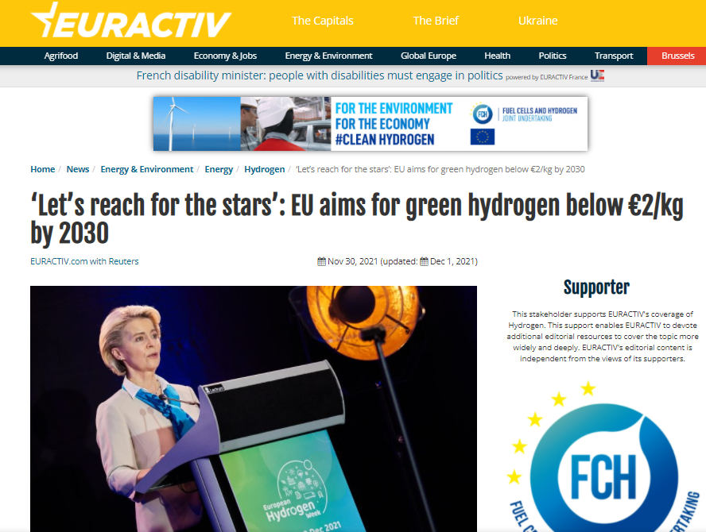

In addition, we have partnered with Politico Europe for the launch of the Clean Hydrogen Joint Undertaking, using a multi-platform approach – including homepage takeover and POLITICO Studio editorial – to create a solid awareness campaign.


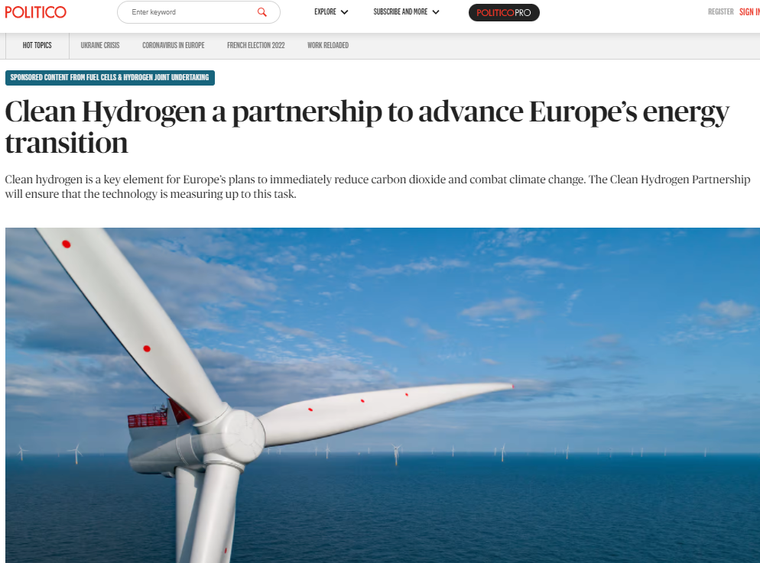

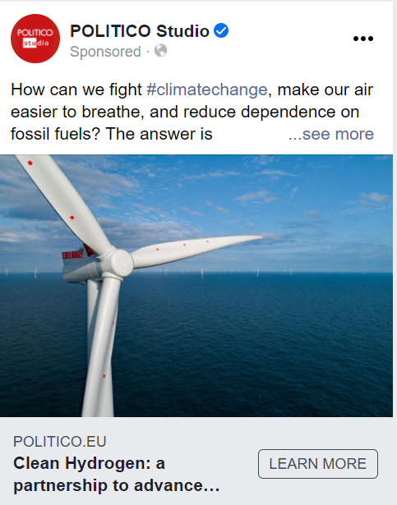
A series of 5 articles was published in the specialised “Science and business” website, representing a network of universities, companies, and research and policy organisations. Some of the themes included: “How Europe can stay at the heart of the hydrogen economy”, “Unleashing the potential of hydrogen for Europe’s ports”, “Bringing hydrogen power to the steel industry”, “Awarding excellence in hydrogen technology”, “How Europe can step-up shift to clean hydrogen power”.
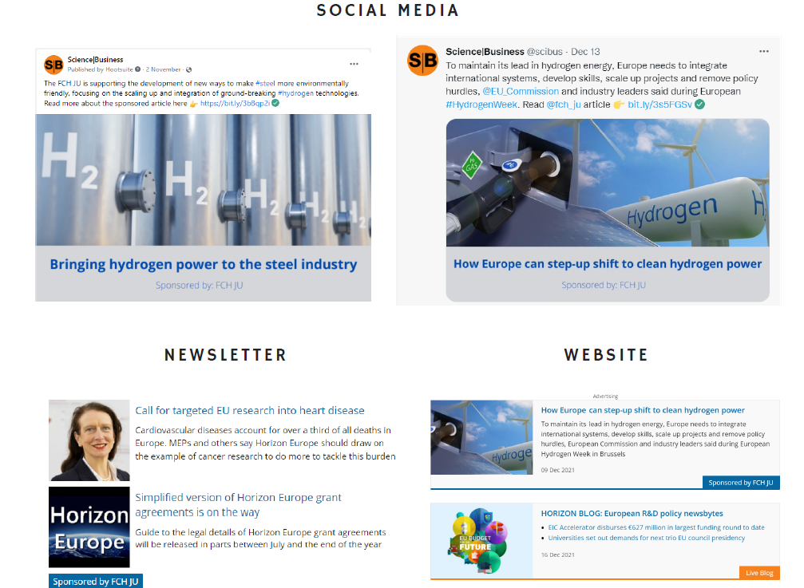
The partnership with H2 View, an established platform to support and promote the growing hydrogen economy, continued to promote the JU projects and success stories within the ‘Pillars of Progress’ section and the monthly opinion columns from the JU Executive Director. The Pillars of Progress series continued receiving positive attention in 2021.
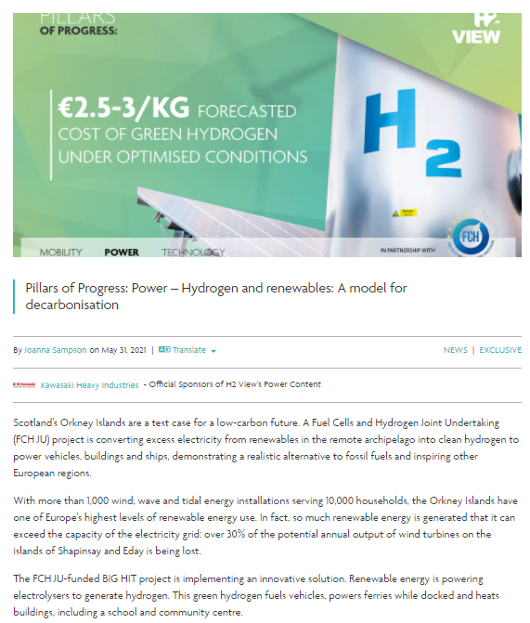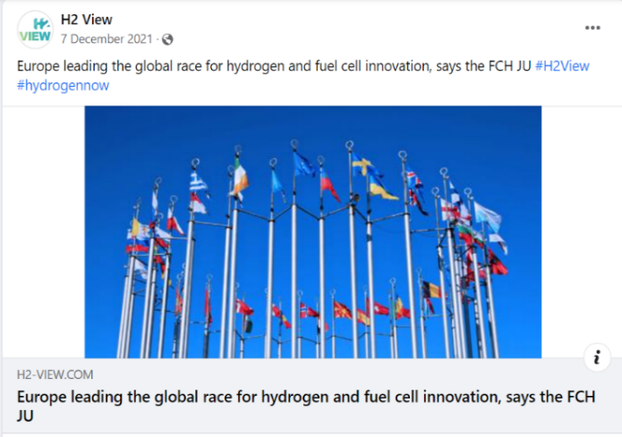

Another partnership, with Brussels Times, allowed the JU to reach out to a large audience and obtain more than 1.900.000 views by publishing two promoted articles on the magazine’s homepage.
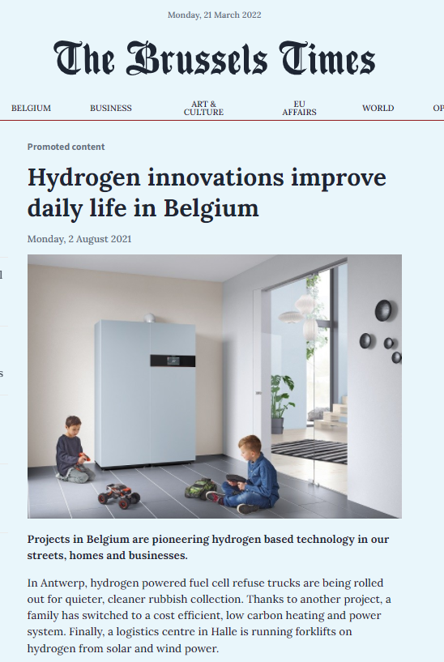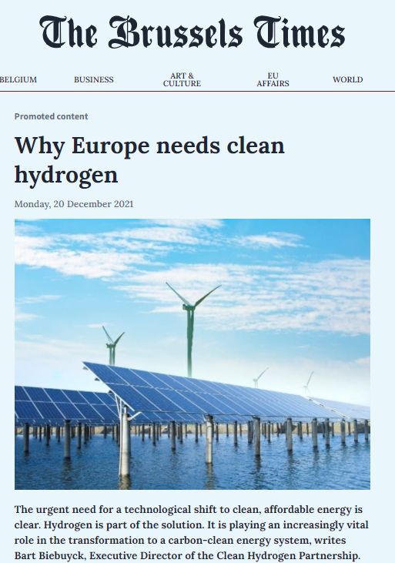

2.1.2. Delivering the new branding and visual identity
With the publication of the Council Regulation (EU) 2021/2085 in the Official Journal, the Clean Hydrogen Partnership (legal name: Clean Hydrogen Joint Undertaking) is the universal successor of the Fuel Cells and Hydrogen 2 Joint Undertaking (FCH 2 JU) and has taken over its legacy portfolio.
To ensure a smooth transition to its new name and keep connected with its extended audience, the Clean Hydrogen Partnership underwent a rebranding process. The results of the rebranding were a new logo, corporate visual identity and website.
We aligned our style with the Visual Identity Guidelines of the European Commission, in particular the newly developed ones for partnerships. Our aim was to create a compelling, modern visual identity that speaks to our overall brand promise, which is further used across all our communication touch points: website, social media, collateral print, email signature, business cards, e-newsletter, letterheads, presentations, branded products (vehicles, trucks, buses etc.)
2.1.3. Website and social media
The Clean Hydrogen JU website -www.clean-hydrogen.europa.eu- was launched in December 2021, shortly after the Hydrogen Week and the entering into force of the new partnership; the website boasts a new structure and visual presentation, compatible with the europa.eu – EWPP platform, on which is hosted. You can now browse through all our initiatives, events, news and find out more about the new partnership. The FCH 2 JU website https://www.fch.europa.eu/ will still continue to exist until the end of FCH 2 JU legacy.
Social media evolution 2020 – 2021
2021 marked a continued growth of social media channels, in particular LinkedIn and You Tube, in accordance with the new trends and the yearly media plan.

Figure 2.1

According to YouTube key performance metrics, the official channel of the JU recorded increased figures in 2021: the number of views tripled (from 3912 in 2020 to 11.333 views in 2021). Additionally, the channel became more popular in 2021: the YouTube search engine reported 1.188 queries mentioning the name of the JU, compared to 428 in 2020.

The summary of the official Twitter account, as well as the breakdown of additional data indicated that in 2021, the JU published less tweets per month (an average of 22 posts), compared to 2020 (an average of 30 posts). As a result, the average number of impressions decreased approximately 44%.

Contrary to Twitter, less content shared on LinkedIn platform in 2021 attracted more traffic and more engagement from the online community. Although the impressions KPI remained constant over these two years, the reach increased substantially from an average of 1540 clicks/post in 2020, to 1916 clicks/post in 2021.
Monthly newsletters have been sent throughout 2021 to a database of more than 11.000 subscribers. In December 2021, following the transition to the new website and the new visual identity, a new newsletter has been developed based on the Newsroom platform provided by the European Commission’s DG CONNECT. The first issue of the Clean Hydrogen Partnership newsletter was sent out to a database comprising over 12.000 subscribers.
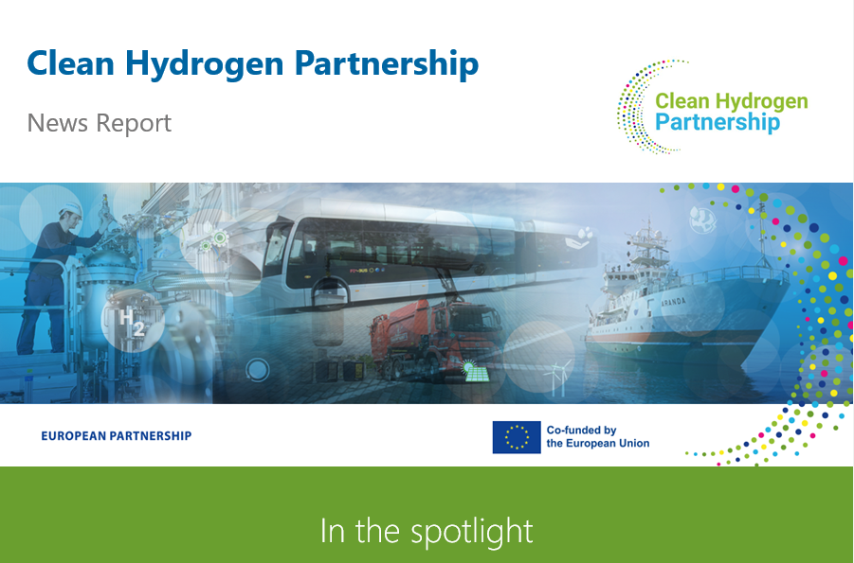

2.1.4. European Hydrogen Week
The second edition of European Hydrogen Week brought together over 2 000 participants from the public and private sectors across Europe and beyond to review progress and look ahead to new opportunities for the production and use of hydrogen throughout the economy.
The event marked the public launch of the Clean Hydrogen Partnership – as the successor of the FCH 2 JU, in the presence of the President of the European Commission, Ursula von der Leyen.
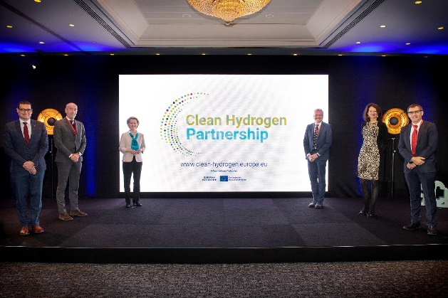
"This new Partnership builds on years of cooperation promoted by the Fuel Cell and Hydrogen Joint Undertaking. And many thanks for that. And it brings that model to the next level. It is a new big step forward to bring innovative technologies from the laboratory to the factory and, ultimately, to European businesses and consumers" (..) "Clean hydrogen is the energy of the next generation", said President von der Leyen.
The event benefited from the participation of several high-level speakers from the European Commission as well other international organisations. Among these: Frans Timmermans, Executive Vice President of the European Commission, EU Commissioners for Energy, Kadri Simson and Transport, Adina Valean, Jean-Eric Paquet, Director General of DG Research and Innovation at the European Commission, Fatih Birol, Executive Director of International Energy Agency.
Participants discussed among others the actions needed for a large-scale roll-out of clean hydrogen, hydrogen contribution to global climate mitigation actions, and the role of EU Member States in setting synergies and work jointly at EU, national, regional and city levels.
Other topics included: education and skills needed for the hydrogen economy, renewable hydrogen production, distribution and storage, and ports role as drivers and beneficiaries of hydrogen technologies.
A day was dedicated to discussions on the scientific priorities of the new Clean Hydrogen Partnership. All sectors, including the wider European scientific community, were invited to define the strategic scientific priorities for the hydrogen economy and ways to bridge the gaps between ready-to-market technology and large-scale uptake, while improving and diversifying the technological options.
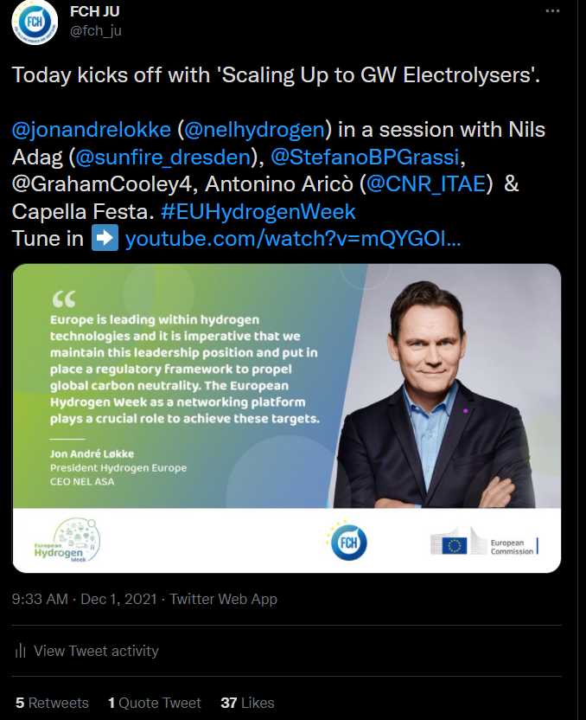

Hydrogen week concluded with the FCH 2 JU Programme Review Days, which presented the progress of FCH 2 JU supported projects and technological developments (more details in section 1.2).

2.1.5. FCH JU AWARDS
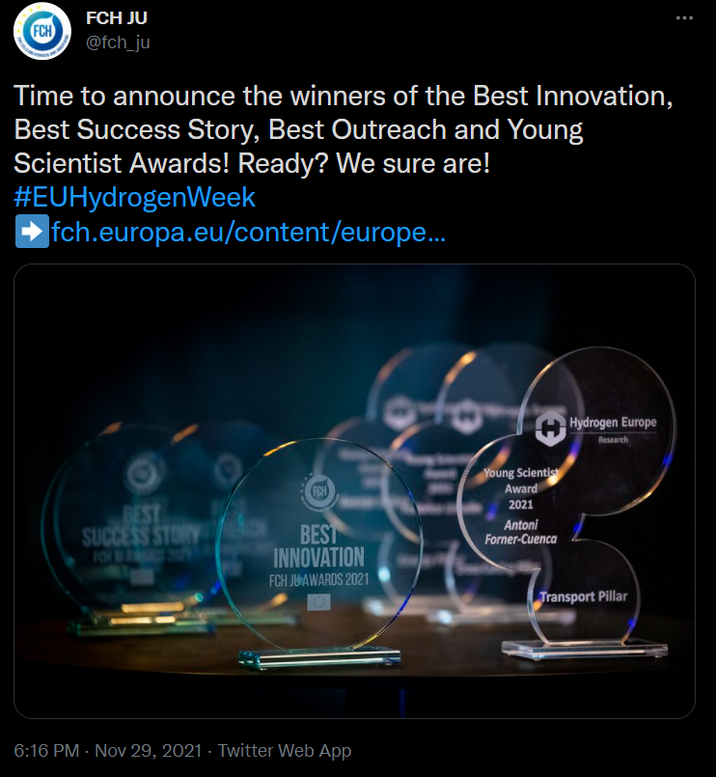
FCH JU awarded its trailblazing clean hydrogen energy projects during the Hydrogen Week
The JU acknowledged successful collaborations between research, industry and policymakers at its awards ceremony in Brussels on 29 November. The winning projects are delivering world-class solutions and accelerating the transition to a greener world. The JU introduced this award in 2018 as an additional incentive for project beneficiaries to excel.
Best Innovation Award: EVERYWH2ERE
Proving that hydrogen power development is not only for industrial users, the winning project, EVERYWH2ERE is a demonstration-to-market project that developed portable fuel-cell units, or gensets. These can provide power to construction sites, music festivals and other temporary events in European cities, providing a solution to a real need. The gensets feature proton-exchange membrane fuel cells and safe, pressurised-hydrogen technology.
The innovation has helped to bring hydrogen fuel cell technology closer to citizens, eliminating the noise and pollution of diesel generators. Receiving the award on behalf of the consortium, Rina project manager Stefano Barberis said: ‘Our project will increase social awareness of FCH technologies, which will be the backbone of future clean energy and a hydrogen-based EU society.’
Best Success Story Award: Towards a sustainable and circular hydrogen economy
This award, also introduced in 2018, goes to a group of projects that contributed to the circularity of the hydrogen sector. This year there were 13 finalists, with project achievements across the entire hydrogen value chain, ranging from hydrogen-powered aviation to hydrogen valleys.
Six projects contributed to the winning success story and each received the award: FC-HYGUIDE, SH2E, HYTECHCYCLING, BEST4HY, EGHOST and CERTIFHY.
The winning success story demonstrates that hydrogen power must not only deliver clean energy efficiently and cost-effectively but should also incorporate sustainability.
The industrial partners and researchers involved in this success story are developing guidelines on materials sourcing, dismantling, and recycling in line with a circular, clean hydrogen economy.
FC-HYGUIDE developed guidance, training materials and courses on how to use life cycle assessments. The SH2E project is building on this to include economic and social dimensions.
HYTECHCYCLING and BEST4HY focused on recycling and dismantling, recovery and reuse of resources such as platinum. Currently, EGHOST is developing environmentally friendly design criteria in technology development.
Finally, CERTIFHY created the first EU-wide guarantee of origin (GO) scheme for green and low-carbon hydrogen. The project’s current third phase includes building a market for GO trade and harmonisation across all Member States.
‘Without the backing of the FCH JU since 2014, CERTIFHY could have never achieved the leading role we now have worldwide on certification schemes. We are honoured to get this award. It boosts our enthusiasm to continue the project,’ said Wouter Vanhoudt, Director Europe and Asia at Hinicio, the coordinators of CERTIFHY.
Best Outreach Award: REFHYNE
This award goes to a project for excellent public engagement and creative use of communication activities, to spread the word about the production of clean hydrogen. The 2021 winner is Clean Refinery Hydrogen for Europe (REFHYNE).
The five-year project began in 2018 and built a 10 MW Proton Exchange Membrane (PEM) electrolysis plant, the largest in Europe, at the Shell Rhineland Refinery in Wesseling, near Cologne, Germany. This electrolyser for industrial applications started operation this year in July and can produce up to four tonnes of hydrogen a day when running at full power. It can also help balance the refinery’s internal electricity grid, while selling Primary Control Reserve service to the German Transmission System Operators. Plans are underway to expand the capacity of the electrolysis plant to 100MW.
Anders Ødegård of SINTEF, REFHYNE project coordinator concluded: "We are honoured to receive this award in recognition of our dissemination activities. We believe it is vital to share our experiences and learnings to accelerate the further scale up of clean hydrogen production. On behalf of the entire REFHYNE consortium, I want to thank the FCH JU for the support for our 10MW PEM electrolyser project and for this distinct outreach award".
FCH JU projects videos
On the occasion of the European Hydrogen Week, the JU produced three videos with a focus on three main topics: Hydrogen for decarbonising industry (steel industry), Hydrogen for transport and Hydrogen Valleys. Several projects have been featured in the respective videos, to showcase their activities through on-site interviews and presentations.
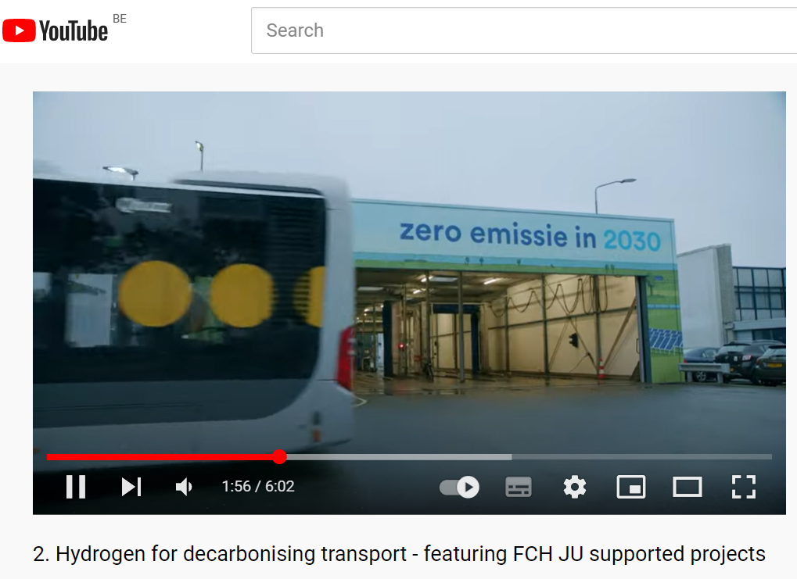

2.1.6. EVENTS
FCH 2 JU Webinars
The JU organised a series of 4 webinars, covering a variety of topics. The online events have reached more than 2300 participants in total.
Launch of Hydrogen Valleys Mission Innovation Platform
The launch event of the Hydrogen Valley Mission Innovation Platform took place on 19 January 2021 and included keynote speakers from the Mission Innovation IC8 Co-Leads Australia, the European Commission and Germany. The event featured presentations from the developers of the platform, Roland Berger and Inycom, which presented the platform's functionalities as well as key findings of the global analysis of Hydrogen Valleys. The Mission Innovation Hydrogen Valley Platform was developed under the Mission Innovation - Innovation Challenge 8 (IC8) "Renewable and Clean Hydrogen”. The platform features comprehensive insights into the most advanced and ambitious Hydrogen Valleys around the globe.
Hydrogen Certification
By showcasing the results from the CertifHy initiative supported by the JU, European policy makers, industry representatives and NGOs had the opportunity to debate on 21 May 2021 what is needed to harmonize hydrogen GO schemes around Europe and beyond.
Anion Exchange Membrane Electrolyser
Still in early development stage, AEMEL have the potential of combining the strengths of alkaline and PEM electrolysers. Since 2020 the JU has supported the three cutting-edge projects on this research field: ANIONE, CHANNEL and NEWELY. The projects showcased their achievements and challenges in developing 2kW prototypes of AEMEL. The presentations followed by a discussion on the steps needed to upscale AEMEL, including EU support.
Project Development Assistance
The final report of the PDA and the major achievements of this initiative were presented on 19 October 2021, during an exclusive webinar with the participation of some of the regions involved and the representatives of the European Commission, and the European Investment Bank.

Project events
GrinHy2.0 - Salzgitter
On July 14, the JU Executive Director, Bart Biebuyck was a guest of the GrInHy2.0 project, to discuss the progress of the project and the operation of the world's most powerful high temperature electrolyser.
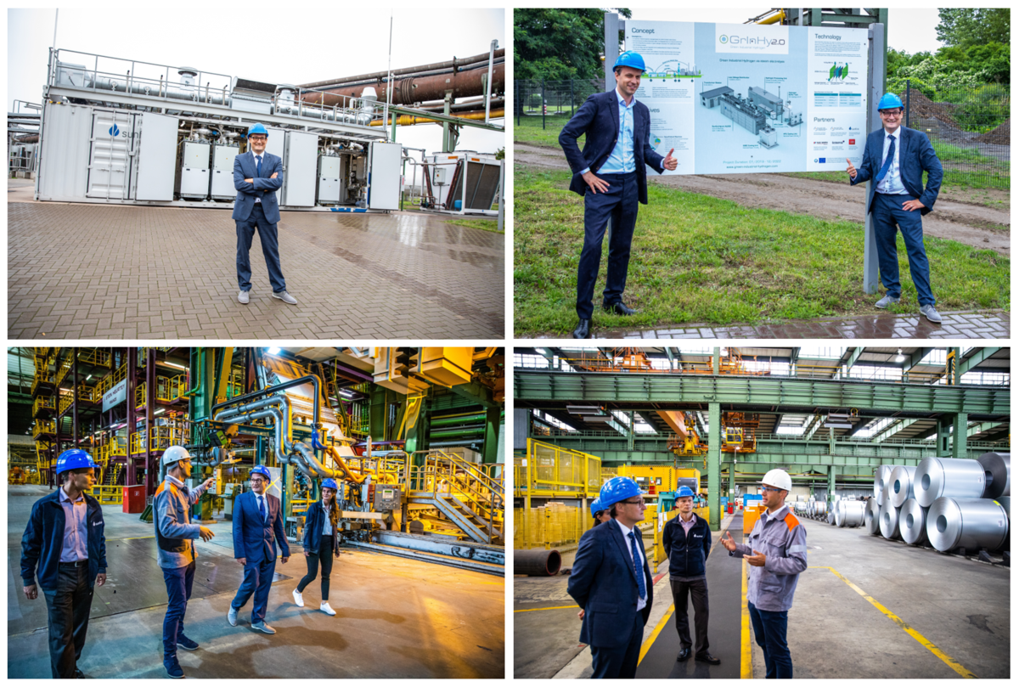
Inauguration of Europe’s largest PEM electrolysis plant - Refhyne project
The REFHYNE project is at the forefront of the effort to supply green hydrogen for Europe. Europe’s largest Polymer electrolyte membrane (PEM) water electrolyser began operations at Shell’s Energy and Chemicals Park in Rhineland near Cologne, producing green hydrogen. As part of the REFHYNE European consortium and with EU funding through the JU, the fully operational plant is the first to use this technology at such a large scale in a refinery.
EUSEW 2022: The JU has co-hosted 3 high-level EUSEW sessions on greening European industry, to showcase ground-breaking JU-funded projects and initiatives.
1. Hydrogen and its potential to decarbonise industrial hubs through ports (14 October 2021)
This session brough together policy makers, industry representatives and regional authorities to talk about their experiences and share their visions on how ports can play a key role towards a green hydrogen economy.
2. Clean Steel with Hydrogen (18 October 2021)
Achieving climate-neutrality in the next 30 years requires radical changes in the way steel is produced: a higher level of circular economy and the integration of renewable energy sources directly or indirectly through hydrogen. Participants discussed technology and policy issues related to the decarbonisation of the steel industry through hydrogen.
3. The key role of European regions in kick-starting and advancing the clean hydrogen economy (26 October 2021)
The increasing importance of clean hydrogen in the energy mix provides opportunities and raises as much if not more questions. The entire clean hydrogen value chain can support sustainable regional development, increase growth and provide long-term employment. The speakers and panelists shared their experience and views with the audience in developing a hydrogen economy.

Other events with JU participation
EU Regions Week: Youth Engagement for the European Green Deal and a Carbon-Neutral Society with Hydrogen (13 October 2021)
At the core of the European Green Deal lies the need to fight climate change. Hydrogen technologies are an important part of the overall solution for meeting the 2050 climate-neutrality goal of the European Green Deal. The involvement and support of the younger generation is essential in order to increase confidence in and acceptance of these new technologies.
The workshop brought together local and regional authorities, industry and business sectors and young people to learn from each other and see the impact that young people can have and their possibilities to influence the decision-making process.

COP 26 event: the JU was part of the programme of the Science, technology, research, and innovation Day at COP26, which took place on 1 November 2021. The session highlighted how R&I funding, corporate companies, start-ups, and local authorities can work together to make the hydrogen transformation become a reality.
In addition, the JU presented the new policy and finance models for ‘hydrogen valleys at the H2 Transition Forum in Glasgow, which took place on 11 November 2021.
Expo Dubai 2021 – Swedish Pavilion
On 3-4 October 2021, the JU Executive Director, Bart Biebuyck, participated in a high-level event organised in the framework of Expo2020 which aimed to highlight the EU’s excellence in research and innovation as a tool towards climate neutrality and sustainability. The high-level event brought together policy makers and innovators from the EU and the world to present the new EU research and innovation programme (Horizon Europe) and the Mission Innovation initiative. It was also an occasion to showcase some of the JU projects.
The JU also participated in two events organised jointly with the EU Council Presidencies of 2021:
The Conference on a Hydrogen ecosystem for North Adriatic on 24 November 2021 was part of the agenda of Slovenian presidency of the Council of the European Union, and a side event to the 15th SET PLAN Conference Bled.
The High-Level Conference on “Hydrogen in Society - Bridging the Gaps”, organised in collaboration with the Portuguese Presidency of the Council of the European Union took place on 7 April 2021.

Legal and financial framework
During 2021, the following procedures were drafted or updated and adopted:
- Decision of the Governing Board of the Clean Hydrogen Joint Undertaking no CleanHydrogen-GB-2021-03 adopting the transfer of decisions of the Fuel Cells and Hydrogen 2 Joint Undertaking’s Governing Board to Clean Hydrogen Joint Undertaking.
In accordance with Article 174(12) of Regulation (EU) 2021/2085, in its first meeting, the Governing Board of each joint undertaking shall adopt a list of decisions adopted by the Governing Board of the preceding joint undertakings that shall continue to apply for the joint undertaking concerned established by the Regulation.
the Governing Board Decision comprises in its annex all previous decision that shall continue to apply.
- Decision of the Governing Board of the Clean Hydrogen Joint Undertaking no CleanHydrogen-GB-2021-02 adopting the rules of procedure of the Governing Board.

Data protection
As an EU body applying Regulation (EU) 2018/1725, in the course of 2021, the JU continues its data protection activities as follows:
- further implementation of mitigating measures that resulted of the data protection impact assessment done in the previous year; as apart of the mitigating measures, the JU has adopted a Manual for Handling Sensitive Data In Microsoft Tools - it is a practical guidance to be followed each time the JU processes sensitive personal data, ensuring internal harmonised practices.

Budgetary and financial management

2.3.1 BUDGET
The JU budget comprises revenue and expenditure. On the expenditure side, the budget is divided into three titles:
• Title 1 covers staff expenditure, such as salaries, allowances and benefits, contributions and taxes. In addition, it includes expenses for training, missions and medical services as well as the costs associated with the recruitment procedure and representational costs;
• Title 2 covers the costs associated with the functioning of the Programme Office (PO), such as renting premises, IT needs, expenses related to communications, experts’ fees, other service contracts and various office supplies;
• Title 3 covers the operational activities for both the FP7 and H2020 programmes.
Compared to 2020, the 2021 appropriations decreased by 85% in terms of commitments and by 46% in terms of payments. The decrease in 2021 budget was due to the absence of calls launched in 2021. In addition, no pre-financing was foreseen in 2021.
There were 3 budget amendments and 3 budget transfers in 2021. The first 2 amendments introduced unused administrative payment appropriations as well as unused operational commitment and payment appropriations, whereas the 3rd one decreased FP7 and H2020 operational payment appropriations in the context of the Global Transfer of Appropriations. An overview of the initial budget, the amendments and transfers is presented below:

Table 2.3.1: Budget evolution
BUDGET 2021 (in EUR)
 | Voted Budget |  | Amendments |  | Transfers |  | Assigned revenues | Final budget
 | CA | PA | CA | PA | CA | PA | CA+PA | CA | PA
Revenue
EU operational FP7 |  | 1,150,639 |  | -810,598 |  |  |  | 0 | 340,041
EU administrative | 2,649,250 | 2,649,250 |  |  |  |  |  | 2,649,250 | 2,649,250
Hydrogen Europe | 2,278,355 | 2,278,355 |  |  |  |  |  | 2,278,355 | 2,278,355
Hydrogen Europe Research | 370,895 | 370,895 |  |  |  |  |  | 370,895 | 370,895
EU operational H2020 |  | 60,815,319 |  | -16,500,000 |  |  |  | 0 | 44,315,319
Reactivations from previous years | 1,493,500 | 2,777,987 | 7,041,287 | 1,471,501 |  |  |  | 8,534,787 | 4,249,488
JTI revenues |  |  |  |  |  |  | 2,014,143 | 2,014,143 | 2,014,143
Total revenue | 6,792,000 | 70,042,445 | 7,041,287 | -15,839,097 | 0 | 0 | 2,014,143 | 15,847,430 | 56,217,491
Expenditure
Title 1 | 3,814,800 | 3,814,800 |  | 110,622 | -66,225 | -66,225 | 19,122 | 3,767,697 | 3,878,319
Title 2 | 1,777,200 | 1,777,200 |  | 810,281 | 66,225 | 66,225 | 9,141 | 1,852,566 | 2,662,848
Title 3 - FP7 | 0 | 1,368,001 |  | -260,000 |  |  | 7,774 | 7,774 | 1,115,775
Title 3 - H2020 | 1,200,000 | 63,082,444 | 7,041,287 | -16,500,000 |  |  | 1,978,106 | 10,219,393 | 48,560,550
Total expenditure | 6,792,000 | 70,042,445 | 7,041,287 | -15,839,097 | 0 | 0 | 2,014,143 | 15,847,430 | 56,217,491

2.3.2 BUDGET EXECUTION
In 2021, the level of commitments showed the highest rate of execution in the last 4 years. The main driver was the high execution rate observed for administrative expenses, which constitutes a record in JU’s history.
The payment execution rate decreased by 8 percentage points compared to 2020, affected by the rate of execution for H2020 payments.
Figure 2.3.2:

The execution rates for the operational budget reached 98% and 88% for commitments and payments, respectively, as shown in figure.
The utilisation rates for administrative commitments and payments improved from 2020 to 93% and 78% respectively.
Further details on budget execution:
Revenues
JU revenue for 2021:
TABLE 2.3.3: IMPLEMENTATION OF REVENUES
Revenue (in EUR)
Heading | Income appropriation (budgeted) | Cashed
Operational expenditure, Union | 44,655,360 | 44,655,360
Administrative expenditure, Union | 2,649,250 | 2,649,250
Administrative expenditure, IG | 2,278,355 | 2,278,355
Administrative expenditure, RG | 370,895 | 370,895
Recoveries |  | 2,015,423
Reactivation of appropriations | 4,081,303
TOTAL | 54,035,163 | 51,969,283

The amount shown above as cashed refers to revenue cashed and recorded in the budget.

Expenditure
TABLE 2.3.4: IMPLEMENTATION OF EXPENDITURE
Title  Chapter  Article  Item | Heading | Commitment |  |  | Payment
Title  Chapter  Article  Item | Heading | Commitment appropriations (in EUR) | Committed (in EUR) | % execution | Payment appropriations (in EUR) | Paid (in EUR) | % execution
1 1 | Staff in active employment | 3,643,698 | 3,515,254 | 96.5% | 3,750,274 | 3,429,142 | 91.4%
1 2 | Expenditure related to recruitment | 10,400 | 9,451 | 90.9% | 10,400 | 9,451 | 90.9%
1 3 | Missions and travel | 58,398 | 11,000 | 18.8% | 58,398 | 5,826 | 10.0%
1 4 | Sociomedical infrastructure | 50,200 | 33,992 | 67.7% | 53,196 | 27,750 | 52.2%
1 5 | Entertainment and representation expenses | 5,000 | 2,124 | 42.5% | 6,050 | 3,175 | 52.5%
Total Title 1 | Staff expenditure | 3,767,697 | 3,571,822 | 94.8% | 3,878,319 | 3,475,344 | 89.6%
2 0 | Investments in immovable property, rental of buildings and associated cost | 357,872 | 353,580 | 98.8% | 363,922 | 350,651 | 96.4%
2 1 | Information technology | 464,750 | 458,180 | 98.6% | 727,503 | 464,887 | 63.9%
2 2 | Movable property and associated costs | 10,000 | 498 | 0.0% | 10,000 | 0 | 0.0%
2 3 | Current administrative expenditure | 9,394 | 6,772 | 72.1% | 12,001 | 5,782 | 48.2%
2 4 | Correspondence, postage and telecommunications | 13,000 | 10,961 | 84.3% | 29,359 | 10,765 | 36.7%
2 5 | Expenditure on formal and other meetings | 46,600 | 0 | 0.0% | 46,600 | 0 | 0.0%
2 6 | Communication costs | 660,051 | 608,276 | 92.2% | 1,057,716 | 537,226 | 50.8%
2 7 | Service contracts | 167,000 | 156,453 | 93.7% | 287,572 | 160,626 | 55.9%
2 8 | Expert contracts and meetings | 123,900 | 87,750 | 70.8% | 128,175 | 90,900 | 70.9%
Total Title 2 | Infrastructure | 1,852,566 | 1,682,471 | 90.8% | 2,662,848 | 1,620,836 | 60.9%
Total Title 1+2 | Administrative expenditure | 5,620,263 | 5,254,293 | 93.5% | 6,541,166 | 5,096,181 | 77.9%
3 0 0 1 | Implementing the research agenda of FCH JU: FP7 | 7,774 | 0 | 0.0% | 1,115,775 | 1,091,651 | 97.8%
3 0 0 2 | Implementing the research agenda of FCH JU: H2020 | 10,219,393 | 10,057,144 | 98.4% | 48,560,550 | 42,621,296 | 87.8%
Total Title 3 | Operational expenditure | 10,227,166 | 10,057,144 | 98.3% | 49,676,325 | 43,712,948 | 88.0%
Total budget implementation |  | 15,847,430 | 15,311,437 | 96.6% | 56,217,491 | 48,809,128 | 86.8%

Administrative expenditure
The JU’s administrative budget execution improved to 93% (86% in 2020) in terms of commitment appropriations, recording the best performance in its history. This improvement is attributed to the improved planning for 2021 activities, taking into account all potential disruptions and limitations.
Unused appropriations coming from the 2021 budget as well as appropriations becoming available in 2021 from decommitments of previous years totalled EUR 459 829 and will be reactivated either in 2022 budget (through amendment) or in 2023 initial budget, in accordance with the needs and JU’s financial rules.
In terms of payments appropriations, the execution rate also improved to 78% (from 73% in 2020).
More specifically, Title 1 commitment and payment rates improved compared to 2020 (commitment rates: 95% in 2021, 88% in 2020, payment rates: 90% in 2021 and 85% in 2020). Staff in active employment comprised 57% of total administrative budget and showed a commitment rate of 96%, showcasing a very good planning. Mission budget execution improved to 19% in 2021 (from 12% in 2020) but falls behind the levels of pre-COVID period.
Title 2 also improved in both commitment and payments rates compared to 2020 (committed: 91% in 2021 and 82% in 2020, paid: 61% in 2021 and 56% in 2020).
Specifically, the budget lines for investments in immovable property, rental of building and associated costs as well as information technology showed a perfect execution of 99%, followed closely by service contracts (94%) and communication costs (92%). Unused commitment appropriations come mainly from communication costs (EUR 51 775) since the organisation of the annual European Hydrogen week was less expensive than initially budgeted, as well as expert contracts and meetings (EUR 36 150) due to changes in planned reviews, stemming from amendments of grants’ reporting periods. In terms of payments, the improvement compared to 2020 came a result of enhanced planning for payments. In 2022, it is expected that this rate will be further improved as any potential reactivation unused appropriations come from Information technology (EUR 262 616 which represents ¼ of the unused payment appropriations in Title 2) and communication costs EUR 520 490 which represents half of the unused payment appropriations in Title 2) since many contracts and agreements will be paid only in 2022.
Operational expenditure
As regards FP7 operational costs, the execution rate on the payment appropriations reached 98% (from 89% in 2020). It should be noted that only 3 FP7 payments were carried out in 2021.
In reference to H2020 operational costs (call, procurement activities, JRC and European Hydrogen Safety Panel), the commitment execution rate slightly improved to 98% in 2021 (97% in 2020). In terms of payments, the implementation rate reached 88% lower than in 2020 (97%).
Several delays in grants’ progress and implementation were reported in 2021. These delays were mitigated with amendments that shifted planned payments from 2021 to 2022. Other delays resulted in claims much lower than initially estimated. In total, delays in project implementation accounted for an estimated deviation of EUR 22 400 000 compared to initial forecast, representing 1/3 of initial budget for H2020 payments. Most of this deviation was timely identified and corrected by returning to the Commission an amount of EUR 16 500 000 in the context of the Global Transfer of Appropriations. The unused payment appropriations of EUR 5 939 254 came from underclaim of 2 projects for which their claims were submitted after the abovementioned correction.
Overview of programme implementation
The following tables give an overview of FP7 and H2020 implementation:

TABLE 2.3.5: IMPLEMENTATION OF FP7 PROGRAMME (amounts in EUR)
Type | Execution until 31/12/2021 | Subsequent years | Total
Commitments (operational costs) | 425,813,121 |  | 425,813,121
Payments (operational costs) | 422,506,398 | 3,039,328 | 425,545,726
Cumulative execution (operational costs) | 99.2% | 99.9% | 99.9%
Commitments (administrative costs) | 30,658,610 |  | 30,658,610
Payments (administrative costs) | 30,658,610 |  | 30,658,610
Cumulative execution (administrative costs) | 100.0% | 100.0% | 100.0%
Overall FP7 execution | 99.3% | 99.9% | 99.9%

As regards operational costs, the overall execution rate until 31/12/2021 reaches 99.2%. In the summary table above, it should be noted that operational commitments refer to individual commitments for grants and studies. The amounts showed under ‘Subsequent years’ represent the remaining obligations under the last open Grant Agreement for which the final payment is expected in 2023. An amount of EUR 267 395 will be decommitted in 2022. From the total 155 grant agreements signed, 1 project was cancelled, final payments were made for 153 projects and 1 project remains open. In addition, 12 operational studies were conducted.

TABLE 2.3.6: IMPLEMENTATION OF H2020 PROGRAMME (amounts in EUR)
Type | Execution until 31.12.2021 | Subsequent years | Total
Commitments (operational costs) | 649,248,096 | 1,474,819 | 650,722,914
Recoveries | - 4,722,914 |  | - 4,722,914
Payments (operational costs) | 532,962,122 | 113,037,878 | 646,000,000
Cumulative execution (operational costs) | 82.7% | 100.0% | 100.0%
Commitments (administrative costs) | 21,464,518 | 16,535,482 | 38,000,000
Payments (administrative costs) | 20,479,362 | 17,520,639 | 38,000,000
Cumulative execution (administrative costs) | 95.4% | 100.0% | 100.0%
Overall H2020 execution | 83.1% | 100.0% | 100.0%

Regarding H2020 operational costs, the amount committed at the end of 2020 refers to the 134 individual commitments for H2020 projects. In addition, it includes the committed amounts for 25 procurement activities and a global commitment for the outstanding procurement activities from AWP 2021. It also includes 4 annual commitments for the European Hydrogen Safety Panel and 6 commitments for the JRC’s annual work.
With regards to H2020 administrative costs, an amount of EUR 985 156 was committed in 2020 and 2021 but not paid (as services are ongoing and/or invoices pending).

Amendments signed in 2021
Besides assessing the periodic reports, JU financial management also includes the processing of project amendments. In 2021, the ED signed 1 FP7 and 51 H2020 amendments.

2.3.3 TIME TO PAY
Operational payments
In 2021, 3 FP7 and 62 H2020 reports (interim and final) were assessed (59 in 2020). The overall time to pay (TTP) for FP7 and H2020 combined further improved compared to 2020, from 67 to 64 days. The gross TTP (including any suspensions due to requests for clarifications and amendments) reached 100 days.
In more detail:
FP7
3 reports were assessed in 2021 (4 in 2020), of which two were final and one interim.
The average TTP of these reports was 53 days (78 days in 2020). The gross TTP (80 days) significantly improved compared to 2020 (235 days).
H2020
In 2020, 46 interim and 16 final reports were assessed with an average TTP of 65 days (66 in 2020). The gross time to assess was 101 days (98 in 2020).
Administrative payments
The average TTP for administrative payments (invoices from suppliers of goods, service providers and cost claims from experts/staff) was 15.1 days (15.8 in 2020). The number of late payments (1%) marked the best performance in FCH records, improving further the 2020 performance. Strong monitoring measures on the open invoices contributed to this record.

Procurement and contracts
The tender and contract management has been simplified as far as possible by following the inter-institutional procurement procedures launched by the EC and using the resulting multi-annual Framework Contracts. The JU also cooperates with other Joint Undertakings on tendering needs in order to minimise the administrative effort.
As in previous years, most of JU’s contracting was carried out under existing multi-annual Framework Contracts, except mainly for operational procurement activities (see procurement studies under Section 1.4 Call for tenders). In terms of volume, operational procurement activities, IT services and the organisation of European Hydrogen week for 2021 were the contracts with the highest value.
Launching and publishing a call for tender as well as receiving and opening tenders has been simplified by using eTendering, eNotices and eSubmission modules. The latter enables the automatic registration of tenders with the EC Document Management IT System (ARES). The JU is using the latest version of eSubmission and thus the publication, submission and reception of offers and opening stages are now fully digital.
In addition, the JU made use of EU Sign, a software solution provided by the EC’s DG DIGIT which allows a qualified electronic signature to be applied to documents. The Programme Office now applies a Qualified Electronic Signature (QES) on its contracts, which facilitates business processes by significantly reducing the time and cost of signing a contract in blue ink. In addition, QES – as applied via EU Sign – is legally binding as it is compliant with EU Regulation No. 910/2014 (eIDAS Regulation) for electronic transactions within the internal European market and provides a higher level of technical security.
The table below gives an overview of the contracts awarded in 2021, including the procedure used in each case and the name of the contractor(s).
Only those contracts with a value exceeding EUR 15 000 are listed. In case of specific contracts implementing framework ones, the information is aggregated per contractor under the same framework contract.
TABLE 2.4.1: CONTRACTS AWARDED IN 2021 (CONTRACTS OF > EUR 15 000)
Type of contract | Contract title | Contract reference | Selection procedure (if applicable for contract awards) | Name of contractor | Amount
Specific contracts | 2 specific contracts under FWC | Specific contract No14 and No15 | Specific contract under framework | REALDOLMEN N.V. | € 649,308.53
Direct service contract | Study Hydrogen in ports | FCH/OP/Contract 300 | Open procedure | Deloitte Consulting & Advisory | € 518,000.00
Framework contract for services | e-HRS availability | FCH/Contract 282 | Open procedure | Spilett New technologies GmbH | € 400,000.00
Specific contract | European Hydrogen week 2021 | FWC/PCO/Lot3-21/025 | Specific contract under framework | VO Communications | € 308,896.88
Specific contracts | 7 specific contracts for use of interim services | FCH JU 2021 PO14, PO51, PO61, PO13, PO52, PO7 and PO19 | Specific contract under framework | Randstad Belgium NV | € 233,900.29
Direct service contract | Study impact of deployment of BEV and FCEV infrastructure | FCH/OP/Contract 296 | Open procedure | McKinsey solutions | € 200,000.00
Specific contracts | 2 specific contracts under FWC | Specific contract No1 and No2 | Specific contract under framework | Spilett New technologies GmbH | € 83,195.00
Specific contract | Media buying services | COMM-2019-OP-0029-Lot2 –FCH-2 | Specific contract under framework | Consortium E2COMMs formed by EUROPEAN SERVICE NETWORK (leader) and ECORYS EUROPE | € 70,196.00
Specific contract | Development of new Visual Identity | AV0187-FCH JU | Specific contract under framework | European Service Network SA | € 59,603.69
Specific contract | Equipment and installation material for meeting room 4/25 | Specific contract No2 | Specific contract under framework | Telmaco Societé Anonyme Production & Trade of Electronic Products | € 46,666.48
Specific contract | Editorial, writing and proof-reading assignment 2021 | FCH/Contarct 227-4 | Specific contract under framework | European Service Network SA | € 42,698.00
Specific contract | 1 specific contract for use of interim services | FCH JU 2021 PO53 | Specific contract under framework | Start People N.V. | € 38,211.13
Direct service contract | Data protection services | FCH/Contract 294 | Negotiated procedure | LYDIAN | € 35,000.00
Specific contract | Ongoing services Eurodomain 01.01.2022-31.12.2022 | Testa-ng II SC76 | Specific contract under framework | Deutsche Telekom Business Solutions GmbH | € 31,463.76
Specific contract | Microsoft annual fee for software licenses renewal | Order Form No 07722-OF-4854 | Specific contract under framework | Insight Technology Solutions Belgium Inc | € 17,744.24

IT and logistics
The year 2021 was driven by the new ways of working accelerated by the COVID-19 situation.IT has accelerated the deployment of Software-as-a-service solution (SaaS), starting with the implementation of the mitigation measures identified in the Office365 DPIA. The year was marked by replacement of in person meetings by virtual meetings and conferences. It was reinforced by the unified communication project as replacement of the classic telephony. The last quarter was marked by the organization and success of the European Hydrogen Week as hybrid virtual web conference and the highest attendance of the PRD days ever which were for the first time broadcasted from the newly created studio of the JU but also by the transition to the new Clean Hydrogen Joint Undertaking.
Support to FCH core business
As in previous years, FCH staff were assured adequate access to the complete set of EC applications for grant management. The roles of the Single Point of Contact for COMPASS (SPOC) and Local Authorisations Manager for ABAC (LAM) were again useful to ensure the successful implementation of H2020 Call 2021. More important as the efficient remote support provided by the IT Officer and the service desk took into account reduced presence in the office, increased hybrid modes of working as well as health and safety requirements.
The deployment in urgency of the Teams voice project during the second quarter, due to the Covid-19 situation, helped a lot the JU to continue without interruption the usual business activities.
A close follow-up of the infrastructure-as-a-service (IaaS) solution and IT managed services contracts available to the JU has been performed and as indicators supporting the new internal control framework we can mention the following:
- The business continuity operations were evident during all 2021
- The quality and performance indicators of the IT Managed services, the downtime of the key systems are reported on a quarterly basis in the inter JUs IT Governance report.
- We have several sources of monitoring depending on the type of service: performance metrics of EC Tools, ScienceLogic portal for the IT Infrastructure and end support, Icinga portal for the IaaS cloud services, Splunk from CERT-EU for the log files and security analysis.
- The Joint Undertaking was not affected by security incident coming for external cyberattack(s).

Business support tools
The JU continued to adopt more common EU solutions for Grants & Procurement. Amongst them, the module eSubmission form the new e-Procurement suite provided by DIGIT was used allowing a smoother process, simplified interactions, and efficiency gains for the evaluation process. The legacy tools, named historically ePRIOR is gradually replaced by the end-to-end business process support covered in the new Corporate eProcurement suite. The JU is already engaged in the adoption of the new PPMT (Public Procurement Management Tool) to support negotiated procedures for middle and low value contracts, and the Contract management module which will be the link with eSubmission for the automatic generation of contract and electronic signature.
The JU started the effective use of the of the EC application SYSPER (for personnel management) in February and is now preparing the next module MiPS (Mission Processing System) as IT application for the management of mission approval workflows and the reimbursement of costs incurred by mission performers. The transition to the next Clean Hydrogen JU was also the occasion to automate further the processes with synchronization of the user profiles between the document management system Ares and Sysper improving the data quality.
The JU website is hosted by DIGIT under the Next-Europa services to ensure the stability and continuity of this essential tool for the external communication and visibility of the FCH programme. With the setup of the new Clean Hydrogen we have achieved the creation of a completely new website compliant with the EWPP norm, released in a perfect timing in November. The old website will be archived in 2022.
There were plenty of challenges in 2021, specifically during the transition to the new Clean Hydrogen JU in November, where we had to deal with all the implications of the renaming, change of logo and graphical chart in all the applications, in due time without business interruption. One of the positive impacts was the progress achieved in moving from a simple “Qualified Electronic Signature (QES)” to the official sealing certificate with EU Sign.
FCH internal support
The specific contract under the EC Framework Contract TESTA NG II for the provision of the secured telecommunications was signed to enable the continuation of services for all Joint Undertakings, ERA, ELA and Berec Office. The technical choice to operate from a community cloud in Hamburg (operated by CANCOM) has been proven very efficient and resilient, supporting without issue the massive use of teleworking during the confinement.
FCH 2 is engaged in the deployment of Microsoft Office 365 (O365) as Software-as-a-service solution (SaaS). The implementation of the mitigation measures after the DPIA performed by Deloitte in 2020 were completed by the DPOs, ITOs, DMOs and HR Officers with some external consultancy. Teams with UCC features was deployed already in 2021, where Sharepoint, Onedrive and Exchange online identified as priority assets will be deployed during 2022.
The JU is the leading contracting authority for the Framework Contract for the IT Managed Services provided for the six JUs hosted in the White Atrium building. The specific contract for the associated services entered into force on 1 January 2022 after preparation and signature during the last quarter of 2021.
The evolutive maintenance and support contract on the internally developed data collection platform TRUST (Technology Reporting Using Structured Templates) is in place. The necessary technical & security improvements were delivered earlier in 2021 and the helpdesk and service requests support is now used on ad basis to keep this application efficient.
As enhancement of the applications regarding performance, usability and user interface we have also deployed the windows VPN solution available with windows 10 as an essential IT support for teleworking.
Given the reinforced used of teleworking, the JU has also put in place a failover solution when a corporate device is damaged or missing. The private equipment using a virtual desktop solutions was effective from August. The next step is the more modern Mobile Device Management (MDM) as temporary environment using Office 365 tools under evaluation in 2021 and to be released earlier in 2022.
The JU started the effective use of the of the SYSTAL tool for recruitments in June. The tool is shared by five Joint Undertakings. A Service Level Agreement was signed with BBI JU who leads the project. As SYSTAL is configured now, all JUs can participate to common recruitments with the advantage of using the same functionalities. It also supports the establishment of a future common back office with the migration of user to a new entity but was out of scope of the initial project and could led to additional customization in a next phase.
Logistics
In addition, logistical support has been provided in the context of general administration. This encompasses the management of supply and maintenance of equipment, namely stationery, goods and services for administration, and includes the monitoring of services provided in particular through the Office des Infrastructures de Bruxelles (OIB), the translation centre and the publications office (OPOCE).
Similar to 2020 the use of web conference as communication method highly increased, with events in hybrid or complete virtual mode. We observed again a shift of the costs from the missions to the telecommunications. Taking this into account, a special achievement was the implementation of new equipment for video conference in a flexible audio-visual studio where we can organise such new kind of events. It is proven to be capable producing live streaming event during the Program Review Days in November.

Human Resources
By the end of 2021, the JU programme office had a total of 25 statutory staff (23 temporary agents, 2 contract agents) and 2 SNEs from 10 different countries.

There is a good gender balance at JU as you can see in the chart below.

The Covid-19 situation continued throughout the year with short periods of return to the office on voluntary basis. In October 2021 we were able to organise a half day outdoor team building event. The JU followed closely the guidelines of the Commission as set by the Belgian Government in the situation of the pandemic.
During the pandemic we continued to have online meetings with the whole office, they were set every 2 weeks on Thursday morning to maintain motivation and well-being of staff members.
As a follow-up of the resilience training, organized for 6 JUs in 2020, 3 workgroups were created in 2021 to discuss and develop guidelines on the following topics:
- Effective use of tools and the right to disconnect
- Wellbeing during Telework/Managing teams remotely
- Integration, support and learning
The 3 working groups produced a ‘best practices for hybrid working’ document. It was an inter JU effort, with a good mix of Staff Levels and different JU members.
We had organized a staff survey in 2020 and to follow up on the results we had a GRIP workshop (GRIP = Goals, Roles, Interaction Rules and procedures) with a Human Resources Specialist. In 2021, three work groups were created for the following topics:
- WG1: Vision and Mission of the next JU (~ Sept. 2021)
- WG2: Define responsibilities, roles & objectives to be reflected in the revised job descriptions (~Jun. 2021)
- WG3: Implementing the new ways of working (Start after the EC has published the new guidelines)
The 3 working groups finalised the work and the end results were shared with management.
At the same time that the working groups were established we also looked for a volunteer to be the ‘Social Chair’ of the JU. Two people volunteered and they tried to interact with staff while creating group challenges.

Recruitment
We published the post for Head of Administration and Finance on 7 May 2021 with deadline of application on 13 June 2021. The selection was completed on 10 September. The starting date for the Head of Unit was 01 January 2022.
On 28 June we published vacancy for AD5 position. The deadline for application was 19 September 2021. This publication was to create a reserve list to recruit one additional project officer and one to replace a project officer who left in 2021.
On 15 September 2022 we published a post for AST3 Legal Assistant. The deadline was set for 30 November 2021 and was extended until 31 December 2021. The deadline was extended because the 2 units involved in the selection procedure needed to focus on preparing all the relevant documents for the change of identity and name of the Joint Undertaking. We decided that it would be better to have the Legal Officer as member of the selection team, since the Legal Assistant would be working directly with her. This selection procedure will start in 2022.
To provide support to the Programme office, in projects, in communication and knowledge management and to cover for the maternity leave of the legal officer, short-term contracts for interim services were used in 2021.

Learning and development
In 2021 joint IT sessions were organised together with the other JUs with the main purpose to prepare ourselves for the switch to 0365, Sharepoint and Onedrive. There were also interesting sessions on cybersecurity for the JUs. Furthermore, the Programme Office had organised session for the whole organization on ‘fraud awareness and prevention’ presented by OLAF and ‘Horizon Europe rules’ organized by the Common Implementation Centre (CIC). A specialised session on ‘Accounting training on Equipment treatment and R&D’ was organized for the financial and project officers. During the pandemic, staff members took time to participate in on-line trainings to expand their knowledge related to their job. Participation in trainings were highly encouraged to keep staff motivated and connected with others during the lock-down.

Digitalisation of HR
In February 2021 we onboarded SYSPER. The following modules were available to us: ORG/DOT/TIM/PER&FAM/CAR. Throughout the year new modules were added, such as: DOC/JIS. We are anticipating the use of: MIPS and also the feature: EVAL-PRO
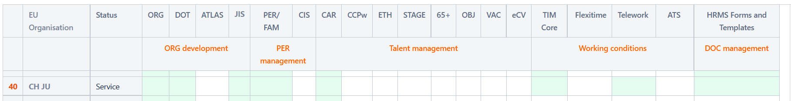

Workshops were organised to introduce the new recruitment tool, Systal. This tool came into production for the JU in November 2021 and the next recruitment will be done by using this system.

Other HR related activities
The Appraisal and reclassification exercise 2021 was carried out and the decision on staff reclassified (4 Temporary agents) was adopted with reclassifications taking effect retroactively on 1 January 2021.
The JU participated in the meetings organised by the European Union Network of Agencies (EUAN), which continued the ‘new ways of working’ meetings giving updates on the different situations in the member states on Covid-19. Learning Network meetings were followed as well, to be informed on the different developments in EU learn and linkedIn learn.

GOVERNANCE

Governing Board
The JU GB comprised three representatives from the EC representing the EU, six representatives from Hydrogen Europe and one from Hydrogen Europe Research.

The GB chair was René Schutte, Director of HyNorth. The vice-chair was Rosalinde van der Vlies, Director of Clean Planet in DG Research and Innovation of the European Commission.

In July 2021, three representatives from Hydrogen Europe left and were replaced by two new
representatives: Patrick Huber (H2 Energy), Melissa Verykios (Helbio), Glenn Llewellyn (Airbus).
During the year, the JU GB held three meetings: 24 March, 18 June and 10 November.

Due to the COVID-19 situation all meetings were virtual.

All the meetings focused on strategic issues and discussions on the progress of the programme and included updates from the members on policy developments and preparations for Horizon Europe.

• The first meeting in March was mainly dedicated to discussions regarding SRIA (ex-MAWP) 2021-2027, AWP 2021, AWP 2022 and strategic priorities, as well as AAR 2020 and the implementation of JRC Annual rolling plan for 2020.

• The June meeting included an update on progress in the SRIA 2021-2027, AWP 2021, AWP 2022 and the preparation of the second European Hydrogen Week.

• In October, the main topics included the latest developments on the set up of the Clean Hydrogen Partnership and its synergies, the state of play of the SRIA 2021-2027, and the FCH 2 JU AWP 2022 but also new JU call 2022 status.

The GB also adopted major decisions by written procedure, including:
- FCH-GB-2021-01 Approval of 26 February 2021 of amendment n°1 to the FCH 2 JU AWP and Budget for 2021
- FCH-GB-2021-02 Approval of 07 April 2021 of independent assessment of aggregate level of IK (FP7) at 31.12.2020
- FCH-GB-2021-03 Approval of 15 June 2021 of the minutes of GB meeting of 24 March 2021
- FCH-GB-2021-04 Approval of 31 May 2021 of amendment n°2 to the FCH 2 JU AWP and Budget for 2021
- FCH-GB-2021-05 Assessment and approval of 15 June 2021 of the FCH 2 JU AAR 2020
- FCH-GB-2021-06 Approval of 30 June 2021 of the FCH 2 JU final accounts for 2020
- FCH-GB-2021-07 Approval of 30 September 2021 of the minutes of GB meeting of 18 June 2021
- FCH-GB-2021-08 Approval of 29 November 2021 of the FCH 2 JU AWP and Budget for 2022
- FCH-GB-2021-09 Approval of 29 November 2021 of amendment n°3 to the FCH 2 JU AWP and Budget for 2021

More information on the role and composition of the FCH 2 JU GB is available at: http://www.fch.europa.eu/page/governing-board

CLEAN HYDROGEN JU
In 2021 the Clean Hydrogen JU had its first Governing Board Meeting on 17 December.
It was dedicated to main important decisions such as:
- CleanHydrogen-GB-2021-01 Approval of 17 December 2021 of the Minutes of the FCH JU GB meeting of 10 November 2021
- CleanHydrogen-GB-2021-02 Rules of procedures of the Governing Board
- CleanHydrogen-GB-2021-03 Omnibus
- CleanHydrogen-GB-2021-04 Specific criteria and selection process for the composition of the Stakeholders Group
In addition, the Chair and vice-chair have been elected (respectively Mr René Schutte and Rosalinde van der Vlies).
More information on the role and composition of the GB is available at: https://www.clean-hydrogen.europa.eu/about-us/organisation/governing-board_en

Executive Director
According to Article 19 of the Council Regulation establishing Clean Hydrogen JU, the ED is the legal representative and the chief executive responsible for the day-to-day management of the JU, in accordance with the decisions of the GB.
Bart Biebuyck was appointed as ED by the JU GB and took up his duties on 16 May 2016. In 2019, his contract was extended until May 2023.

States Representatives Group
During 2021, the States Representatives Group (SRG) met on 5 March, 27 May and 19 October. Among other things, its activities focused on monitoring JU’s achievements and results as well as on preparations for a future partnership, including the following:
• In the June meeting, the main topics included: an update on the Single Basic Act establishing partnerships under Horizon Europe and in particular the “Clean Hydrogen Partnership” as well as coordination mechanisms with other partnerships; an update on the status of the Multi-Annual Work Programme (SRIA or ex-MAWP) 2021-2027; a presentation on the Clean Hydrogen Alliance status and on the results of the study on Fuel Cells Hydrogen Trucks.
• During the May meeting, the SRG members were updated on the status of SRIA 2021-2027 and AWP 2021-2022, as well as on the Single Basic Act establishing partnerships under Horizon Europe and in particular the “Clean Hydrogen Partnership’ including coordination mechanisms with other partnerships and synergies; DG ENER presented HyENet.
• In the November meeting, the Programme Office presented the status of SRIA and Annual Work Programme 2022, as well as the status of tenders/studies in view of potential synergies/collaboration with Members States (incl. alignment of R&I activities). The EC updated the SRG members on the Single Basic Act establishing partnerships under Horizon Europe and in particular the “Clean Hydrogen Partnership”, as well as the Coordination with other partnerships (incl. Clean Energy Transition) and synergies with other initiatives such as ERA.

Scientific Committee
The Scientific Committee (SC) is an advisory body to the GB and comprises a maximum of nine members reflecting a balanced representation of globally renowned expertise from academia, industry and regulatory bodies. The role of the SC is to provide: (a) advice on scientific priorities to be addressed in the annual work plans; and (b) advice on scientific achievements described in the annual activity reports. The SC was consulted on the latter.

Stakeholders Forum
The Stakeholders Forum is one of the FCH 2 JU key governance bodies, which ensures the transparency and openness of the FCH 2 JU programme for all stakeholders, including the public. It also provides opportunities to enhance FCH 2 JU communication activities as it brings together a large number of policymakers and EU stakeholders.
The Stakeholder Forum was integrated in the European Hydrogen Week. The event was held on 29 November 2021, in a hybrid format, with the participation of high-level speakers from the European Commission as well as from the industry and research sectors. The Clean Hydrogen Partnership was launched during the forum, in the presence of the European Commission’s President, Ursula von der Leyen.
Clean hydrogen power is indispensable to Europe’s competitiveness and for limiting global warming to 1.5 degrees Celsius. Europe is leading the global hydrogen energy revolution and needs to ensure it maintains its competitive advantage by integrating systems, developing skills, scaling up projects and removing policy hurdles, said European Commission and industry, speaking at the event.
“This is the time to invest in Europe's leadership on hydrogen, for our own sake and for the world's sake,” European Commission President Ursula von der Leyen said in her opening speech. The EU had started investing in new generation electrolysers before the rest of the world, making it the global leader in patents and publications on this technology, highlighted von der Leyen.
The need for cooperation, for connecting the various stakeholders and sectors, was a recurring theme of the event, as was urgency of turning plans into reality. Decisions on large investments must be synchronised and multiple projects linked to create a snowball effect and build a viable market.
“The synergies and joint agenda have been well identified politically. Now it needs to happen. You can count on Commission services to support this agenda,” said Jean-Eric Paquet, Director General of DG Research and Innovation.
For more information on the European Hydrogen Forum (including the FCH Awards), please see section 2.1.2.

Preparation of Stakeholders Group
In its first meeting on 17/12/2021, the Governing Board of the Clean Hydrogen JU approved the ‘specific criteria and selection process for the composition of the Stakeholders Group. . The Stakeholders Group is an official advisory body, to be consulted on various horizontal issues or specific questions. It shall provide input on the strategic and the technological priorities to be addressed by the JU as laid down in the SRIA; provide suggestions to enable concrete synergies to take place between the JU and the adjacent sectors or any sector with which synergies are deemed of added value and provide input to the European Clean Hydrogen partnership forum and to the European Hydrogen Forum of the Clean Hydrogen Alliance. The Stakeholders Group shall be regularly informed of the activities of the JU and shall be invited to provide comments on the JU’s planned initiatives.
An open Call for Expression of Interest for membership of its Stakeholders Group was launched on the same day and remained open for a month. Following the open call for interest more than 60 applications were received, which shows a high interest in the activities of the JU. On 2 February 2022, the Governing Board selected and appointed the 13 members of the Stakeholders Group, consisting of representatives of most sectors along the hydrogen value chain across the Union, including the representatives of other relevant European partnerships, as well as representatives of the European Hydrogen Valleys Interregional Partnership and of the scientific community. The Stakeholders Group will meet at least twice a year, and the first meeting of its newly members was convened on the 9 February 2022. Considering the continuous need to ensure full sector coverage, as well as geographical and gender balance, the composition of the Stakeholders Group will be reassessed in 2023.

INTERNAL CONTROL FRAMEWORK

Financial Procedures
The financial procedures guide JU operations and set out how it uses and manages its funds and resources. Effective implementation of COMPASS workflows adds efficiency in managing grants. Publication of calls for tenders, managing the calls (in particular questions and publishing answers), submission of offers and opening of tenders is based on IT solutions that significantly reduce the resources expended. The financial circuits were updated in September 2021 following the departure of the Head of Unit for Finance and Administration, acting also as Financial Verifying Agent.

Ex ante Controls on Operational Expenditure
Ex-ante controls are essential to prevent errors and avoid the need for ex-post corrective action. In 2021, the JU continued to apply the provisions of Article 74 of the Financial Regulation and Article 21 of JU Financial Rules: ‘each operation shall be subject at least to an ex-ante control relating to the operational and financial aspects of the operation, on the basis of a multiannual control strategy which takes risk into account’.
Therefore, the main objective of ex-ante controls is to ascertain that the principles of sound financial management have been applied.
The JU has developed and continues to apply well-developed procedures defining the controls to be performed by project and finance officers for every financial claim, invoice, commitment, payment and recovery order, taking into account risk-based and cost-effectiveness considerations.
For operational expenditure, the processing and recording of transactions in the IT accounting system (ABAC) are performed via the corporate Horizon 2020 IT tools (Sygma/COMPASS) for H2020 grants and experts, which ensures a high degree of automation, and the controls are embedded in each workflow.
Ex-ante control activities in 2021 included:
- Assessment of 65 periodic reports;
- Participation of project and finance officers in H2020 project kick-off meetings in order to clearly communicate the financial reporting requirements;
- Targeted webinars focused on the specificities of each project;
- Based on a detailed analysis of the most common audit findings and financial claims, a list of selected beneficiaries (mostly SMEs, and newcomers) was drawn up and a financial questionnaire was sent to them with the purpose of enhancing knowledge of FCH beneficiaries and strengthening their sound financial management and understanding of the H2020 rules;
- As a follow up on the answers of the questionnaires (following risk-fiches of H2020 guidance), targeted bilateral financial webinars with the purpose of enhancing knowledge of FCH beneficiaries and strengthening their sound financial management and understanding of the H2020 rules and an individual follow up was performed;
- Reinforced monitoring and targeted checks during ex-ante controls for interim and final payments in accordance with the H2020 ex-ante control strategy, as published by the CSC Steering Board on 18 December 2020.
In addition, the JU actively contributed to the development of the Horizon Europe control strategy (ex-ante, audit and fraud prevention) by participating to the dedicated working groups set up by the CIC and providing input. The work started in 2020 and continued in 2021.
Due to persistent systemic errors for declared personnel costs, particularly in case of SMEs and new beneficiaries (who are more error-prone than other beneficiaries), the JU has already strengthened its internal control in 2020 to address the increased risk regarding SMEs and new beneficiaries.
In 2021, first results of the pilot project (started in 2020) of reinforced risk-based ex-ante controls among top JU beneficiaries, specifically dedicated to newcomers and SMEs, in terms of error rates reductions, were available, see a table below:
- TABLE: QUANTITATIVE impact of ex-ante webinars project in 2020 and 2021: reduced error rates

 | Ex-post audits (year of launch of the audit) | Representative error rate* SMEs + newcomers (from closed audits as at 31 December 2021)
Before ex-ante webinars | 2017 - 2019 | -2,35%
After introduction of ex-ante webinars | 2020 - 2021 | -0,74%
TOTAL | 2017 - 2021 | -1,99%

The benefits of the reinformed ex-ante controls included, among others the following elements:
- QUANTITATIVE BENEFITS reinforced ex-ante controls via ex-ante webinars - >
- Reduced error rates and reduced amount of ineligible costs;
- Timely corrections of the potential errors at ex-ante level; e.g. an average duration of the entire exercise from the moment of identification of the risky beneficiary until the closure of a follow up action was 6 months as compared to an average duration of a risk-based audit (moment of identification until the Letter of Conclusion for a duration of 24-36 months).
- QUALITATIVE BENEFITS of reinforced ex-ante controls via ex-ante webinars - >
- Preventive measure with a long term effect;
- Learning for both grant officers and beneficiaries;
- Reinforced teamwork and cooperation among officers with technical and financial knowledge.
Thanks to positive results in terms or error rates reductions and encouraging feedback received from the beneficiaries on this initiative, the JU will continue with the reinforced risk-based controls in 2022, with aid of reinforced monitoring tool available in the corporate COMPASS / SYGMA system for H2020 grants management.
COST OF CONTROLS
Recently re-adopted Financial Rules of the JU envisaged that the annual activity report shall indicate the results of efficiency and effectiveness of the internal control systems, including an overall assessment of the costs and benefits of controls.
The principle of efficiency concerns the best relationship between resources employed and results achieved. The principle of effectiveness concerns the attainment of the specific objectives set and the achievement of the intended results.
EFFICIENCY & EFFECTIVENESS
In order to demonstrate effective & efficient use of resources in order to achieve application of sound financial management in all ongoing projects as at 31 December 2021, the following relationship between cost of ex-ante controls (FTE estimate) over the operational expenditure in 2021 was considered:
EFFICIENCY and EFFECTIVENESS OF CONTROLS as at December 2021 | Operational expenditure / running grants | Cost of FTEs in EUR  / FTEs in ex-ante & ex-post controls – estimated | In % on average
Operational expenditure for 2021 in EUR | 95,868.825 | 1,020.500 | 1.06%
Number of running grants as at 31 December 2021 | 82 | 6.5 | 1 FTE / 12.5 grant agreements

The cost for controls represents 1.06% of the JU operational expenditure in 2021 and can be quantified as EUR 12.445 per a running Grant Agreement.
As additional measure of effectiveness, we consider that the residual error rate shows a stable trend over the years, well below 2%. In 2021 we were also able to demonstrate a significant decrease of the error rate with SMEs and newcomers after introduction of the targeted risk-based ex-ante webinars in 2020.
COST AND BENEFITS
In the cost-benefit analysis, JU considered cost of controls employed at ex-ante and ex-post level vs. amount of recoveries and ineligible costs detected either during ex-ante or at ex-post level.
The ratio average cost/average benefit for one running project in 2021 is 1:13 and this is mainly due to the relatively high level of rejected costs.
BENEFITS and COSTS of CONTROLS  as at 31 December 2021 | in EUR | Number of running grants | Average cost of control / average benefit of control per one running grant  in EUR
Costs of ex-ante & ex-post controls in 2021 – estimated | 1,020.500 | 82 | 12.445
Ex-ante rejections | 12,087.692 | 82 | 159.971
Recoveries and ex-post audits adjustments in 2021 | 1,029.921 | 82 | 159.971

The tables above demonstrate measurable benefits of the efficient and effective use of resources in the JU in terms of error rates reduction and efforts to ensure that principles of sound financial management are well understood and followed by the JU beneficiaries. In the long term perspective, we believe that there are other not directly measurable benefits of a preventive nature which will materialize in future.

Ex-post Control of Operational Expenditure and Error Rates identified

The main objectives of the ex-post controls are to ensure that legality, regularity and sound financial management (economy, efficiency and effectiveness) have been respected and to provide the basis for corrective and recovery activities, if necessary.
H2020 programme – ex-post controls, H2020 audit strategy and cooperation with the Common Implementation Centre (CIC)
Ex-post controls of operational expenditure for H2020 are designed and implemented in line with the Horizon 2020 Ex-Post Audit Strategy. For the Horizon 2020, CIC (formerly known as Common Support Centre) developed this audit strategy in cooperation with all of its clients (i.e. the entities that implement the Horizon 2020 budget: EC services, executive agencies and joint undertakings).
RTD.H.2 unit of the CIC, Common Audit Service (CAS) ensures harmonised implementation of the H2020 Ex-Post Audit Strategy for the EU’s research and innovation expenditure, serving all 20 H2020 stakeholders. The CAS uses the IT tool AUDEX for audit process management. Its mission is to deliver a corporate approach for the audit cycle: audit selection, planning, application of rules, relations with beneficiaries, and management information on the audit process.
The main objective of the audit strategy is to provide the individual authorising officers with the necessary elements of assurance in a timely manner, thereby allowing them to report on the budget expenditure for which they are responsible. Ex-post controls on operational expenditure contribute in particular to:
• Assessing the legality and regularity of expenditure on a multi-annual basis;
• Providing an indication of the effectiveness of the related ex-ante controls;
• Providing the basis for corrective and recovery mechanisms, if necessary.
The JU is effectively integrated in this control chain: it participates in the audit process definition and in the monitoring of its implementation in close cooperation with the CAS and its clients. The main objectives of this cooperation are to align operations and exploit synergies on the common audit effort. The efficiency gains will reduce audit costs and the administrative burden on auditees, always in line with the specific objectives explained above for ex-post controls.
The implementation of all ex-post audit results remains the responsibility of the JU.
The JU also ensures the implementation of the research community’s common anti-fraud strategy. The main actions derived from the strategy include the organisation of awareness-raising sessions within the JU and cooperation with the European Anti-Fraud Office (OLAF) (in the case of risk-based audits conducted by the CAS or outsourced contractors). Implementation of the action plan derived from the strategy is monitored by the Fraud and Irregularity Committee (FAIR) – see also section 4.6.
In 2021, the following main achievements were reached:
- Selection of 28 new corrective and representative H2020 ex-post audits in cooperation between JU and CAS (RTD.H.2 unit of the CIC) for execution of the audits in 2022 with expected results (Letter of Conclusion sent) by 31 December 2022, focusing primarily on top 100 beneficiaries;
- By continuous application of the JUs’ sampling methodology (endorsed by the CIC Executive Committee on 19 July 2019), the JU reached a significant cumulative audit coverage (see graph below) of the overall H2020 expenditures forming a strong pillar for the declaration of assurance in 2021;
- Closure of the 43 representative audits by 31 December 2021 (reaching approximately one half of the overall H2020 targets for representative ex-post audits);
- Participation of the JU in the extension of the audit findings exercise, common for all H2020 stakeholders, enabling further cleaning of the representative error rate down to -1,73% of the residual error rate.

Figure 4.3.1

H2020 ex-post audit methodology and error rates – corporate approach
The Common Representative Sample (CRaS) provides an estimate, via a representative sample of cost claims across the research and innovation family, of the overall level of error in the research FPs, across all services involved in its management. All of these grants follow the same homogeneous overall control system set out in this report.
The H2020 ex-post audit strategy builds upon different layers of audits:
- A corporate layer consisting of a CRaS complemented by risk-based samples;
- An additional sample for entities with specific GAs or a separate discharge procedure and Article 10 audits on the demand of the JUs.
In H2020, all 22 implementing entities are expected to follow the same homogeneous overall ex-ante control system.
The Horizon 2020 audit campaign started in 2016. At this stage, four Common Representative Samples with a total of 629 expected results have been selected. By the end of 2021, cost claims amounting to EUR 31.8 billion have been submitted by the beneficiaries to the services.
The error rates at 31 December 2021 were:
- Representative detected error rate: 2,29%,
- Cumulative residual error rate for the Research and Innovation Family DGs: 1,60 % (1,67 % for DG Research and Innovation).

H2020 ex-post audit methodology and error rates – JU approach
For classification, reporting and error-rate calculation purposes, the JU distinguishes between representative and corrective audits. Corrective audits are defined as all audits which were not selected by statistically representative sampling.
Chart: H2020 ex-post audit strategy at the JU – classification of the ex-post audits

Given the relatively small share of the Clean Hydrogen’s budget (target for H2020 overall EC contribution of EUR 665 million: 1 %) compared to the overall H2020 target budget (EUR 63 584 million: 100 %), the number of participations selected for ex-post audit by the CAS via the CRaS is very limited.
This observation was further confirmed by the fact that in the four rounds of CRaS (629 participations), there were only three JU participations directly hit by the monetary unit sampling. The items hit by CRaS are considered as representative for calculation of the JU specific error rates.
By 31 December 2021 there were two results available and incorporated into the JU specific error rate calculation.
In addition to CRaS samples and in line with Annex 1 to the H2020 ex-post audit strategy, the JU planned for additional audit sampling (i.e. JUs’ specific sample) in order to ensure sufficient ex-post audit coverage and enable a representative error rate on JU expenditure to be calculated over time. This is necessary to provide reasonable assurance to the JU Executive Director in view of his declaration of assurance and the separate discharge procedure for the JU.
By 31 December 2021, the JU had selected 153 participations for ex-post audits (compared to the estimated target of 295 participations audited for the whole H2020 programme).
As observed in the table and graphs below, the JU is approximately in the middle of the H2020 campaign, reflecting a progressive validation of the H2020 expenditures in the ongoing actions.
Table 4.3.6: Ex-post audits in-progress table at 31 December 2021 - completeness status
H2020 audits with JU participations | Number of participations
H2020 audits with JU participations | Closed | Ongoing | To be selected | H2020 overall target
Total up to 31 December 2021 | 92 | 61 | 142 | 295

Figure 4.3.2

In 2021, the JU validated cost claims totalling EUR 159.78 million (EUR 88.14 million in 2020), of which EUR 88.62 million represented the EU contribution (EUR 70.03 million in 2020).
Of this EUR 88.62 million, throughout the year the JU selected corrective and representative audits to target overall audit coverage of around 20 % of H2020 expenditure, as per the table below.
Table 4.3.7: Ex-post audits in-progress table as at 31 December 2021 – direct audit coverage
YEAR | JU contribution in mil. EUR
YEAR | Accepted by the JU | Selected for ex-post audits | Cumulative coverage | Audits closed | Cumulative coverage
2017 | 37.09 | 8.14 | 21.96% | 8.14 | 21.96%
2018 | 58.65 | 10.80 | 19.79% | 10.80 | 19.79%
2019 | 98.53 | 27.27 | 23.79% | 27.27 | 23.79%
2020 | 70.03 | 47.50 | 35.46% | 9.09 | 20.92%
2021 | 88.62 | 17.38 | 32.59% | 0.00 | 15.67%
Total up to 31 December 2021 | 352.91 | 111.09 | 31.48% | 55.30 | 15.67%

Figure 4.3.3

Representative audits were selected following the common JUs’ sampling methodology. This methodology was built on the principles of stratified random sampling (which is similar to the method used by the FCH JU in FP7) with the following objectives:
- Efficient use of resources
- Focusing on large-value cost claims
- Providing an overview of the full range of projects and beneficiaries in the JU programme
- Ensuring representability of the results, as per the International Standards on Auditing.
Risk-based audits in 2021 were selected by applying an analytical approach of reviewing the inherent risk and exposure profiles of JU beneficiaries (first step). In the second step, the selected beneficiaries were assessed internally by the project and financial officers to validate a rationale and specific risks involved in projects signed with those beneficiaries.
As a result of this approach, nine beneficiaries were selected for the risk-based audits, following a discussion with the operational services.
For efficiency purposes, all available cost claims validated by the JU until the audit was launched, if available, were added to the selection.
Distribution of the coverage of two main audit streams is captured in the table and graph below.
Table 4.3.8: Ex-post audits in-progress table as at 31 December 2021 - classification of participations selected for ex-post audits
YEAR | JU contribution in mil. EUR
YEAR | Corrective | Representative | Total
2017 | 4.98 | 3.16 | 8.14
2018 | 2.59 | 8.22 | 10.80
2019 | 14.66 | 12.61 | 27.27
2020 | 20.68 | 26.81 | 47.50
2021 | 10.30 | 7.08 | 17.38
Total up to 31 December 2021 | 53.21 | 57.88 | 111.09

Figure 4.3.4

JU specific error rates for H2020
For the calculation of the JU representative error rate, only results coming from the items either directly hit by JU sampling or by MUS sampling of the CRaS are taken into consideration.
Results of 43 representative items were used to calculate an indicative cumulative representative error rate on H2020 expenditure specific to the JU, as at 31 December 2021:
Representative error rate on JU contribution: -3.84%
Residual error rate on JU contribution: -1.73%

FP7 programme
The JU ex-post controls of FP7 grants included financial audits carried out by external audit firms.
In 2021 no new audits were launched on FP7 projects. The last batch of FP7 audits launched in November 2019 was completed and finalised in 2020, with an ongoing implementation in 2021.

Ex-post audits – coverage
The following table gives an overview of the number of ex-post audits and their audit coverage:

Table 4.3.2: Number of audits and audit coverage, cumulative²⁵

Batch | Year | To be launched | On-going | Finalised | TOTAL | Of which
 |  |  |  |  |  | Representative | Risk-Based
1 to 12 | 2011 to 2019 | 0 | 0 | 145 | 145 | 120 | 25
Total (audits) |  | 0 | 0 | 145 | 145 | 120 | 25
Total (cost claims) |  |  |  |  | 574
Total costs accepted by FCH JU (cumulative) (in €) (A) |  |  |  |  | 852,333,828
Total costs of audits launched (cumulative) (in €) (B) |  |  |  |  | 189,657,854
Total costs of audits finalised (cumulative) (in €) (C) |  |  |  |  | 189,657,854
Direct audit coverage of total audits (in %) (B/A) |  |  |  |  | 22%
Direct audit coverage of finalised audits (in %) (C/A) |  |  |  |  | 22%
Total FCH JU beneficiaries (D) |  |  |  |  | 561
FCH JU beneficiaries audited (E) |  |  |  |  | 142
Audit coverage (number of benef.) of total audits (in %) (E/D) |  |  |  |  | 25%

In conclusion, for the whole Programme FP7, 145 ex-post audits have been launched of which 120 were representative and 25 risk-based, covering in total EUR 189.66 million of accepted costs declared by the beneficiaries, with an average sum of EUR 1.31 million of accepted costs per individual audit.
This resulted in direct audit coverage of 25 %, from all validated costs claims by the FCH for all 155 projects totalling EUR 852.33 million since the beginning of the FP7 Programme (as at 31 December 2021).
Ex-post audits – error rates
The error rates resulting from the 145 finalised audits are as follows:
Representative error rate on the FCH contribution: -1.97%
Residual error rate on the FCH contribution: -1.11%
Implementation of audit results
The JU has implemented the necessary controls and monitoring mechanisms to ensure that all errors detected in favour of the JU are corrected in due course (either through a recovery order or by offsetting a future payment).
Since the last FP7 audits were finalised in the end of the year 2020, implementation of the audit results was still ongoing in 2021 in line with the implementation rules and legal deadlines for the FP7 programme.
As at 31 December 2021, JU has cumulatively implemented positive adjustments on JU contribution at the amount of EUR 2.24 million, stemming from the results of 145 FP 7 ex-post audits.
Implementation of extrapolation/’extension of audit findings’
Extension of the audit findings (formerly known as ‘extrapolation’) is the process whereby ‘systematic’ errors detected in audited cost claims are ‘extrapolated’ to all other non-audited JU claims from the same audited beneficiary. The timely implementation of extension of audit findings relies on beneficiaries preparing and submitting revised cost claims from which the effect of any systematic error(s) detected in audits has been eradicated.
The overall situation on the implementation of the extension of audit findings in the FP7 programme, is the following:
- From 145 finalised FP7 audits, 44 audits (81 projects) were concerned by extrapolation (30%), in other words, one out of 3 audits included findings of potentially systemic nature;
- As part of the FP7 audit engagements with the external audit firms, all the cost claims potentially impacted by the extrapolation were assessed by the audit firm and the results were presented to JU for the implementation.

ECA audits
In 2020, the ECA started to perform additional systems testing at the relevant JU.
This additional testing, based on a MUS sample of 30 transactions should provide the additional assurance required to assess the implementation of H2020 and FP7 projects, and ensure the quality of the audit opinion, in line with auditing standards. In view of COVID-19 situation, and to ensure the efficient use of audit resources, ECA have requested that the necessary supporting documents be provided by the JU or final beneficiary, to perform desk reviews, rather than on-site visits.
In respect of the individual discharge for each of the JUs, ECA will continue to provide each JU with a separate audit opinion.
The opinion on the legality and regularity of underlying transactions will be assessed separately taking into account the following elements:
- the JU individual error rate of the ex-post audits;
- the common error rate based on the results of our substantive testing;
- the error rate related to the transactions of a specific JU within our substantive testing; and
- the correctness of the calculation of the residual error rate reported by the JUs, based on the ex-post audit results for their grant payments.
In 2021 and early in 2022, ECA has selected and reviewed 4 transactions (out of 30) from JU participations validated in 2021.
COVID-19 considerations in H2020 ex-post audits
As a result of the COVID-19 pandemic crisis and related travel limitations during 2020 and in 2021, the Common Audit Service (CAS) – in line with the instructions of the Commission – had to postpone on-the-spot missions until further notice. To minimise the impact of COVID-19 on the implementation of the audit campaign, the CAS converted traditional in-house audit assignments into desk reviews, in line with international best practice and auditing standards. Regarding outsourced audits, the CAS instructed the audit firms to perform remotely the maximum possible amount of audit tests while complementing those with on-the-spot audit missions once travel restrictions were eased.

Audit of the European Court of Auditors

In 2021, the JU:
- Continued its cooperation with an independent auditor to audit JU accounts, as required by the JU financial rules;
- Provided support for the ECA auditors in the framework of their audit on the 2020 accounts;
- Liaised with ECA in their review of 4 transactions selected for the on-the-spot checks with the JU beneficiaries;
- Followed up and implemented the recommendations made in the European Court of Auditors’ reports on the 2020 JU annual accounts;
- Assisted ECA in their preliminary review of the accounts and legality and regularity checks conducted in connection with the 2021 annual account;
- Assisted ECA in their newly announced horizontal audit on Commission’s staff planning for JUs under the new programme Horizon Europe (HE) and the consequences and risks for the JU which was announced in December 2021.

Internal Audit
The internal audit is carried out according to Article 20 of the JU financial rules.
In 2021, the Internal Audit Service (IAS) accepted an action plan developed by the JU to address two important recommendations stemming from the IAS Audit on Horizon 2020 grant implementation in the Fuel Cells and Hydrogen 2 Joint Undertaking and concluded that the action plan is adequate to mitigate the risks identified.
In 2021, in line with the agreed action plan, the JU formalised the current monitoring practices regarding risks and complexity of the grant agreements and has developed an internal guidance for monitoring D&E of the H2020 project results – mostly referring to the D&E monitoring after the end of the projects lifetime.
The JU shared general observations and recommendations (including the recommendations as raised by the IAS) concerning the implementation of the D&E plan in the letter to the director of the CIC to which we have also obtained a reply.
By the end of 2021, the JU considered all action plans as fully implemented.

Risk management and Conflict of Interest
Risk management
During the annual risk assessment workshop, held in October 2021, the JU team focused on critical risks affecting the achievement of the JU objectives as well as action plans that had been identified in the previous year, and assessed their adequacy and relevance for 2020 and 2021 – for the activities of H2020 programme which would continue also in the year 2022.
Additionally, in preparing for the transition to the next Clean Hydrogen Partnership/JU, there were other transitional risks already identified. Early in 2022, an additional risk assessment exercise was conducted in order to prepare a new input for an updated version of the AWP 2022, including objectives and activities under the new partnership.
The full list of important risks and related action plans identified can be found in the AWP 2022.
A complete risk matrix (including lower-priority risks) is regularly assessed and discussed by management, as part of an ongoing risk assessment process, to reflect on any changes in the organisation’s internal and external environment. This exercise, part of the internal control system, is designed to capture, in a timely way, any new and emerging risks that could potentially influence the achievement of the JU objectives, as well as to provide timely reflection on the rating and relevance of the existing risks to ensure that appropriate actions and mitigating measures are put in place.
The revision of the entire risk matrix is planned for Q2 of 2022, during which also newly emerged situation - Ukrainian war and its impact on the JU work plan and its activities will be considered.
Managing potential conflict of interest
The Programme Office has developed a comprehensive set of rules and procedures that are effectively implemented across its entire governance structure, as follows:
- When joining the Programme Office team, each staff member agrees to the application of the Staff Regulation and signs a declaration of honour on the management of conflicts of interest.
- With ED decision of 27/09/2019, the JU applies by analogy ‘mutatis mutandis’ the ‘Code of Good Administrative Behaviour for Staff of the European Commission in their Relations with the Public’.
- Conflict of interest procedures were in place for the members of both the FCH 2 JU GB and the advisory bodies and were renewed in December 2021 in the scope of newly adopted Rules of Procedures of the Governing Board for the Clean Hydrogen JU.
- Specific measures have been implemented for the prevention and management of conflicts of interest of experts in charge of the evaluation of grant applications and of the review of projects and tenders.
In addition, the JU implements the common Research Anti-Fraud Strategy. In March 2019, the CIC adopted the revised Strategy (RAFS 2019) and the associated action plan. The implementation of the action plan is monitored through regular meetings of FAIR in which the JU participates.
Furthermore, for areas of expenditure other than grants, the JU applies mutatis mutandis by analogy the anti-fraud strategy of DG R&I. This is relevant in particular for expert management, procurement and internal fraud and the risk analysis leads to the conclusion that the residual risks (after mitigating actions) are low.

4.7. Compliance and effectiveness of internal control
The JU internal control framework is designed to provide reasonable assurance regarding the achievement of the following five objectives:
- Effectiveness, efficiency and economy of operations;
- Reliability of reporting;
- Safeguarding of assets and information;
- Prevention, detection, correction and follow-up of fraud and irregularities, and
- Adequate management of the risks relating to the legality and regularity of the underlying transactions.
In line with the objectives and priorities described in the AWP 2021, the robustness of the internal control system was monitored throughout the year. Internal control matters, such as ex-ante and ex-post controls, segregation of duties, documented processes and procedures and sound financial management, were discussed at least on a weekly basis during unit meetings and on an ad-hoc basis when preparing new processes or revising existing operating processes. Risks identified through the annual risk assessment exercise (see sections 1.1 and 4.6), which might pose a threat to achieving the JU’s mission and objectives, were also systematically assessed and managed through appropriate controlling and mitigating actions. Throughout the year, particular efforts were made to monitor the KPIs, which led to further improvement in financial management as indicated by the TTP.
Register of exceptions, analysis of internal control weakness or control failures recorded during 2021
The Programme Office keeps a register of all exceptions and non-compliance events; reports are entered into the register through a dedicated procedure and using pre-defined templates. The central register is reviewed regularly by the Head of Finance and Administration, the Internal Audit Service (IAS) and, in the course of the Declaration of Assurance (DAS) procedure, by the European Court of Auditors (ECA). The reasons of the events reported in 2021 have been analysed by JU management in order to further strengthen the internal control system and ensure compliance with rules and procedures. Related risks and financial impacts have been assessed and monitored when material, corrective measures were introduced (e.g. internal instructions). Other deviations considered of limited relevance after management assessment were controlled and documented in appropriate notes to the file.
Reliability of financial reporting and accounting
In addition, DG BUDG carried out its annual evaluation of the Undertaking’s local financial by reviewing the information on changes in the local systems and/or in the control environment. The DG BUDG team also verified a sample of transactions for the operations authorised by the JU during the 2020 financial year. The evaluation did not identify any weaknesses in the internal control systems which would materially affect the accuracy, completeness and timeliness of the information required to draft the annual accounts and produce reliable reporting.
The self-assessment of the effectiveness of the internal control framework in 2021 was based on:
- an objective examination of reports and assessments carried out by management and by internal (Internal Audit Service) and external auditors (independent auditors on the annual accounts and the European Court of Auditors)
- the management’s overview on progress made on the implementation of the corresponding action plans.

The latter was implemented in the following ways:
- In 2021, we continued trainings and awareness sessions on cyber-security, phishing, etc. The IT systems have continuously been updated.
- In 2021, mitigating measures to overcome COVID-19 pandemic were implemented, including: vaccinations, limits on the presence of the % of the people physically in the office, reinforced use of teleworking, adopting new ways of hybrid working, etc.
Assessment of the functioning of internal control system
In conclusion, it can be confirmed that the JU is in compliance with all the principles, the controls in place are working as intended, and the internal control system is providing an effective framework for managing any risks to the JU’s ability to achieve its objectives.

MANAGEMENT assurance

Assessment of the Annual Activity Report by the Governing Board
This section will be provided separately

Elements supporting assurance
Reasonable assurance is the personal judgement of the JU’s Executive Director – as the JU's authorising officer at the date of signature of this Annual Activity Report – based on all the information at his disposal.
The main elements supporting the assurance are based on the JU’s management assessment of the robustness of the JU’s Internal Control Framework, the results of audits from the ECA and the IAS, the reporting from the internal control and audit manager, and the reporting from the heads of unit.
No significant weaknesses were identified or reported under Section 2 (‘Support to Operations’) and Section 4 (‘Internal Control Framework’). Furthermore, based on their review, the heads of unit consider that, given the scope of the statement of assurance and taking into account the controls and monitoring system in place, there are no weaknesses that could call into question the reasonable assurance as to the use of resources for their intended purpose, in accordance with the principles of sound financial management, and the fact that the implemented control procedures provide the necessary guarantees on the legality and regularity of the underlying transactions.

Reservations
H2020 programme
The indicative representative error rate resulting from the 43 representative audits finalised is 3.84 % (2020: -2.16 %) at JU contribution level.
The residual error rate (i.e. error remaining in the population after corrections and recoveries) calculated at this point is 1.73 % (2020: -1.34 %) at JU contribution level. This rate should develop as more audits are closed and more corrections and recoveries undertaken.
Taking into consideration:
• The residual error rates below 2 % at this point in time
• The adequate audit coverage, comprising a representative number of finalised audits
• The experience gained by JU staff in the ex-ante validation of costs claims
• The JU’s strong and further reinforced risk-based ex-ante controls (financial webinars, etc.)
no reservation is necessary. In the opinion of the Executive Director, considering the aspects above and with the information available at this stage, it is possible to state with reasonable assurance that by the end of the programme the residual error rate will be below the materiality threshold (i.e. 2 %) established in Annex 9 (‘Materiality criteria’).

FP7 programme
The representative error rate resulting from the 145 representative audits finalised is stable 1.97 % (2020: -1.97 %) at the JU contribution level.
The residual error rate (i.e. error remaining in the population after corrections and recoveries) is 1.11 % (2020: 1.01 %) at JU contribution level. This rate is final as all FP7 audits were closed.
JU actions towards an acceptable level of residual error rate:
The declaration of assurance in 2020 did not include a reservation, as is the case in 2021. This is the result of the JU’s firm commitment to maintain a robust internal control system where ex-post audits play a significant role. The residual error rate is a key indicator of the legality and regularity of the JU’s transactions.
The JU actions include a combination of preventive, detective and corrective measures and they are closely monitored. The measures/actions are as follows:

• Organisation of financial webinars to explain key aspects of the financial provisions of the H2020 Model Grant Agreement and of financial reporting with a focus on specificities and business models pertinent to the JU and aiming to prevent errors. Since 2016, for all new signed grants, specific targeted financial webinars have been organized within the first year following the start of the action, which are available to all members of the consortia (see also section 4.2).

• Greater involvement by the financial officers during grant agreement preparations and in project kick-off meetings in order to check the financial aspects and clarify financial reporting requirements.

• Ad-hoc financial webinars for individual projects, depending on the complexity of the project and needs of the beneficiaries.

• Since 2020, bilateral targeted webinars with beneficiaries selected based on risk-assessment.

• Ex-ante controls consistent with the guidelines on ex-ante controls in H2020, adopted by the CIC, which are predominantly risk-based and/or justified by deviations from the budget.

• Ex-post audits: as indicated in the sections on H2020 ex-post audits above, the JU will ensure that, in line with Annex 1 to the H2020 Audit Strategy, the audit effort is sufficient to allow for adequate coverage and the calculation of a representative error rate on JU expenditure.

• Participation by the financial officers in the ex-post audits as observers to further improve the system of ex-ante controls.

The JU has a clear control strategy which is multi-annual in nature and combines ex-ante and ex-post controls while taking cost-efficiency into consideration. Since this strategy has proved its effectiveness from an assurance point of view, the JU is fully committed to continuing its work along the same control principles and to further improve in the upcoming Horizon Europe framework programme.

Overall conclusion

The purpose of this section is to provide an overall conclusion on the declaration of assurance as a whole (section 6).
It is important to note that only material weaknesses/risks lead to any reservation concerning the assurances in section 6. The concept of ‘materiality’ provides the Executive Director with the basis for assessing the importance of the weaknesses/risks identified. Deciding whether something is material involves making a judgement in both qualitative and quantitative terms (see details on the Materiality criteria in Annex 9).
Based on the information provided in the sections above, the following conclusions can be drawn.
- Concerning the JU’s policy activities, no qualification needs to be made. Likewise, there is no reservation in the procedures relating to the selection of contractors and beneficiaries for JU grant agreements and their underlying financial operations (legal and financial commitments). This is also the case for JU’s payments relating to administrative expenditure and procurement, as well as for pre-financing payments in the case of grants.
- The amounts with a greater risk of being affected by errors are the expenditures incurred against cost statements. Based on the analysis of error rates and the effectiveness of the preventive, detective and corrective actions presented in section 5.3, no reservation is necessary in this area either.
In conclusion, the JU’s management has reasonable assurance that, overall, suitable controls are in place and are working as intended, risks are being properly monitored and mitigated, and necessary improvements noted by the auditors (i.e. the EC’s IAS and the ECA) are being implemented. Therefore, the Executive Director, in his capacity as authorising officer, has signed the declaration of assurance presented in section 6.

Statement on management reporting
For the Manager in charge of risk management and internal control:
I declare that in accordance with the JU Governing Board decision No FCH-GB-2018-12 on Revision of FCH 2 JU internal control framework, I have reported my advice and recommendations on the overall state of internal control in the JU to the Executive Director.
I hereby certify that the information provided in the present Annual Activity Report and in its annexes is, to the best of my knowledge, accurate and complete.
Brussels, 22 April 2022
signed
Philippe Binet, Head of Finance and Administration
For the Manager taking responsibility for the completeness and reliability of management reporting on results and on the achievement of objectives:
I hereby certify that the information provided in the present Annual Activity Report and in its annexes is, to the best of my knowledge, accurate and complete.
Brussels, 22 April 2022
signed
Mirela Atanasiu, Head of Unit Operations and Communications

DECLARATION OF ASSURANCE
I, the undersigned, Bart Biebuyck
Executive Director of the Clean Hydrogen JU
In my capacity as authorising officer
Declare that the information contained in this report gives a true and fair view.
State that I have reasonable assurance that the resources assigned to the activities described in this report have been used for their intended purpose and in accordance with the principles of sound financial management, and that the control procedures put in place give the necessary guarantees concerning the legality and regularity of the underlying transactions.
This reasonable assurance is based on my own judgement and on the information at my disposal, such as the results of the self-assessment, ex-post controls, the work of the internal control and audit manager, the observations of the Internal Audit Service and the lessons learnt from the reports of the Court of Auditors for years prior to the year of this declaration.
Confirm that I am not aware of anything not reported here which could harm the interests of the Joint Undertaking.
Brussels, 30 April 2022

signed
Bart Biebuyck

ANNEXES

Annex 1 – Organisational chart
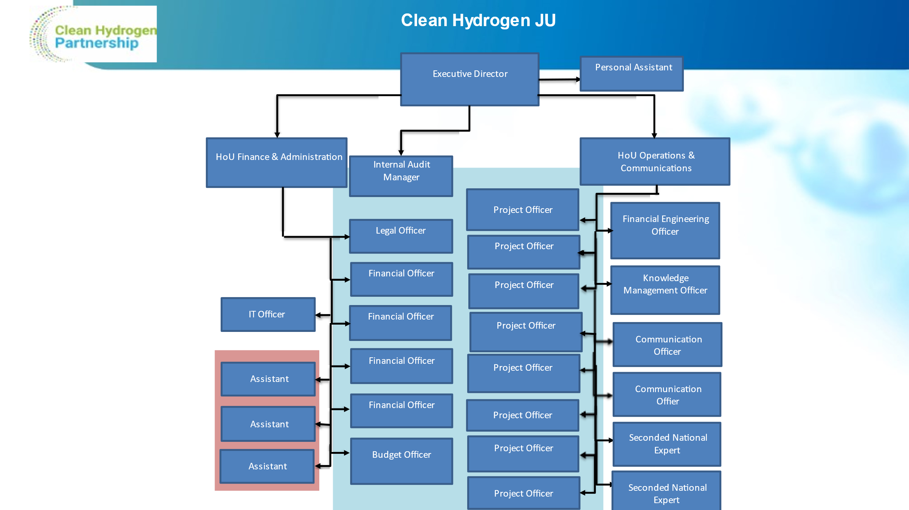

Annex 2 – Staff Establishment Plan

The JU had 23 temporary agents, 2 contract agents and 2 SNEs on 31/12/2021.
The 2020-2021 staff establishment plan is shown below:
Grade | 2020 budget | 2020 filled | 2021 budget | 2021 filled
AD 16
AD 15
AD 14 | 1 | 1 | 1 | 1
AD 13
AD 12 |  |  | 2 | 1
AD 11 | 2 | 2
AD 10
AD 9 | 4 | 4 | 5 | 4
AD 8 | 4 | 4 | 3 | 1
AD 7 | 1 | 1 | 2 | 2
AD 6 | 3 | 3 | 2 | 5
AD 5
Total AD | 15 | 15 | 15 | 14
AST 11
AST 10
AST 9 | 1 | 1 | 1 | 1
AST 8 | 1 | 1 | 1 | 1
AST 7 | 1 | 1 | 1 | 1
AST 6 | 1 | 1 | 1
AST 5 | 1 | 1 | 2 | 1
AST 4 | 4 | 4 | 3 | 5
Total AST | 9 | 9 | 9 | 9
Function Group IV | 1 | 1 | 1 | 1
Function Group III | 1 | 1 | 1 | 1
Function Group II | 1 | 1 | 1
Total  contract agents | 3 | 3 | 3 | 2
Total  Seconded National Experts | 2 | 2 | 2 | 2

Annex 3 - Publications from projects
Publications related to H2020 projects. Information extracted from CORDA for the years 2020 and after, that were not already included in AAR2020. For previous years, please refer to our past Annual Activity Report publications.
Project Acronym | CR Publ Type | CR Publ Title | CR Publ DOI | CR Publ ISSN | CR Publ Authors | CR Publ Journal Title | CR Publ Journal Nbr | CR Publ Publisher | CR Publ Published Place | CR Publ Published Year | CR Publ Relevant Pages | CR Publ Is Joint Public/Private ? | CR Publ In Green O-A ? | CR Publ Repository URL
ANIONE | CONFERENCE_PROCEEDING | Green hydrogen production by innovative membrane electrolysis technologies |  |  | Antonino Salvatore Aricò, Stefania Siracusano, Sabrina Campagna Zignani, Alessandra Carbone | Electrolysers, Fuel Cells & H2 Processing, Proceedings of EFCF 2021 Conference, | EFCF-2021_PoC_Proceedings_A-Sessions_ConfVersion_s | European Fuel Cell Forum AG | Luzern-Adligenswil / Switzerland | 2021 | 123-127 | No | Yes | www.Zenodo.org
CHANNEL | PEER_REVIEWED_ARTICLE | Tuning Ni–MoO2 Catalyst–Ionomer and Electrolyte Interaction for Water Electrolyzers with Anion Exchange Membranes | 10.1021/acsaem.0c03072 | 25740962 | Alaa Y. Faid, Alejandro Oyarce Barnett, Frode Seland, Svein Sunde | ACS Applied Energy Materials | 4/4 | ACS Publications American Chemical Society | Washington, USA | 2021 | 3327-3340 | Yes | No
ComSos | PEER_REVIEWED_ARTICLE | Fuel cell cogeneration for building sector: European status |  | 1307-3729 | Marta Gandiglio, Domenico Ferrero, Andrea Lanzini, Massimo Santarelli | REHVA Journal (REHVA is the Federation of European Heating, Ventilation and Air Conditioning) | 01/2020 (Volume: 57 Issue: 1 February 2020) | Publisher TEKNİK SEKTÖR YAYINCILIĞI A.Ş | Barbaros Mahallesi, Uğur Sk. No: 2/2 Üsküdar/İstanbul, Turkey | 2020 | Pages 21-25 | No | No
ComSos | PEER_REVIEWED_ARTICLE | Installation of fuel cell-based cogeneration systems in the commercial and retail sector: Assessment in the framework of the COMSOS project | 10.1016/j.enconman.2021.114202 | 01968904 | F. Accurso, M. Gandiglio, M. Santarelli, J Buunk, T. Hakala, J. Kiviaho, S. Modena, M. Münch, E. Varkaraki | Energy Conversion and Management | 239 | Pergamon Press Ltd. | United Kingdom | 2021 | 114202 | Yes | No | http://hdl.handle.net/11583/2899252
COSMHYC XL | ARTICLE | Hydrogen Compression with Metal Hydrides - Novel compression concept for hydrogen refueling stations based on metal hydrides |  | 2367-3931 | Jan Zerhusen | H2international - The e-journal on hydrogen and fuel cells | 04 | Hydrogeit Verlag | Oberkraemer, Germany | 2021 | 34-36 | No | No
CRESCENDO | PEER_REVIEWED_ARTICLE | A comparative perspective of electrochemical and photochemical approaches for catalytic H2O2 production | 10.1039/d0cs00458h | 03060012 | Yanyan Sun, Lei Han, Peter Strasser | Chemical Society Reviews | 49/18 | Royal Society of Chemistry | United Kingdom | 2020 | 6605-6631 | No | No | https://zenodo.org/deposit/5607364
CRESCENDO | PEER_REVIEWED_ARTICLE | Advancements in cathode catalyst and cathode layer design for proton exchange membrane fuel cells | 10.1038/s41467-021-25911-x | 20411723 | Yanyan Sun, Shlomi Polani, Fang Luo, Sebastian Ott, Peter Strasser, Fabio Dionigi | Nature Communications | 12/1 | Nature Publishing Group | United Kingdom | 2021 |  | No | No | https://zenodo.org/record/5643621
CRESCENDO | PEER_REVIEWED_ARTICLE | Deactivation, reactivation and super-activation of Fe-N/C oxygen reduction electrocatalysts: Gas sorption, physical and electrochemical investigation using NO and O2 | 10.1016/j.apcatb.2021.120169 | 09263373 | Paul Boldrin, Daniel Malko, Asad Mehmood, Ulrike I. Kramm, Stephan Wagner, Stephen Paul, Natascha Weidler, Anthony Kucernak | Applied Catalysis B: Environmental | 292 | Elsevier BV | Netherlands | 2021 | 120169 | No | Yes | https://spiral.imperial.ac.uk/handle/10044/1/87903
CRESCENDO | PEER_REVIEWED_ARTICLE | Effects of the induced micro- and meso-porosity on the single site density and turn over frequency of Fe-N-C carbon electrodes for the oxygen reduction reaction | 10.1016/j.apcatb.2021.120068 | 09263373 | Marco Mazzucato, Giorgia Daniel, Asad Mehmood, Tomasz Kosmala, Gaetano Granozzi, Anthony Kucernak, Christian Durante | Applied Catalysis B: Environmental | 291 | Elsevier BV | Netherlands | 2021 | 120068 | No | No | https://zenodo.org/record/5607330
CRESCENDO | PEER_REVIEWED_ARTICLE | Establishing reactivity descriptors for platinum group metal (PGM)-free Fe–N–C catalysts for PEM fuel cells | 10.1039/d0ee01013h | 17545692 | Mathias Primbs, Yanyan Sun, Aaron Roy, Daniel Malko, Asad Mehmood, Moulay-Tahar Sougrati, Pierre-Yves Blanchard, Gaetano Granozzi, Tomasz Kosmala, Giorgia Daniel, Plamen Atanassov, Jonathan Sharman, Christian Durante, Anthony Kucernak, Deborah Jones, Frédéric Jaouen, Peter Strasser | Energy & Environmental Science | 13/8 | Royal Society of Chemistry | United Kingdom | 2020 | 2480-2500 | No | No | https://hal.archives-ouvertes.fr/hal-03024561
CRESCENDO | PEER_REVIEWED_ARTICLE | Highly Graphitized Fe-N-C Electrocatalysts Prepared from Chitosan Hydrogel Frameworks | 10.3390/catal11030390 | 20734344 | Giorgia Daniel, Tomasz Kosmala, Federico Brombin, Marco Mazzucato, Alessandro Facchin, Maria Chiara Dalconi, Denis Badocco, Paolo Pastore, Gaetano Granozzi, Christian Durante | Catalysts | 11/3 | Multidisciplinary Digital Publishing Institute (MDPI) | Switzerland | 2021 | 390 | No | No | https://zenodo.org/record/5607307
CRESCENDO | PEER_REVIEWED_ARTICLE | Identification of durable and non-durable FeNx sites in Fe–N–C materials for proton exchange membrane fuel cells | 10.1038/s41929-020-00545-2 | 25201158 | Jingkun Li, Moulay Tahar Sougrati, Andrea Zitolo, James M. Ablett, Ismail Can Oğuz, Tzonka Mineva, Ivana Matanovic, Plamen Atanassov, Ying Huang, Iryna Zenyuk, Andrea Di Cicco, Kavita Kumar, Laetitia Dubau, Frédéric Maillard, Goran Dražić, Frédéric Jaouen | Nature Catalysis | 4/1 | Springer Nature | United Kingdom | 2021 | 10-19 | No | Yes | https://hal.archives-ouvertes.fr/hal-02931434
CRESCENDO | PEER_REVIEWED_ARTICLE | Impact of ionomer structuration on the performance of bio-inspired noble-metal-free fuel cell anodes | 10.1016/j.checat.2021.01.001 | 26671093 | Nathan Coutard, Bertrand Reuillard, Tran Ngoc Huan, Fabrice Valentino, Reuben T. Jane, Solène Gentil, Eugen S. Andreiadis, Alan Le Goff, Tristan Asset, Frédéric Maillard, Bruno Jousselme, Adina Morozan, Sandrine Lyonnard, Vincent Artero, Pascale Chenevier | Chem Catalysis | 1/1 | Elsevier | The Netherlands | 2021 | 88-105 | No | No | https://hal-cnrs.archives-ouvertes.fr/hal-03126604
CRESCENDO | PEER_REVIEWED_ARTICLE | Noncovalent Integration of a Bioinspired Ni Catalyst to Graphene Acid for Reversible Electrocatalytic Hydrogen Oxidation | 10.1021/acsami.9b18922 | 19448244 | Bertrand Reuillard, Matías Blanco, Laura Calvillo, Nathan Coutard, Ahmed Ghedjatti, Pascale Chenevier, Stefano Agnoli, Michal Otyepka, Gaetano Granozzi, Vincent Artero | ACS Applied Materials & Interfaces | 12/5 | American Chemical Society | United States | 2020 | 5805-5811 | No | No | https://hal.archives-ouvertes.fr/hal-02468287
CRESCENDO | PEER_REVIEWED_ARTICLE | Stable, Active, and Methanol-Tolerant PGM-Free Surfaces in an Acidic Medium: Electron Tunneling at Play in Pt/FeNC Hybrid Catalysts for Direct Methanol Fuel Cell Cathodes | 10.1021/acscatal.0c01288 | 21555435 | Tomasz Kosmala, Nicolas Bibent, Moulay Tahar Sougrati, Goran Dražić, Stefano Agnoli, Frédéric Jaouen, Gaetano Granozzi | ACS Catalysis | 10/14 | American Chemical Society | United States | 2020 | 7475-7485 | No | No | https://hal.umontpellier.fr/hal-02918327
CRESCENDO | PEER_REVIEWED_ARTICLE | Sulfur Doping versus Hierarchical Pore Structure: The Dominating Effect on the Fe–N–C Site Density, Activity, and Selectivity in Oxygen Reduction Reaction Electrocatalysis | 10.1021/acsami.1c09659 | 19448244 | Giorgia Daniel, Marco Mazzucato, Riccardo Brandiele, Laura De Lazzari, Denis Badocco, Paolo Pastore, Tomasz Kosmala, Gaetano Granozzi, Christian Durante | ACS Applied Materials & Interfaces | 13/36 | American Chemical Society | United States | 2021 | 42693-42705 | No | No | https://zenodo.org/record/5607252
CRESCENDO | PEER_REVIEWED_ARTICLE | Upcycling of polyurethane into iron-nitrogen-carbon electrocatalysts active for oxygen reduction reaction | 10.1016/j.electacta.2020.137200 | 00134686 | Giorgia Daniel, Tomasz Kosmala, Maria Chiara Dalconi, Luca Nodari, Denis Badocco, Paolo Pastore, Alessandra Lorenzetti, Gaetano Granozzi, Christian Durante | Electrochimica Acta | 362 | Pergamon Press Ltd. | United Kingdom | 2020 | 137200 | No | No | https://doi.org/10.5281/zenodo.5607358
DEMOSOFC | PEER_REVIEWED_ARTICLE | Pathways to commercialisation of biogas fuelled solid oxide fuel cells in European wastewater treatment plants | 10.1016/j.apenergy.2020.116127 | 03062619 | Gbemi Oluleye, Marta Gandiglio, Massimo Santarelli, Adam Hawkes | Applied Energy | 282 | Pergamon Press Ltd. | United Kingdom | 2021 | 116127 | No | Yes
eGHOST | CONFERENCE_PROCEEDING | Social Life Cycle Assessment of a Proton Exchange Membrane Fuel Cell stack | 10.1051/e3sconf/202233409001 |  | Eleonora Bargiacchi, Felipe Campos-Carriedo, Diego Iribarren and Javier Dufour | EFC21 - European Fuel Cells and Hydrogen Piero Lunghi Conference | Volumen 334 | EDP Sciences | E3S Web of Conferences 334, 09001 (2022) | 2022 |  | No | Yes | https://www.e3s-conferences.org/articles/e3sconf/abs/2022/01/e3sconf_efc2022_09001/e3sconf_efc2022_09001.html
EMPOWER | PEER_REVIEWED_ARTICLE | Hydrogen production via aqueous-phase reforming for high-temperature proton exchange membrane fuel cells - a review | 10.12688/openreseurope.13812.1 | 27325121 | Paranjeet Lakhtaria, Paulo Ribeirinha, Werneri Huhtinen, Saara Viik, José Sousa, Adélio Mendes | Open Research Europe | 1 | European Commission | https://open-research-europe.ec.europa.eu/articles/1-81/v1 | 2021 | 81 | Yes | Yes | https://doi.org/10.12688/openreseurope.13812.1
EMPOWER | THESIS_DISSERTATION | Development and characterization of an aqueous phase methanol reformer for a fuel cell system |  |  | Huhtinen, Werneri |  |  | Aalto University | Espoo, Finland | 2021 |  | No | Yes
EMPOWER | THESIS_DISSERTATION | Development and characterization of a thermoelectric generator for a fuel cell system |  |  | Hospu, Jeremias |  |  | Aalto University | Espoo, Finland | 2021 |  | No | Yes
FCHgo | PEER_REVIEWED_ARTICLE | FCHgo: Fuel Cells Hydrogen educational model for schools, an imaginative approach to hydrogen and fuel cell technology for young students and their teachers | 10.1088/1742-6596/1929/1/012019 | 17426588 | E Dumont, H U Fuchs, F Corni, A Contini, T Altiero, M Romagnoli, G P Karwasz | Journal of Physics: Conference Series | 1929/1 | Institute of Physics | United Kingdom | 2021 | 012019 | No | No | https://drive.google.com/file/d/1N2lP_fN-9VxVARyC9U4dDbN3149owsYn/view?usp=sharing
FLAGSHIPS | CONFERENCE_PROCEEDING | FLAGSHIPS: Deploying Two Hydrogen Vessels in Europe – Design Phase | 10.5957/smc-2021-028 |  | Jyrki Mikkola, Alexandre Bellot, Arber Haxhiu, Maria Luisa Angrisani, Victor Laravoire, Hilde-Kristin Sæter, Pavel Berg |  |  | OnePetro | Providence, Rhode Island, USA | 2021 |  | No | No | https://onepetro.org/SNAMESMC/proceedings-abstract/SMC21/2-SMC21/D021S002R002/470680
FLAGSHIPS | PEER_REVIEWED_ARTICLE | Electric Power Integration Schemes of the Hybrid Fuel Cells and Batteries-Fed Marine Vessels – An Overview | 10.1109/tte.2021.3126100 | 2332-7782 | Arber Haxhiu, Ahmed Abdelhakim, Sami Kanerva and Jostein Bogen | IEEE Transactions on Transportation Electrification |  | IEEE | electronic | 2021 |  | Yes | No | https://ieeexplore.ieee.org/document/9606740
FLHYSAFE | CONFERENCE_PROCEEDING | A Novel Re-configurable LLC Converter for Electric Aircraft | 10.1109/ecce-asia49820.2021.9479165 |  | Sumantra Bhattacharya; Caroline Willich; Pia Hoenicke; Josef Kallo | 2021 IEEE 12th Energy Conversion Congress & Exposition - Asia (ECCE-Asia) |  | IEEE | Singapore | 2021 |  | No | Yes | https://ieeexplore.ieee.org/document/9479165
FLHYSAFE | CONFERENCE_PROCEEDING | A seamless Functional Hazard Analysis for a fuel cell system supported by Spreadsheets | 10.3850/978-981-18-2016-8_114-cd | 978-981-18-2016-8 | Axel BERRES, Tim BITTNER | Proceedings of the 31st European Safety and Reliability Conference |  | Research Publishing | Singapore | 2021 |  | No | No | https://rpsonline.com.sg/proceedings/9789811820168/pdf/114.pdf
FLHYSAFE | PEER_REVIEWED_ARTICLE | Proposal of a New Technique to Obtain Some Fuel Cell Internal Parameters Using Polarization Curve Tests and EIS Results | 10.3390/en14217161 | 19961073 | Guillermo Gómez, Pilar Argumosa, Adrian Correro, Jesús Maellas | Energies | 14/21 | Multidisciplinary Digital Publishing Institute (MDPI) | Switzerland | 2021 | 7161 | No | No | https://www.mdpi.com/1996-1073/14/21/7161/htm
GAIA | PEER_REVIEWED_ARTICLE | Advancements in cathode catalyst and cathode layer design for proton exchange membrane fuel cells | 10.1038/s41467-021-25911-x | 20411723 | Yanyan Sun, Shlomi Polani, Fang Luo, Sebastian Ott, Peter Strasser, Fabio Dionigi | Nature Communications | 12/1 | Nature Publishing Group | United Kingdom | 2021 |  | No | No | https://zenodo.org/record/5643621
GAIA | PEER_REVIEWED_ARTICLE | Design and Validation of a Fluidized Bed Catalyst Reduction Reactor for the Synthesis of Well-Dispersed Nanoparticle Ensembles | 10.1149/1945-7111/aba4eb | 19457111 | Elisabeth Hornberger, Henrike Schmies, Benjamin Paul, Stefanie Kühl, Peter Strasser | Journal of The Electrochemical Society | 167/11 | The Electrochemical Society | USA | 2020 | 114509 | No | Yes | https://iopscience.iop.org/article/10.1149/1945-7111/aba4eb
GAIA | PEER_REVIEWED_ARTICLE | Enhancing the activity and stability of carbon-supported platinum–gadolinium nanoalloys towards the oxygen reduction reaction | 10.1039/d1na00740h | 25160230 | C. A. Campos-Roldán, F. Pailloux, P.-Y. Blanchard, D. J. Jones, J. Rozière, S. Cavaliere | Nanoscale Advances | 4 | Royal society of chemistry | United Kingdom | 2021 | 26-29 | No | No | https://hal.archives-ouvertes.fr/hal-03432743/
GAIA | PEER_REVIEWED_ARTICLE | Rational Design of Carbon-Supported Platinum–Gadolinium Nanoalloys for Oxygen Reduction Reaction | 10.1021/acscatal.1c02449 | 21555435 | Carlos A. Campos-Roldán, Frédéric Pailloux, Pierre-Yves Blanchard, Deborah J. Jones, Jacques Rozière, Sara Cavaliere | ACS Catalysis | 11/21 | American Chemical Society | United States | 2021 | 13519-13529 | No | Yes | https://hal.archives-ouvertes.fr/hal-03424386/
GAIA | PEER_REVIEWED_ARTICLE | Seed-Mediated Synthesis and Catalytic ORR Reactivity of Facet-Stable, Monodisperse Platinum Nano-Octahedra | 10.1021/acsaem.1c01696 | 25740962 | Elisabeth Hornberger, Valentina Mastronardi, Rosaria Brescia, Pier Paolo Pompa, Malte Klingenhof, Fabio Dionigi, Mauro Moglianetti, Peter Strasser | ACS Applied Energy Materials | 4/9 | American Chemical Society | USA | 2021 | 9542-9552 | No | Yes
HIGGS | CONFERENCE_PROCEEDING | Hydrogen In Gas GridS: a systematic validation approach at various admixture levels into high-pressure grids |  |  | Agustin Pascual Aranda |  |  | Gasnam | https://greengasmobilitysummit.com/edicionesanteriores/ggms2020/ | 2020 |  | No | No
HIGGS | CONFERENCE_PROCEEDING | Injection of hydrogen in high-pressure gas grids: technical, regulatory and legal aspects |  |  | Javier Sánchez-Laínez, Rodrigo Pérez, Alberto Cerezo, Virginia Madina, Michael Walter, Vanesa Gil1 |  |  | WHTC 2021 | Montreal (Canada) | 2021 |  | No | No
HIGGS | CONFERENCE_PROCEEDING | Presentation of project HIGGS |  |  | Vanesa Gil | EU Green Week |  | ERIG | Virtual | 2021 |  | No | No
HIGGS | CONFERENCE_PROCEEDING | Presentation of project HIGGS |  |  | Vanesa Gil | European Hydrogen Forum 2021 |  | European Clean Hydrogen Alliance | Belguium | 2020 |  | No | No
HIGGS | OTHER | Presentation of HIGGS project |  |  | Vanesa Gil | Prime movers’ group on Gas Quality and H2 handling Sub-Group 2) #2 meeting |  | ENTSOG | Belgium | 2021 |  | No | No
HyCARE | OTHER | Characterisation of powder and pellets | 10.5281/zenodo.4638519 |  | Dematteis, Erika Michela; Cuevas, Fermin; Latroche, Michel |  |  | Zenodo | Zenodo | 2021 |  | No | No | https://zenodo.org/record/4638519
HyCARE | OTHER | Data Management Plan M6 | 10.5281/zenodo.3824773 |  | Sabina Fiorot |  | 1 | Zenodo | Zenodo | 2020 |  | No | No | https://zenodo.org/record/3824773
HyCARE | OTHER | Design of hydrogen-heat-storage module | 10.5281/zenodo.4639812 |  | Capurso, Giovanni |  | 1 | Zenodo | Zenodo | 2020 |  | No | No | https://zenodo.org/record/4639812
HyCARE | OTHER | Optimized alloy composition | 10.5281/zenodo.3712826 |  | Erika Michela Dematteis; Fermin Cuevas; Michel Latroche |  | 1 | Zenodo | Zenodo | 2020 |  | No | No | https://dx.doi.org/10.5281/zenodo.3712826
HyCARE | OTHER | Processing parameters | 10.5281/zenodo.3712858 |  | Dematteis, Erika Michela; Cuevas, Fermin; Latroche, Michel |  |  | Zenodo | Zenodo | 2020 |  | No | No | https://zenodo.org/record/3712858
HyCARE | OTHER | Selected alloy characterisation | 10.5281/zenodo.3712849 |  | Dematteis, Erika Michela; Cuevas, Fermin; Latroche, Michel |  | 1 | Zenodo | Zenodo | 2020 |  | No | No | https://dx.doi.org/10.5281/zenodo.3712849
HyCARE | PEER_REVIEWED_ARTICLE | Fundamental hydrogen storage properties of TiFe-alloy with partial substitution of Fe by Ti and Mn | 10.1016/j.jallcom.2021.159925 | 0925-8388 | Erika Michela Dematteis; David Michael Dreistadt; Giovanni Capurso; Julian Jepsen; Julian Jepsen; Fermin Cuevas; Michel Latroche | Journal of Alloys and Compounds | 8 | Elsevier BV | Netherlands | 2021 | 159925 | No | Yes | https://hal.archives-ouvertes.fr/hal-03211535
HyCARE | PEER_REVIEWED_ARTICLE | Metal (boro-) hydrides for high energy density storage and relevant emerging technologies | 10.1016/j.ijhydene.2020.08.119 | 0360-3199 | L. J. Bannenberg; Michael Heere; Michael Heere; H. Benzidi; Jorge Montero; Erika Michela Dematteis; Erika Michela Dematteis; Suwarno Suwarno; Tomasz Jaroń; M. Winny; P. A. Orłowski; Wojciech Wegner; Agnieszka Starobrat; Karol J. Fijalkowski; Wojciech Grochala; Zhao Qian; J.-P. Bonnet; Ioana Nuta; Wiebke Lohstroh; Claudia Zlotea; Omar Mounkachi; Fermin Cuevas; C. Chatillon; Michel Latroche; Maxim | International Journal of Hydrogen Energy | 7 | Pergamon Press Ltd. | United Kingdom | 2020 |  | No | Yes | https://hal.archives-ouvertes.fr/hal-02954746
HyCARE | PEER_REVIEWED_ARTICLE | Solid-State Hydrogen Storage Systems and the Relevance of a Gender Perspective | 10.3390/en14196158 | 1996-1073 | Erika Michela Dematteis; Jussara Barale; Marta Corno; Alessandro Sciullo; Marcello Baricco; Paola Rizzi | Energies |  | Multidisciplinary Digital Publishing Institute (MDPI) | Switzerland | 2021 |  | No | No | https://www.mdpi.com/1996-1073/14/19/6158
HyCARE | PEER_REVIEWED_ARTICLE | Substitutional effects in TiFe for hydrogen storage: a comprehensive review | 10.1039/d1ma00101a | 2633-5409 | Erika Michela Dematteis; Erika Michela Dematteis; Nicola Berti; Fermin Cuevas; Michel Latroche; Marcello Baricco | Materials Advances | 2 | Royal Society of Chemistry | Cambridge, United Kingdom | 2021 | 2524 | No | No | https://hal.archives-ouvertes.fr/hal-03190450
HyResponder | PEER_REVIEWED_ARTICLE | Hydrogen Jet Fire from a Thermally Activated Pressure Relief Device (TPRD) from Onboard Storage in a Naturally Ventilated Covered Car Park | 10.3390/hydrogen2030018 | 26734141 | Harem Hussein, Síle Brennan, Vladimir Molkov | Hydrogen | 2/3 | MDPI | Online | 2021 | 343-361 | No | No
HyStorIES | ARTICLE | Wodór jako paliwo przysz³oœci. Wyzwania dla polskiej geologii |  | 0033-2151 | Radoslaw Tarkowski | Przegl¹d Geologiczny Journal | vol. 69, nr 4, 2021 | Panstwowy Instytut Geologiczny | Poland | 2021 |  | No | No | https://www.pgi.gov.pl/dokumenty-pig-pib-all/publikacje-2/przeglad-geologiczny/2021-2/4-kwiecien-1/8374-wodor-jako-paliwo-przyszlosci-wyzwania-dla-polskiej-geologii/file.html
HyStorIES | CONFERENCE_PROCEEDING | Four Ways to Store Large Quantities of Hydrogen | 10.2118/208178-ms | 978-1-61399-834-2 | Louis Londe | Paper presented at the Abu Dhabi International Petroleum Exhibition & Conference, Abu Dhabi, UAE | November 2021. | OnePetro | online | 2021 |  | No | Yes | https://hystories.eu/wp-content/uploads/2022/01/Unformated-Londe_H2_ADIPEC_SPE-208178-MS.pdf
ID-FAST | PEER_REVIEWED_ARTICLE | Advancement of Segmented Cell Technology in Low Temperature Hydrogen Technologies | 10.3390/en13092301 | 19961073 | Indro Biswas, Daniel G. Sánchez, Mathias Schulze, Jens Mitzel, Benjamin Kimmel, Aldo Saul Gago, Pawel Gazdzicki, K. Andreas Friedrich | Energies | 13/9 | Multidisciplinary Digital Publishing Institute (MDPI) | Switzerland | 2020 | 2301 | No | No | https://www.mdpi.com/1996-1073/13/9/2301
ID-FAST | PEER_REVIEWED_ARTICLE | Mitigated Start-Up of PEMFC in Real Automotive Conditions: Local Experimental Investigation and Development of a New Accelerated Stress Test Protocol | 10.1149/1945-7111/abf77b | 00134651 | Andrea Bisello, Elena Colombo, Andrea Baricci, Claudio Rabissi, Laure Guetaz, Pawel Gazdzicki, Andrea Casalegno | Journal of The Electrochemical Society | 168/5 | Electrochemical Society, Inc. | United States | 2021 | 054501 | No | No | http://hdl.handle.net/11311/1177724
ID-FAST | PEER_REVIEWED_ARTICLE | Mitigating PEMFC Degradation During Start-Up: Locally Resolved Experimental Analysis and Transient Physical Modelling | 10.1149/1945-7111/abf4eb | 00134651 | Elena Colombo, Andrea Bisello, Andrea Casalegno, Andrea Baricci | Journal of The Electrochemical Society | 168/5 | Electrochemical Society, Inc. | United States | 2021 | 054508 | No | No | http://hdl.handle.net/11311/1177796
ID-FAST | PEER_REVIEWED_ARTICLE | The Challenges in Reliable Determination of Degradation Rates and Lifetime in Polymer Electrolyte Membrane Fuel Cells | 10.1016/j.coelec.2021.100863 | 24519103 | Qian Zhang, Corinna Harms, Jens Mitzel, Pawel Gazdzicki, K. Andreas Friedrich | Current Opinion in Electrochemistry |  | Elseiver | online | 2021 |  | No | No | https://elib.dlr.de/144829/
LOWCOST-IC | PEER_REVIEWED_ARTICLE | Fast and stable approximation of laminar and turbulent flows in channels by Darcy’s Law | 10.1016/j.aej.2020.12.033 | 1110-0168 | Omid Babaie Rizvandi, Xing-Yuan Miao, Henrik Lund Frandsen | Alexandria Engineering Journal | Vol. 60 | Alexandria University | Egypt | 2021 | 2155-2165 | No | No | https://orbit.dtu.dk/en/publications/fast-and-stable-approximation-of-laminar-and-turbulent-flows-in-c
LOWCOST-IC | PEER_REVIEWED_ARTICLE | High toughness well conducting contact layers for solid oxide cell stacks by reactive oxidative bonding | 10.1016/j.jeurceramsoc.2020.11.021 | 0955-2219 | Ilaria Ritucci, Belma Talic, Ragnar Kiebach, Henrik Lund Frandsen | Journal of the European Ceramic Society | Vol. 41 | Elsevier BV | Netherlands | 2021 | 2699-2708 | No | No | https://orbit.dtu.dk/en/publications/high-toughness-well-conducting-contact-layers-for-solid-oxide-cel
LOWCOST-IC | PEER_REVIEWED_ARTICLE | Modelling of local mechanical failures in solid oxide cell stacks | 10.1016/j.apenergy.2021.116901 | 0306-2619 | Xing-Yuan Miao, Omid Babaie Rizvandi, Maria Navasa, Henrik Lund Frandsen | Applied Energy | Vol. 293 | Pergamon Press Ltd. | United Kingdom | 2021 | 116901 | No | No | https://orbit.dtu.dk/en/publications/modelling-of-local-mechanical-failures-in-solid-oxide-cell-stacks
LOWCOST-IC | PEER_REVIEWED_ARTICLE | Self-healing properties of Ce/Co-coated stainless steel under simulated intermediate temperature solid oxide fuel cell conditions | 10.1016/j.surfcoat.2021.127894 | 0257-8972 | Claudia Goebel, Vijayshankar Asokan, Sarah Khieu, Jan-Erik Svensson, Jan Froitzheim | Surface and Coatings Technology | Vol. 428 | Elsevier BV | Netherlands | 2021 | 127894 | No | No | https://research.chalmers.se/en/publication/527227
MAMA-MEA | PEER_REVIEWED_ARTICLE | An experimental approach to evaluate drying kinetics and foam formation in inks for inkjet printing of fuel-cell layers |  | 0894-1777 | P.E. Santangelo, M. Romagnoli, M. Puglia | Experimental Thermal and Fluid Science |  | Elsevier BV | Netherlands | 2021 |  | No | No
MAMA-MEA | PEER_REVIEWED_ARTICLE | Smart catalyst deposition by 3D printing for Polymer Electrolyte Membrane Fuel Cell manufacturing | 10.1016/j.renene.2020.08.064 | 09601481 | Maria Cannio, Stefania Righi, Paolo E. Santangelo, Marcello Romagnoli, Rolando Pedicini, Alessandra Carbone, Irene Gatto | Renewable Energy | 163 | Pergamon Press Ltd. | United Kingdom | 2021 | 414-422 | No | No
NEWELY | PEER_REVIEWED_ARTICLE | From polybenzimidazoles to polybenzimidazoliums and polybenzimidazolides | 10.1039/d0ta01788d | 20507488 | David Aili, Jingshuai Yang, Katja Jankova, Dirk Henkensmeier, Qingfeng Li | Journal of Materials Chemistry A | 8/26 | Royal Society of Chemistry | United Kingdom | 2020 | 12854-12886 | No | Yes | https://zenodo.org/record/5031357
NewSOC | PEER_REVIEWED_ARTICLE | 3D printing the next generation of enhanced solid oxide fuel and electrolysis cells | 10.1039/d0ta02803g | 20507488 | Arianna Pesce, Aitor Hornés, Marc Núñez, Alex Morata, Marc Torrell, Albert Tarancón | Journal of Materials Chemistry A | 8/33 | Royal Society of Chemistry | United Kingdom | 2020 | 16926-16932 | No | No
NewSOC | PEER_REVIEWED_ARTICLE | An Elementary Kinetic Model for the LSCF and LSCF-CGO Electrodes of Solid Oxide Cells: Impact of Operating Conditions and Degradation on the Electrode Response | 10.1149/1945-7111/abf40a | 00134651 | E. Effori, J. Laurencin, E. Da Rosa Silva, M. Hubert, T. David, M. Petitjean, G. Geneste, L. Dessemond, E. Siebert | Journal of The Electrochemical Society | 168/4 | Electrochemical Society, Inc. | United States | 2021 | 044520 | Yes | Yes | https://hal.archives-ouvertes.fr/hal-03205084
NewSOC | PEER_REVIEWED_ARTICLE | Effect of the PH2O/PCO2 and PH2 on the intrinsic electro-catalytic interactions and the CO production pathway on Ni/GDC during solid oxide H2O/CO2 co-electrolysis | 10.1016/j.jcat.2021.09.024 | 00219517 | E. Ioannidou, M. Chavani, S.G. Neophytides, D.K. Niakolas | Journal of Catalysis | 404 | Academic Press | United States | 2021 | 174-186 | No | No | http://hdl.handle.net/10889/15309
NewSOC | PEER_REVIEWED_ARTICLE | Electrical characterization of glass-ceramic sealant-metallic interconnect joined samples under solid oxide electrolysis cell conditions; influence on the microstructure and composition at the different polarized interfaces | 10.1016/j.ceramint.2020.11.176 | 02728842 | Hassan Javed, Kai Herbrig, Antonio Gianfranco Sabato, Domenico Ferrero, Massimo Santarelli, Christian Walter, Federico Smeacetto | Ceramics International | 47/6 | Pergamon Press Ltd. | United Kingdom | 2021 | 8184-8190 | Yes | No
NewSOC | PEER_REVIEWED_ARTICLE | Electrode kinetics of porous Ni-3YSZ cermet operated in fuel cell and electrolysis modes for solid oxide cell application | 10.1016/j.electacta.2021.138765 | 00134686 | Federico Monaco, Elisa Effori, Maxime Hubert, Elisabeth Siebert, Gregory Geneste, Bertrand Morel, Elisabeth Djurado, Dario Montinaro, Jérôme Laurencin | Electrochimica Acta | 389 | Pergamon Press Ltd. | United Kingdom | 2021 | 138765 | Yes | Yes | https://hal.archives-ouvertes.fr/hal-03267352
PECSYS | PEER_REVIEWED_ARTICLE | Host, Suppressor, and Promoter—The Roles of Ni and Fe on Oxygen Evolution Reaction Activity and Stability of NiFe Alloy Thin Films in Alkaline Media | 10.1021/acscatal.1c01190 | 21555435 | Fuxi Bao, Erno Kemppainen, Iris Dorbandt, Fanxing Xi, Radu Bors, Natalia Maticiuc, Robert Wenisch, Rory Bagacki, Christian Schary, Ursula Michalczik, Peter Bogdanoff, Iver Lauermann, Roel van de Krol, Rutger Schlatmann, Sonya Calnan | ACS Catalysis | 11/16 | American Chemical Society | United States | 2021 | 10537-10552 | No | Yes | https://pubs.acs.org/doi/10.1021/acscatal.1c01190
PEGASUS | PEER_REVIEWED_ARTICLE | Fe doped porous triazine as efficient electrocatalysts for the oxygen reduction reaction in acid electrolyte | 10.1016/j.apcatb.2019.118507 | 09263373 | Álvaro García, María Retuerto, Carlota Dominguez, Laura Pascual, Pilar Ferrer, Diego Gianolio, Aida Serrano, Pia Aßmann, Daniel G. Sanchez, Miguel A. Peña, Sergio Rojas | Applied Catalysis B: Environmental | 264 | Elsevier BV | Netherlands | 2020 | 118507 | No | No | https://digital.csic.es/handle/10261/211725?mode=full
PEGASUS | PEER_REVIEWED_ARTICLE | Impact of the Cathode Layer Printing Process on the Performance of MEA Integrating PGM Free Catalyst | 10.3390/catal11060669 | 20734344 | Pierre Toudret, Jean-François Blachot, Marie Heitzmann, Pierre-André Jacques | Catalysts | 11/6 | Multidisciplinary Digital Publishing Institute (MDPI) | Switzerland | 2021 | 669 | No | No
PRETZEL | PEER_REVIEWED_ARTICLE | Electrochemical Evaluation of Niobium Corrosion Resistance in Simulated Anodic PEM Electrolyzer Environment | 10.20964/2020.11.47 | 14523981 | Andrea Kellenberger | International Journal of Electrochemical Science | 15 | Electrochemical Science Group, University of Belgrade | Serbia | 2020 | 10664-10673 | No | Yes
PRETZEL | PEER_REVIEWED_ARTICLE | Porous Transport Layers for Proton Exchange Membrane Electrolysis Under Extreme Conditions of Current Density, Temperature, and Pressure | 10.1002/aenm.202100630 | 16146832 | Svenja Stiber, Harald Balzer, Astrid Wierhake, Florian Josef Wirkert, Jeffrey Roth, Ulrich Rost, Michael Brodmann, Jason Keonhag Lee, Aimy Bazylak, Wendelin Waiblinger, Aldo Sau Gago, Kaspar Andreas Friedrich | Advanced Energy Materials | 11/33 | Wiley-VCH Verlag | Germany | 2021 | 2100630 | Yes | Yes
REFLEX | ARTICLE | Development of an efficient rSOC based renewable energy storage system | 10.1149/10301.0337ecst | 19385862 | 1. Julie Mougin, Geraud Cubizolles, Anne Hauch, Jari Pennanen, Joaquin Alvarez, Sergii Pylypko, Marc Potron, Bastien Marquillier, Stephane Hody, Gianna Cesareo, Sabina Fiorot, Guillermo Perez | ECS Transactions | 103 (1), 2021 | Electrochemical Society, Inc. | United States | 2021 | 337-350 | No | No
REFLEX | ARTICLE | Load Cycling Tests of Reversible Solid Oxide Cells – Effects of Current Density, Steam Content and Utilization | 10.1149/10301.0437ecst | 19385862 | Anne Hauch, S. Pylypko, Geraud Cubizolles and J. Mougin | ECS Transations | 103 (1), 2021 | Electrochemical Society, Inc. | United States | 2021 | 437-450 | No | No
REFLEX | ARTICLE | Stack Optimization and Testing for its Integration in a rSOC-Based Renewable Energy Storage System | 10.1149/10301.0351ecst | 19385862 | G. Cubizolles, J. Mougin, S. Di Iorio, P.Hanoux and S. Pylypko | ECS Transations | 103 (1), 2021 | Electrochemical Society, Inc. | United States | 2021 | 351-361 | No | No
REMOTE | ARTICLE | REMOTE: Green hydrogen to support renewable energy storage in remote communities |  | 2516-3817 | Massimo Santarelli | Open Access Government | October 2021 | Adjacent Digital Politics Ltd | United Kingdom | 2021 |  | No | No
REMOTE | PEER_REVIEWED_ARTICLE | An MILP approach for the optimal design of renewable battery-hydrogen energy systems for off-grid insular communities | 10.1016/j.enconman.2021.114564 | 0196-8904 | Paolo Marocco, Domenico Ferrero, Emanuele Martelli, Massimo Santarelli, Andrea Lanzini | Energy Conversion and Management | Volume 245, 1 October 2021, 114564 | Pergamon Press Ltd. | United Kingdom | 2021 |  | No | No | http://hdl.handle.net/11583/2917770
REMOTE | PEER_REVIEWED_ARTICLE | A study of the techno-economic feasibility of H2-based energy storage systems in remote areas | 10.1016/j.enconman.2020.112768 | 01968904 | P. Marocco, D. Ferrero, M. Gandiglio, M.M. Ortiz, K. Sundseth, A. Lanzini, M. Santarelli | Energy Conversion and Management | 211 | Pergamon Press Ltd. | United Kingdom | 2020 | 112768 | No | Yes | https://api.elsevier.com/content/article/PII:S019689042030306X?httpAccept=text/xml
REMOTE | PEER_REVIEWED_ARTICLE | Energy management strategies based on hybrid automata for islanded microgrids with renewable sources, batteries and hydrogen | 10.1016/j.rser.2020.110118 | 13640321 | A. Kafetzis, C. Ziogou, K.D. Panopoulos, S. Papadopoulou, P. Seferlis, S. Voutetakis | Renewable and Sustainable Energy Reviews | 134 | Elsevier BV | Netherlands | 2020 | 110118 | No | No | https://api.elsevier.com/content/article/PII:S1364032120304093?httpAccept=text/xml
REMOTE | PEER_REVIEWED_ARTICLE | Optimal design of stand-alone solutions based on RES + hydrogen storage feeding off-grid communities | 10.1016/j.enconman.2021.114147 | 01968904 | Paolo Marocco, Domenico Ferrero, Andrea Lanzini, Massimo Santarelli | Energy Conversion and Management | 238 | Pergamon Press Ltd. | United Kingdom | 2021 | 114147 | No | No | http://hdl.handle.net/11583/2917772
REMOTE | PEER_REVIEWED_ARTICLE | The role of hydrogen in the optimal design of off-grid hybrid renewable energy systems | 10.1016/j.est.2021.103893 | 2352-152X | Paolo Marocco, Domenico Ferrero, Andrea Lanzini, Massimo Santarelli | Journal of Energy Storage | Volume 46, February 2022, 103893 | Elsevier BV | Netherlands | 2022 |  | No | No
TAHYA | PEER_REVIEWED_ARTICLE | Composite storage systems for compressed hydrogen - systematic improvement of regulations for more attractive storage units | 10.1016/j.ijhydene.2018.04.068 | 03603199 | G.W. Mair, B. Becker, S. John, E. Duffner | International Journal of Hydrogen Energy | 45/25 | Pergamon Press Ltd. | United Kingdom | 2020 | 13672-13679 | No | Yes
TAHYA | PEER_REVIEWED_ARTICLE | Safety criteria for the transport of hydrogen in permanently mounted composite pressure vessels | 10.1016/j.ijhydene.2020.07.268 | 03603199 | G.W. Mair, S. Thomas, B. Schalau, B. Wang | International Journal of Hydrogen Energy | 46/23 | Pergamon Press Ltd. | United Kingdom | 2021 | 12577-12593 | No | Yes
TeacHy | CONFERENCE_PROCEEDING | An MSc Course in FCH Technologies |  |  | Robert Steinberger-Wilckens, Aravind Purushothaman Vellayani, Massimo Santarelli, Yegor Brodnikovskyi, Lars N. Cleeman, Karel Bouzek, Jan Van herle, Jean-Luc Delplancke, Ioan Iordache, Florence Druart, Vladimir Molkov, Olaf Jedicke | Proceedings of the 15th European Fuel Cell Forum | bi-annual | EFCF | Lucerne | 2021 | A1505 | No | Yes
VIRTUAL-FCS | PEER_REVIEWED_ARTICLE | Hybrid fuel cell system degradation modeling methods: A comprehensive review | 10.1016/j.jpowsour.2021.230071 | 03787753 | L. Vichard, N. Yousfi Steiner, N. Zerhouni, D. Hissel | Journal of Power Sources | 506 | Elsevier BV | Netherlands | 2021 | 230071 | Yes | Yes

Annex 4 - Patents from projects
- Information extracted from CORDA for H2020
Project number | Project acronym | Patent application title | Patent appl. name | Patent appl. date | Patent awarded
671473 | D2Service | Heat Exchanger and Method for Manufacturing a Heat Exchanger Core with Manifold | Bosal Emission Control Systems Nv | 19/04/2018 | YES
671403 | INNO-SOFC | Protection arrangement and method of solid oxide cells | Elcogen Oy | 14/03/2018 | NO
671403 | INNO-SOFC | Sealing Arrangement and Method of Solid Oxide Cell Stacks | Elcogen Oy | 17/07/2014 | YES
700101 | Giantleap | Inrichting voor het koppelen van een trekkend voertuig met een te trekken voertuig | VDL Enabling Transport Solutions BV | 06/02/2018 | YES
700667 | SOSLeM | Method for Determining an Operating State of an Electrochemical System | AVL List GmbH | 07/12/2018 | YES
700667 | SOSLeM | Recursive, Time-Series-Based Method for Determining the State of an Electrochemical Reactor | AVL List GmbH | 27/11/2018 | YES
779644 | TAHYA | Composite Pressure Vessel with Reinforced Inner Liner and Process for the Production Thereof | Optimum CPV | 26/06/2019 | YES
779644 | TAHYA | Composite Pressure Vessel with Boss Connector | Optimum CPV | 26/06/2019 | YES
779644 | TAHYA | Tank Liner Having Two Cylindrical Sections | Optimum CPV | 26/06/2019 | YES
- Additional information to CORDA, coming directly from the projects (for H2020)
Project number | Project acronym | Patent application title | Patent appl. name | Patent appl. date | Patent awarded
700355 | HyGrid | Carbon molecular sieve membrane and its use in separation processes | TUE Tecnalia | 2019 | YES
700355 | HyGrid | Method for low hydrogen content separation from a natural gas mixture | TUE Tecnalia | 12/2018 | YES
621181 | FERRET | Advanced double skin membranes for membrane reactors | TUE Tecnalia | 2017 | YES
700266 | Cell3Ditor | Method and device for Manufacturing of Ceramic or Metallic Pieces by Additive Manufacturing | 3DCERAM | 20/06/2018 | NO
700266 | Cell3Ditor | Method and device for manufacturing at least one piece of at least ceramic and/or metallic material by additive manufacturing | 3DCERAM | 20/06/2018 | NO
700266 | Cell3Ditor | Method of manufacturing pieces by the technique of additive manufacturing by pasty process with an improved supply of paste and manufacturing machine for implementing the method | 3DCERAM | 20/06/2018 | NO
700266 | Cell3Ditor | Electrochemical cell device for use in a SOFC and/or a SOEC and methods for operating a SOFC or a SOEC by using thereof | 3DCERAM | 20/06/2018 | NO
826204 | DOLPHIN | Procédé de fabrication d'un guide d'écoulement pour réacteur électrochimique | CEA | 2019 | YES
875118 | NEWELY | Composite ion-exchange membrane, method for preparing  the same, and use thereof | KIST | 11/06/2020 | YES
875118 | NEWELY | Polymer grafted with cationic groups as side chain,  preparation method thereof, and anion exchange  membrane made of the same | KIST, Technion | 27/01/2021 | NO
735918 | INSIGHT | Stack monitoring by means of stack segments |  |  | NO
735918 | INSIGHT | Monitoring by periodic non-sinusoidal excitation,  multi frequency based metric approach |  |  | NO
735918 | INLINE | Kalibrierverfahren für einen Projektor | Profactor Gmbh | 07/05/2019 | YES

Annex 5 - Scoreboard of H2020 common KPIs
 | H2020 KPI number | KPI | Type of data required | Results H2020 up to 31 December 2020 (Calls 2014-2020)
INDUSTRIAL LEADERSHIP | 12 | SME - Share of participating SMEs introducing innovations new to the company or the market (covering the period of the project plus three years) | Number of SMEs that have introduced innovations | 96
INDUSTRIAL LEADERSHIP | 13 | SME - Growth and job creation in participating SMEs | Turnover of company, number of employees | Turnover of SMEs at most recent reporting: EUR 1 261 mil  No. of employees in SMEs at most recent reporting: 12 791
SOCIETAL CHALLENGES | 14 | Publications in peer-reviewed high-impact journals | Publications from relevant funded projects (DOI: digital object identifiers); journal impact benchmark (ranking) data to be collected by commercially available bibliometric databases | 377 publications  in peer-reviewed high-impact journals
SOCIETAL CHALLENGES | 15 | Patent applications and patents awarded in the area of the JTI | Patent application number | 14 patents awarded  and 8 patent pending applications  (aligned with ANNEX 4)
SOCIETAL CHALLENGES | 16 | Number of prototypes testing activities and clinical trials | Reports on prototypes, and testing activities, clinical trials | Nr of prototypes: 469  Nr of testing activities: 672  Nr of clinical trials: 0
SOCIETAL CHALLENGES | 17 | Number of joint public-private publications in projects | Properly flagged publications data (DOI) from relevant funded projects | 91 Joint Public/Private
SOCIETAL CHALLENGES | 18 | New products, processes and methods launched on the market | Project count and drop-down list enabling choice of the type of processes, products and methods | Nr of projects with:  New products: 65  New processes: 36  New methods: 25
EVALUATION | NA | Time to inform (TTI) all applicants of the outcome of the evaluation of their application from the final date for submission of completed proposals | Number and % of information letters sent to applicants within target  Average TTI (calendar days)  Maximum TTI (calendar days) | 135 information letters with an average of 107 days (100% within target)
EVALUATION | NA | Redress after evaluations | Number of redresses requested | 13
GRANTS | N/A | Time to Grant (TTG) measured (average) from call deadline to signature of grants | Number and % of grants signed within target  Average TTG in calendar days  Maximum TTG in calendar days | Average TTG: 243 days  Maximum TTG: 589 days
GRANTS | NA | Time to grant (TTG) measured (average) from call deadline to signature of grants | Number and % of grants signed within target | 134 GA signed (81% within target)
PAYMENTS | N/A | Time to Pay (TTP)  (% made on time)  -pre-financing  - interim payment  -final payment | Average TTG in calendar days | Average TTG: 243 days
HR | N/A | Vacancy rate (%) | Maximum TTG in calendar days | Maximum TTG: 589 days
JU EFFICIENCY | NA | Time to sign (TTS) grant agreements from the date of informing successful applicants (information letters) | Number and % of grants signed within target | 134 GA signed
JU EFFICIENCY | N/A | Administrative budget:  Number and % of total of late payments | Average TTS in calendar days | Average TTS: 130 days

Annex 6 - Indicators for monitoring cross-cutting issues

Number | Definition/Responding to question | Type of data required | AAR 2021 (CALLS 2014-2020)
2.1 | Total number of participations by EU-27 Member States  + the UK | Nationality of H2020 applicants and beneficiaries (number)
  EU-27 + UK
  Application Participations |  | Application Participants
  3197 |  | 1329
  Grant Participations |  | Grant Participants
  1370 |  | 698
2.2 | Total amount of EU financial contribution by EU-27 Member State + the UK  (EUR million) | Nationality of H2020 beneficiaries and corresponding EU financial contribution | In EUR million per country (total EUR 585.99 million):
  AT | 24.72 | ES | 39.10 | LV | 0.66
  BE | 23.23 | FI | 18.81 | MT | 0.03
  BG | 0.39 | FR | 85.90 | NL | 53.79
  CY | 0.17 | HR | 0.73 | PL | 1.07
  CZ | 1.46 | HU | 0.02 | PT | 0.76
  DE | 155.32 | IE | 0.28 | RO | 0.26
  DK | 24.05 | IT | 54.40 | SE | 9.60
  EE | 0.61 | LT | 0.13 | SI | 4.31
  EL | 6.15 | LU | 1.64 | UK | 78.39
N/A | Total number of participations by Associated Countries | Nationality of H2020 applicants and beneficiaries (number)
  Associated Countries
  Application Participations |  | Application Participants
  353 |  | 150
  Grant Participations |  | Grant Participants
  153 |  | 80
N/A | Total amount of EU financial contribution by Associated Country (EUR million) | Nationality of H2020 beneficiaries and corresponding EU financial contribution | In EUR million per country (total EUR 46.63 million):
  CH | 12.62
  IL | 0.24
  IS | 1.07
  NO | 31.81
  TR | 0.85
  UA | 0.06
3.1 | Share of EU financial contribution going to SMEs (Enabling and industrial tech and Part III of H2020) | Number of H2020 beneficiaries flagged as SMEs
  SME beneficiaries
  Grants participations | Grant participants | Funding
  353  (23 %) | 166  (21 %) | EUR 179.8 mil. (32 %)
3.1 |  | % of EU contribution going to beneficiaries flagged as SMEs
6.1 | Percentage of women participants in H2020 projects | Gender of participants in H2020 projects | According to continuous reporting:  25.94 %
6.2 | Percentage of women project coordinators in H2020 | Gender of MSC fellows, ERC principal investigators and scientific coordinators in other H2020 activities | 39/133 (29.3 %)
6.3 | Percentage of women in EC advisory groups, expert groups, evaluation panels, individual experts, etc. | Gender of members of advisory groups, panels, etc. | Scientific Com: 3/9 (33.3 %)  SRG: 9/42 (21.4 %)  Evaluators: N/A (no evaluations in 2021)
7.1 | Share of third-country participants in H2020 | Nationality of H2020 beneficiaries
  Third Countries
  Grants participations | Grant participants | EU Funding
  14 | 12 | EUR  0.26 mil.
7.2 | Percentage of EU financial contribution attributed to third-country participants | Nationality of H2020 beneficiaries and corresponding EU financial contribution | 0.04 %
9.1 | Share of projects and EU financial contribution allocated to IAs | Number of IA proposals and projects properly flagged in the WP; follow-up at grant level | No: 37/131 (28.2%) Funding: EUR 372 732 793.62/ EUR 632 885 427.4 (58.89 %)
9.2 | Within the IAs, share of EU financial contribution focused on demonstration and first-of-a-kind activities | Topics properly flagged in the WP; follow-up at grant level | 40.2%
N/A | Scale of impact of projects (high technology readiness level - TRL) | Number of projects addressing TRL between (2-3, 4-6, 5-7) | Based on TRL specified in the topic (project start)
  TRL | # projects
  2 | 14
  3 | 30
  4 | 27
  5 | 15
  6 | 11
  7 | 10
  8 | 1
  unspecified | 24
11.1 | Percentage of H2020 beneficiaries from the private-for-profit sector | Number of and % of the total H2020 beneficiaries classified by type of activity and legal status | Participations: 915 / 1537 (59.5 %)  Participants: 523/ 790 (66.2 %)
11.2 | Share of EU financial contribution going to private-for-profit entities (Enabling and industrial tech and Part III of Horizon 2020) | H2020 beneficiaries classified by type of activity; corresponding EU contribution | EUR 442.3 mil / EUR 632.9 mil  (69.9 %)
12.1 | EU financial contribution for public-private partnerships (PPP) (Art. 187) | EU contribution to PPP (Art. 187) | Cumulative EU contribution to administrative and operational budget for the period 2014-2021:  CA: 657,362,659  PA: 550,402,484
12.2 | PPPs leverage: total amount of funds leveraged through Art. 187 initiatives, including additional activities, divided by the EU contribution | Total funding made by private actors involved in PPPs | 2.56  (see section 1.1, Formula B)
12.2 |  | - in-kind contribution already committed by private members in projects selected for funding | 2.56  (see section 1.1, Formula B)
12.2 |  | - additional activities (i.e. research expenditure/investment of industry in the sector, compared to previous year) | 2.56  (see section 1.1, Formula B)
13.3 | Dissemination and outreach activities other than peer-reviewed publications [conferences, workshops, press releases, publications, flyers, exhibitions, training, social media, websites, communication campaigns (e.g. radio, TV)] | A drop-down list allows for selection of the type of dissemination activity. Number of events, funding amount and number of persons reached thanks to the dissemination activities | Activities as reported by the projects during FCH 2 JU data collection exercise for 2020:
  Dissemination activities  (excl. Scientific Publications)  (64 projects) | 179
  Conferences/Events (Presentations) | 76
  Meetings (with policy stakeholders/working groups, etc) | 42
  Education & Training Activities | 19
  Collaboration with EU projects | 12
  Press Releases, Newsletters, Videos, Interviews | 10
  Clustering Activities | 7
  Workshops, webinars | 4
  Publications, brochures, leaflets etc | 4
  PRD 2020 (85 projects)
  Websites | 85
  Twitter accounts | 52
  LinkedIn accounts | 68
14.2 | Proposal evaluators by country | Nationality of proposal evaluators (at pool level) | N/A  (no evaluations in 2021)
14.3 | Proposal evaluators by organisations' type of activity | Type of activity of evaluators' organisations | N/A  (no evaluations in 2021)
N/A | Participation of RTO[3]s and universities in PPPs (Art. 187 initiatives) | Number of RTOs participations in funded projects and % of the total | 305 / 1537 (19.8 %)
N/A |  | Number of universities participations in funded projects and % of the total | 207 / 1537 (13.5 %)
N/A |  | % of budget allocated to RTOs and to universities | RTO: EUR 99.4 million (15.7 %)  HES: EUR 49.2 million (7.8 %)
N/A | The aim is to ensure that research projects funded are efficiently compliant with provisions on ethics | % of proposals not granted because of non-compliance with ethical rules/proposals invited to grant (target 0 %); time to ethics clearance (target 45 days) | N/A
N/A | Error rate | % of common representative error; % residual error | H2020:  Representative: 3.84%  Residual: 1.73%
N/A | Implementation of ex-post audit results | Number of cases implemented; in total EUR million; of cases implemented/total cases | H2020: # closed participations : 92  Percentage of implementation: 85.31%

Annex 7 - Scoreboard of KPIs specific to JU

KPIs specific to FCH 2 JU

No. | KPI | Results
1 | Share of the funding allocated to the following research activities:  - renewable energy  - end-user energy efficiency  - smart grids  - storage | Renewable energy: EUR 96.2 million (15 %)  End-user energy efficiency: EUR 121.4 million (19 %)  Smart grids: EUR 38 million (6 %)  Storage: EUR 72 million (11 %)
2 | Demonstrator projects hosted in Member States and regions benefiting from EU Structural and Investment Funds | The FCH 2 JU has also collaborated with national programmes for the blending of funds. For instance, the FHC 2 JU project HySHIP on a 3MW FC-powered ferry is benefiting from circa EUR 20 million in funding from ENOVA (Norwegian Innovation Fund) in addition to the EUR 8 million support from the FCH 2 JU.

KPIs specific to Clean Hydrogen JU (Baseline + Targets)
KPI Name | Unit of measurement | Baseline | Target 2023 | Target  2025 | Target  2027 | Ambition  >2027
Resources (input), processes and activities
1. Supporting sustainable solutions | % of budget  (2 indicators) | 2.5¹ | 20 | 35 | 50
2. Early research projects | % of budget | 10¹ | 10 | 10 | 10
3. Demonstration projects | # of projects | 43¹ | 20 | 40 | 60
4. Education and training | # of projects | 4¹ | 2 | 4 | 6
5. Monitoring technology progress | Qualitative indicator | N/A | N/A | N/A | N/A
6. Supporting EC in H2 market uptake | Qualitative indicator | N/A | N/A | N/A | N/A
Outcomes
7. Environmental impact and sustainability | TBD | TBD | TBD | TBD | TBD
8. Capital cost of hydrogen applications | €/kilowatt  (2 indicators) | TBD | TBD | TBD | TBD
9. Research and Innovation Synergies | # of projects | 5¹ | 5 | 10 | 20
10. Public perception of hydrogen | Qualitative indicator | N/A | N/A | N/A | N/A
11. Total persons trained | # of persons | 4,163¹ | 1,000 | 3,000 | 6,000
12. Patents and publications | # of patents / publications | 12¹ /  289 | 17 /  350 | 20 / 400 | 25/ 450
13. Promoting cross-sectoral solutions | # of projects | 15¹ | 10 | 15 | 25
Impacts
14. Expected avoided emissions | Million tonnes of CO2-eq | TBD | N/A | N/A | N/A | TBD (2030/ 2050)
15. Deployment of electrolysers | Gigawatt | 1 | 4 | 6 | 10 | 40 (2030)
16. Market uptake of clean hydrogen | Mt of clean hydrogen consumed | 0.155 | 0.7 | 1 | 2 | 10 (2030)
17. Total cost of hydrogen at end-use | €/kg | 8 | 6.5 | 5.5 | 4.5 | 3 (2030)
18. Size of private hydrogen sector | Qualitative indicator | N/A | N/A | N/A | N/A

Note: The work on the KPIs is under progress, requiring a robust and transparent methodology to be developed with the help of experts in 2022. This especially applies for all elements of the table labelled TBD (to be determined). More detailed information on the Partnership’s KPIs, activities, performance and impacts can be found in the Strategic Research and Innovation Agenda and Activity Reports of the Partnership, available on the Partnership’s website.
¹ Baseline refers to the achievement over the lifetime of the predecessor partnership (FCH 2 JU).

Annex 8- Draft annual accounts
 |  | EUR '000
 | 31.12.2021 | 31.12.2020
NON-CURRENT ASSETS
Intangible assets | 11 | 25
Property, plant and equipment | 173 | 112
Pre-financing | 86,827 | 113,854
 | 87,012 | 113,990
CURRENT ASSETS
Pre-financing | 40,946 | 48,913
Exchange receivables and non-exchange recoverables | 9,645 | 7,028
 | 50,591 | 55,940
TOTAL ASSETS | 137,603 | 169,930
CURRENT LIABILITIES
Payables and other liabilities | (55,888) | (59,139)
Accrued charges | (50,553) | (39,164)
 | (106,440) | (98,303)
TOTAL LIABILITIES | (106,440) | (98,303)
NET ASSETS | 31,163 | 71,628
Contribution from Members | (1,483,783) | (1,403,608)
Accumulated deficit | 1,331,981 | 1,238,612
Economic result of the year | 120,639 | 93,368
NET ASSETS | (31,163) | (71,628)

Statement of financial performance
 |  | EUR '000
 | 31.12.2021 | 31.12.2020
REVENUE
Revenue from non-exchange transactions
Recovery of expenses | (4,994) | (3,444)
 | (4,994) | (3,444)
Revenue from exchange transactions
Financial revenue | (0) | (6)
Other exchange revenue | (3) | (44)
 | (3) | (50)
Total revenue | (4,997) | (3,494)
EXPENSES
Operational costs | 120,395 | 91,913
Staff costs | 3,188 | 3,086
Other expenses | 2,053 | 1,863
Total expenses | 125,636 | 96,862
ECONOMIC RESULT OF THE YEAR | 120,639 | 93,368

Annex 9 – Materiality criteria

The ‘materiality’ concept provides the executive director with a basis for assessing the importance of the weaknesses/risks identified and thus whether those weaknesses should be subject to a formal reservation to his/her declaration. The same materiality criteria are applicable to the FP7 and H2020 programmes.
When deciding whether or not something is material, qualitative and quantitative terms have to be considered.
In qualitative terms, when assessing the significance of any weakness, the following factors are taken into account:
- The nature and scope of the weakness;
- The duration of the weakness;
- The existence of compensatory measures (mitigating controls which reduce the impact of the weakness);
- The existence of effective corrective actions to correct the weaknesses (action plans and financial corrections) which have had a measurable impact.
In quantitative terms, in order to make a judgement on the significance of a weakness, the potential maximum (financial) impact is quantified.
Whereas the JU control strategy is of a multi-annual nature (i.e. the effectiveness of the JU’s control strategy can only be assessed at the end of the programme, when the strategy has been fully implemented and the errors detected have been corrected), the executive director is required to sign a declaration of assurance for each financial year. In order to determine whether to qualify his declaration of assurance with a reservation, the effectiveness of the JU’s control system has to be assessed, not only for the year of reference, but more importantly, with a multi-annual outlook.
The control objective for JU is to ensure that the ‘residual error rate’, i.e. the level of errors which remain undetected and uncorrected, does not exceed 2 % by the end of the JU’s programme. Progress towards this objective is to be (re)assessed annually, in view of the results of the implementation of the ex post audit strategy. As long as the residual error rate is not (yet) below 2 % at the end of a reporting year within the programme's life cycle, a reservation would (still) be made. Nevertheless, apart from the residual error rate, the executive director may also take into account other management information at his/her disposal to identify the overall impact of a weakness and determine whether or not it leads to a reservation.
If an adequate calculation of the residual error rate is not possible, for reasons not involving control deficiencies, the consequences are to be assessed quantitatively by estimating the likely exposure for the reporting year. The relative impact on the declaration of assurance would then be considered by analysing the available information on qualitative grounds and considering evidence from other sources and areas (e.g. information available on error rates in more experienced organisations with similar risk profiles).
Considering the crucial role of ex post audits in the JU’s control system, its effectiveness needs to check whether the scope and results of these audits are sufficient and adequate to meet the control objectives.
EFFECTIVENESS OF CONTROLS
The starting point to determine the effectiveness of the controls in place is the ‘representative error rate’ expressed as a percentage of errors in favour of the JU detected by ex post audits measured with respect to the amounts accepted after ex ante controls.
According to the JU ex post audit strategy approved by the governing board, the representative error rate will be based on the simple average error rate (AER) for a stratified population, from which a representative sample has been drawn according to the following formula:
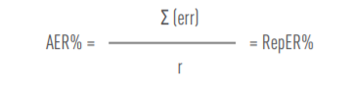

Where:
Σ (err) = sum of all individual error rates of the sample (in %). Only those errors in favour of the JU will be taken into consideration.
n = sample size
Second step: calculation of residual error rate:
To take into account the impact of the ex post controls, this error level is to be adjusted by subtracting:
- errors detected and corrected as a result of the implementation of audit conclusions;
- errors corrected as a result of the extrapolation of audit results to non-audited contracts with the same beneficiary.
This results in a residual error rate, which is calculated by using the following formula:
(RepER% * (P-A) - (RepERsys% * E)
RepER% =
P

Where:
ResER% = residual error rate, expressed as a percentage.
RepER% = representative error rate, or error rate detected in the representative sample, in the form of the AER, expressed as a percentage and calculated as described above (AER%).
RepERsys% = systematic portion of the RepER% (the RepER% is composed of complementary portions reflecting the proportion of ‘systematic’ and ‘non-systematic’ errors detected) expressed as a percentage.
P = total amount in EUR of the auditable population.
A = total of all audited amounts, expressed in EUR.
E = total non-audited amounts of all audited beneficiaries. This will comprise the total amount, expressed in EUR, of all non-audited validated cost statements for all audited beneficiaries, excluding those beneficiaries for which an extrapolation is ongoing.
This calculation will be performed on a point-in-time basis, i.e. all the figures will be provided as of a certain date.

Annex 10 – List of acronyms
Acronym | Explanation
AAR | Annual Activity Report
ABAC | Accrual Based ACcounting
AEMEL | Anion Exhange Membrane electrolysers
ARES | Advanced REcord System (EC Document Management IT system)
AST | Accelerated Stress Test, in section 1.2, assistant in section 2.6
AWP | Annual Work Plan
BEV | Battery Electric Vehicle
BoL | Beginning of Life
BoP | Balance of Plant
CAPEX | Capital expenditure
CAS | Common Audit Service
CEF | Connecting Europe Facility
CFD | Computational Fluid Dynamics
CFS | Certificate of Financial Statements
(μ)CHP | (micro) Combined Heat and Power
CIC | Common Implementation Centre of DG RTD
cm² | Square centimeters
CO₂ | Carbon dioxide
COP | Conference of the Parties
CRaS | Common Representative Sample
CRM | Critical Raw material
CSA | Coordination and support actions
D&E | Dissemination and Exploitation
DBT | Dibenzyltoluene
DC-SRU | Dual-core Single Repeat Unit
DG | Directorate-General
DIGIT | Directorate-General for Informatics
DMO | Document Management Officer
DoE | Department of Energy of United States
DPIA | Data Protection Impact Assessment
DPO | Data Protection Officer
EC | European Commission
ECA | European Court of Auditors
ED | Executive Director
EEA | European Economic Area
EHP | Electrochemical hydrogen purification
EHSP | European Hydrogen Safety Panel
EUSEW | European Sustainable Energy Week
EWPP | Europa Web Publishing Platform
F2P | Feedback to Policy
FAIR | Fraud and Irregularity Committee
FC | Fuel Cells
FCB | Fuel Cell Bus
FCEV | Fuel cell electric vehicle
FCH 2 JU | Fuel Cells and Hydrogen 2 Joint Undertaking
FIB-SEM | Focused Ion Beam Scanning Electron Microscopy
FP7 | European Union’s Seventh Framework Programme
FTE | Full Time Equivalent
GA | Grant agreement
GB | Governing Board
GO | Guarantees of origin
H2020 | Horizon 2020
HDV | Heavy Duty Vehicle
HELLEN | Hydrogen Events and Lessons LEarNed database
HIAD | Hydrogen Incidents and Accidents Database (European Hydrogen Safety Reference Database)
HRB | Horizon Results Booster
HRP | Horizon Results Platform
HRS | Hydrogen refuelling station
HTE | High-Temperature Electrolysis
IA | Innovation Action
IaaS | Infrastructure-as-a-Service
IAS | Internal Audit Service
ICF | Internal Control Framework
ICHS | International Conference on Hydrogen Safety
ICT | Information and Communication Technology
IEA | International Energy Agency
IGF code | International Code of Safety for Ship Using Gases or Other Low-flashpoint Fuels
IKAA | In-kind contributions in additional activities
IKOP | In-kind contributions in operational activities
IMO | International Maritime Organisation
IPHE | International Partnership for Hydrogen into the Economy
(I)PPP | (Institutionalised) Public-Private Partnership
IR | Innovation Radar
ISO | International Organisation for Standardisation
ITO | Information Technology Officer
JRC | Joint Research Centre of the European Commission
JU | Joint Undertaking
KER | Key Exploitable Results
KOH | Potasium hydroxide
KPI | Key Performance Indicators
kWh | Kilowatt hour
LCA | Life Cycle Assessment
LCOH | Levelised cost of Hydrogen
LHV | Lower Heating Value
LOHC | Liquid Organic Hydrogen Carrier
LTWE | Low temperature water electrolysis
MAIP | Multi-Annual Implementation Plan
MAWP | Multi-Annual Work Programme
MEA | Membrane electrode assembly
MGA | Model Grant Agreement
MiPS | Mission Processing System
MPL | Micro Porous Layer
MUS | Monetary Unit Sampling
MW(e ) | Megawatt (electric)
NGO | Non-Governmental Organisation
OEM | Original Equipment Manufacturer
OLAF | European Anti-Fraud Office
OPEX | Operating expenditure
PDA | Project Development Assistance
PEM(FC) | Proton exchange membrane (Fuel Cell)
PEMEL | Proton exchange membrane electrolysers
PGM | Platinum Group Metals
PNR | Pre-normative research
PO | Programme office of the JU
PRD | Programme Review Days
Pt | Platinum
QES | Qualified Electronic Signature
RCS (SC) | Regulations, Codes and Standards (Strategy Coordination)
RES | Renewable Energy Sources
RIA | Research and Innovation Actions
rSOC | Reversible Solid Oxide Systems
RTD/R&I | Copper indium gallium selenide solar cell
RTD/R&I | Research, technological development and demonstration / Research and Innovation
SaaS | Software-as-a-Service
SAE | Society of Automotive Engineers
SET-Plan | European Strategic Energy Technology Plan
SFEM | Sector Forum Energy Management
SHJ | Silicon Heterojunction Solar Cells
SME | Small and medium-sized enterprise
SNE | Seconded National Expert
SoA | State-of-the-art
SOEC | Solid oxide electrolysis
SOFC | Solid oxide fuel cell
SRG | States Representatives Group
SRIA | Strategic Research and Innovation Agenda
SSERR | Support Services for Exploitation of Research Results
SWD | Staff Working Document
SYSPER | SYStème de gestion du PERsonnel
TIM | Tools for Innovation Monitoring
TRL | Technology readiness level
TRUST | Technology Reporting Using Structured Templates
TTG | Time To Grant
TTI | Time To Inform
TTP | Time To Pay
TTS | Time To Sign
WG | Working Group

Total number of buses included in the projects High V.LO-City, HyTransit, 3EMOTION, JIVE and JIVE 2
https://assured-project.eu/storage/files/jive-presentation-user-group-11062019-element-energy-jive-assured-ug-meeting.pdf
Including two discontinued stations
https://ec.europa.eu/info/funding-tenders/opportunities/portal/screen/opportunities/horizon-results-platform
https://www.innoradar.eu/
In this report and for clarity purposes, references will be made in general to JU, meaning the activities carried out by FCH JU, FCH 2 JU and its legal successor Clean Hydrogen JU. When there are specific references, they have the purpose to clarify the legal framework to which they refer to
Council Regulation (EU) 2021/2085 of 19 November 2021 establishing the Joint Undertakings under Horizon Europe and repealing Regulations (EC) No 219/2007, (EU) No 557/2014, (EU) No 558/2014, (EU) No 559/2014, (EU) No 560/2014, (EU) No 561/2014 and (EU) No 642/2014
https://www.clean-hydrogen.europa.eu/about-us/key-documents/strategic-research-and-innovation-agenda_en
Council Regulation (EU) No. 559/2014 of 6 May 2014 establishing the Fuel Cells and Hydrogen 2 Joint Undertaking.
Total minimum contribution from members other than the EU (EUR 380 million) over the total EU contribution (EUR 665 million)
Committed EC contribution together with committed private contributions (members and non-members) in the overall portfolio of 134 signed projects for H2020 programme in FCH 2 JU of EUR 1.180 thousand.
COUNCIL REGULATION (EU) 2021/2085 of 19 November 2021
REGULATION (EU) 2021/695 OF THE EUROPEAN PARLIAMENT AND OF THE COUNCIL of 28 April 2021
https://www.clean-hydrogen.europa.eu/media/publications/programme-review-report-2020-2021_en
The Programme Review Report 2020-2021 covers the years 2019-2020.
https://www.clean-hydrogen.europa.eu/knowledge-management/programme-review-days/prd-2021_en
The TRUST (Technology Reporting Using Structured Templates) data collection platform is used for the purposes of monitoring technology progress against state-of-art, but also to identify how each of the projects contributes to the Clean Hydrogen JU targets, objectives and indicators described in the SRIA. For more information see here.
Including two discontinued stations
https://www.fch.europa.eu/page/transport#FLHYSAFE
https://www.fch.europa.eu/page/transport#HEAVEN
https://www.fch.europa.eu/page/transport#PEGASUS
https://www.fch.europa.eu/page/transport#CRESCENDO
http://www.pace-energy.eu
https://www.cleargen.eu/
https://www.fch.europa.eu/page/hydrogen-production-and-distribution#Don%20Quichote
https://www.fch.europa.eu/page/energy#REFHYNE
https://www.fch.europa.eu/page/energy#Djewels
https://www.fch.europa.eu/page/energy#PRETZEL
https://www.fch.europa.eu/page/energy#MultiPLHY
https://www.fch.europa.eu/page/energy#HySTOC
https://ec.europa.eu/jrc/sites/default/files/jrc124206_assessment_of_hydrogen_delivery_options.pdf
https://www.fch.europa.eu/page/energy#HyCARE
https://www.fch.europa.eu/page/energy#HyGrid
https://www.fch.europa.eu/page/energy#MEMPHYS
https://www.clean-hydrogen.europa.eu/knowledge-management/technology-monitoring-trust_en
https://www.fchobservatory.eu/observatory
https://www.clean-hydrogen.europa.eu/media/publications/programme-review-report-2020-2021_en
https://www.clean-hydrogen.europa.eu/knowledge-management/programme-review-days/prd-2021_en
https://www.fchobservatory.eu/index.php/reports
https://www.clean-hydrogen.europa.eu/system/files/2022-02/Clean%20Hydrogen%20JU%20SRIA%20-%20approved%20by%20GB%20-%20clean%20for%20publication%20%28ID%2013246486%29.pdf
https://www.clean-hydrogen.europa.eu/get-involved/european-hydrogen-safety-panel-0/reference-documents-ehsp_en
https://www.clean-hydrogen.europa.eu/system/files/2022-02/Clean%20Hydrogen%20JU%20SRIA%20-%20approved%20by%20GB%20-%20clean%20for%20publication%20%28ID%2013246486%29.pdf
https://www.clean-hydrogen.europa.eu/get-involved/european-hydrogen-safety-panel-0/reference-documents-ehsp_en
https://www.clean-hydrogen.europa.eu/get-involved/european-hydrogen-safety-panel-0_en
https://www.clean-hydrogen.europa.eu/knowledge-management/tools-innovation-monitoring-tim-0_en
https://www.etipbioenergy.eu/set4bio
https://www.certifhy.eu/
European Maritime Safety Agency: http://www.emsa.europa.eu/
https://www.clean-hydrogen.europa.eu/projects-repository/maranda_en
https://www.clean-hydrogen.europa.eu/projects-repository/flagships_en
https://www.clean-hydrogen.europa.eu/projects-repository/e-shyips_en
14 July 2021: COM(2021) 550 final - 'Fit for 55': delivering the EU's 2030 Climate Target on the way to climate neutrality. https://eur-lex.europa.eu/legal-content/EN/TXT/PDF/?uri=CELEX:52021DC0550&from=EN
15 December 2021: Commission adopted legislative proposals to decarbonise the EU gas market by facilitating the uptake of renewable and low carbon gases, including hydrogen, and to ensure energy security for all citizens in Europe. https://ec.europa.eu/commission/presscorner/detail/en/ip_21_6682
Including the State Aid for Environmental protection and Energy – revised guidelines (https://ec.europa.eu/info/law/better-regulation/have-your-say/initiatives/12616-State-aid-for-environmental-protection-and-energy-revised-guidelines_en); the review of emission standards for Heavy-Duty Vehicles (https://ec.europa.eu/info/law/better-regulation/have-your-say/initiatives/13168-Reducing-carbon-emissions-review-of-emission-standards-for-heavy-duty-vehicles_en); or the TEN-E – new rules for cross-border energy projects (https://www.consilium.europa.eu/en/press/press-releases/2021/12/22/ten-e-council-and-parliament-reach-provisional-agreement-on-new-rules-for-cross-border-energy-projects/)
https://ec.europa.eu/international-partnerships/projects/eu-global-technical-assistance-facility-sustainable-energy-eu-gtaf_ro
To foster cooperation with Africa, it was agreed that Clean Hydrogen JU would support a topic in its Call 2022 aiming to create enabling conditions for the development of renewable hydrogen technology and market that would contribute to the social, economic and environmental transition of the African continent.
The first one will lead to the deployment a minimum of 150 heavy-duty vehicles (trucks) across along the TEN-T corridors. This topic is calling for at least 3 original equipment manufacturers (OEM) and 6 operators to engage in this action. For waterborne applications the focus is on inland waterway vessels. The support will be provided for the deployment of a first of its kind sizeable fleet of at least 5 inland vessels with fuel power above 500kW and preferably at 1 MW scale.
More details on the common Roadmaps can be found in Annex 7 of the Clean Hydrogen JU SRIA.
https://eda.europa.eu/
More information at: https://www.fch.europa.eu/page/fch-regions-hub
https://s3platform.jrc.ec.europa.eu/hydrogen-valleys
https://www.fch.europa.eu/page/fch-regions-hub
https://www.fch.europa.eu/news/project-development-assistance-kicks-selected-regions
https://www.clean-hydrogen.europa.eu/media/news/project-development-assistance-cities-and-regions-summary-report-now-available-2021-10-19_en
https://www.bighit.eu/
https://www.fch.europa.eu/page/energy#HEAVENN
https://www.fch.europa.eu/page/energy#GREEN%20HYSLAND
https://www.h2v.eu/
https://www.fch.europa.eu/page/mission-innovation-hydrogen-valleys-platform
Mission Innovation 2.0 was launched on 2 June 2021, catalysing a decade of action and investment in research, development and demonstration to make clean energy affordable, attractive and accessible for all. http://mission-innovation.net/missions/hydrogen/
https://www.clean-hydrogen.europa.eu/media/news/research-and-innovation-priorities-clean-hydrogen-2022-02-28_en
https://ec.europa.eu/info/research-and-innovation/strategy/goals-research-and-innovation-policy/innovation-union_en
https://ec.europa.eu/research/iscp/pdf/policy/com_2012_497_communication_from_commission_to_inst_en.pdf
http://mission-innovation.net/our-work/innovation-challenges/renewable-and-clean-hydrogen/
https://www.fch.europa.eu/page/mission-innovation-hydrogen-valleys-platform
The JU hosted a Task 41 Definition Meeting (Data and Modelling) on 29 August 2019 in Brussels, Belgium. Topics of discussion included how to model hydrogen in the value chain and improve current methods, experiences from other tasks, and data consolidation of parameters describing hydrogen technologies.
March 2022.
Draft Report 2021/2153(DEC ) available at: https://www.europarl.europa.eu/doceo/document/CONT-PR-698996_EN.pdf
March 2022.
Draft Report 2021/2153(DEC ) available at: https://www.europarl.europa.eu/doceo/document/CONT-PR-698996_EN.pdf
March 2022
Draft Report 2021/2153(DEC ) available at: https://www.europarl.europa.eu/doceo/document/CONT-PR-698996_EN.pdf
https://ec.europa.eu/research/participants/data/ref/h2020/other/mga/jtis/h2020-mga-fch_en.pdf
https://webgate.ec.europa.eu/fpfis/wikis/pages/viewpage.action?pageId=738755339&preview=/738755339/741311561/Dissemination_and_exploitation_strategy_Horizon_Europe%20_%20Endorsed_Nov2020.pdf
https://ec.europa.eu/info/funding-tenders/opportunities/portal/screen/opportunities/horizon-results-platform
Furthermore, a new service, the Dealflow.eu, is available to support the innovations/innovators in further exploitating their results, especially in commercializing their innovations (“go-to-Market”), by facilitating access to clients and investors and providing high-end coaching services (e.g. venture-building, preperation for fundraising, networking, pitching to possible investors, etc).
This legal framework was complemented by a methodology for both IKOP and IKAA agreed by the JU GB on 18 November 2015 and 9 December 2016, respectively.
Calculated as follows: for closed projects based on amount finally paid, for ongoing projects based on the committed amount and for finished projects for which final payment is not made until 31/12/2021 but cost claim received, based on the amounts paid in previous periods + amount received but not yet validated
SWD(2017) 338 final, COMMISSION STAFF WORKING DOCUMENT, INTERIM EVALUATION of the Joint Undertakings operating under Horizon 2020, page 44, Table 12.
Impressions are defined by the total number of times social media browsers have showed the content; impressions count exposure.
Reach, as performance indicator, refers to the number of users who choose to see the social media content and engage with it using ‘likes’, ‘comments’, or ‘shares’.
https://www.clean-hydrogen.europa.eu/get-involved/mission-innovation-hydrogen-valleys-platform_en
https://www.clean-hydrogen.europa.eu/media/news/webinar-hydrogen-certification-2021-05-04_en
https://www.clean-hydrogen.europa.eu/media/news/review-anion-exchange-membrane-electrolysers-webinar-2021-07-07_en
https://www.clean-hydrogen.europa.eu/media/events/webinar-results-fch-jus-project-development-assistance-pda-regions_en
https://www.green-industrial-hydrogen.com/news-detail/fch-ju-meets-grinhy20-in-salzgitter
https://www.clean-hydrogen.europa.eu/media/news/inauguration-europes-largest-pem-electrolysis-plant-refhyne-project-2021-07-02-0_en
https://eusew.eu/extended-programme-sessions/hydrogen-and-its-potential-decarbonize-industrial-hubs-through-ports
https://eusew.eu/extended-programme-sessions/clean-steel-hydrogen
https://eusew.eu/programme-sessions/key-role-european-regions-kick-starting-and-advancing-clean-hydrogen
https://eu.app.swapcard.com/event/eu-regions-week/planning/UGxhbm5pbmdfNjMxMzA3
https://events.climateaction.org/2021/sustainable-innovation-forum/
https://eu-green-deal-2020-research.eugcc-cleanergy.net/About.html
https://setplan2021.eu/sideevents/fuel-cells-and-hydrogen-joint-undertaking-and-ecubes/
https://www.2021portugal.eu/en/events/high-level-conference-on-hydrogen-hydrogen-in-society-bridging-the-gaps/
Regulation (EU) 2018/1725 of the European Parliament and of the Council of 23 October 2018 on the protection of natural persons with regard to the processing of personal data by the Union institutions, bodies, offices and agencies and on the free movement of such data, and repealing Regulation (EC) No 45/2001 and Decision No 1247/2002/EC (Text with EEA relevance.). OJ L 295, 21.11.2018, p. 39–98
https://www.clean-hydrogen.europa.eu/about-us/organisation/stakeholders-group_en
62 reports for H2020, and additional 3 reports for the FP7 programme were assessed in total
Due to COVID-19 restrictions, the meetings were organized online
Decision reference CleanHydrogen-GB-2021 -03 of the Governing Board of the Clean Hydrogen Joint Undertaking of 17/12/2021 adopting the transfer of decisions of the Fuel Cells and Hydrogen 2 Joint Undertaking’s Governing Board to Clean Hydrogen Joint Undertaking
Average cost of temporary agent used for Legislative Financial Sheets as announced by DG BUDG in November 2021 is EUR 157 000 / year
All validated costs in 2021 for running projects as at 31 December 2021 for all running programs (both FP7 & H2020) were considered
Ref. Ares(2016)981660 - 25/02/2016, endorsed by the CSC Steering Board.
Taken biannually for 162 participations; MUS sampling is applied; population is determined by the costs declared and paid by the beneficiaries through financial statements which form the basis for calculating the EU contribution.
Guidance H2020 ex-ante controls on interim and final payments, version 1.0.
Based on the 418 representative results out of the 629 expected in the four Common Representative Samples.
It should be noted that in 2021 most H2020 grants managed by DG R&I were transferred to Executive Agencies. Hence, this figure is based only on the actions that remained with DG R&I at the end of 2021.
H2020 operational budget of EUR 70.280 million less EUR 6.696 million related to the EIT financial instruments and others.
Ares(2019)6087752
Results announced with Ares(2021)7361583
One specific outlier case which impact has been absorbed and cleaned in the subsequent residual error rate calculation.
True and fair in this context means a reliable, complete and correct view on the state of affairs in the Joint Undertaking.
Based on Annex II to Council Decision 2013/743/EU.
MAMA-MEA and THyGA account together for 275 and 376 of the above numbers respectively.
This indicator is not legally compulsory but covers several additional specific indicators requested for more societal challenges by the services in charge.
Based on Annex III to Council Decision 2013/743/EU; source: CORDA, unless specified otherwise.
The figures concern 133 projects, not including ELECTROOU which was terminated early.
As in 2021 both FCH 2 JU and Clean Hydrogen JU were operational, it was decided that the KPIs for both JUs should be presented here. Nevertheless, for the Clean Hydrogen JU only the baseline and targets can be reported.
Projects addressing topics related to renewable energy integration (KPI 1.1) and storage (KPI 1.4) are interrelated, in many cases covering both aspects. Complementarily, a common KPI of 26 % can be reported for KPIs 1.1 and 1.4.

